Open Doors: World Watch List 2026
The World Watch List is Open Doors’ annual ranking of the 50 countries where Christians face the most extreme persecution. Explore the country profiles to find information, stories and prayers for each of the countries, along with ways to pray and stand with your persecuted church family.
More than 380 million Christians face persecution and discrimination because they love Jesus. Where faith looks impossible, God is doing the impossible. The church continues to grow.
Bangladesh: World Watch List #33
Amidst continuing political uncertainty and social unrest in Bangladesh, the persecution facing Christians is intensifying.
Christian men can experience public beatings, torture, false accusations and ostracism from the authorities and the local community.
Christian women and girls are vulnerable to harassment, ostracism, humiliating rituals, sexual assault, rape, forced marriage and house arrest.
Church leaders are especially at risk of arrest.
Christian children can face isolation and bullying in school.

A link to the World Watch Map can be found below or scan the QR code
https://www.opendoorsuk.org/persecution/world-watch-list/

Minister: Rev. James Blackwell 07596 299970
01599 537223
Elders: Ken MacDonald 07895 678496
Colin MacDonald 01599 522719
Finlay MacDonald 07445 646444
Finance Committee: Donnie Lamont
Ronnie Lamont
Moira Lane
Craig Scobie 07502 485998
Safeguarding Co-ordinators: Barbara MacDonald 01599 522719
Moira Lane 01599 522709

Glenelg Inverinate Free Church, Acc. No. 00218787, Sort code 83 24 09
Scottish Charity Number - SC038152

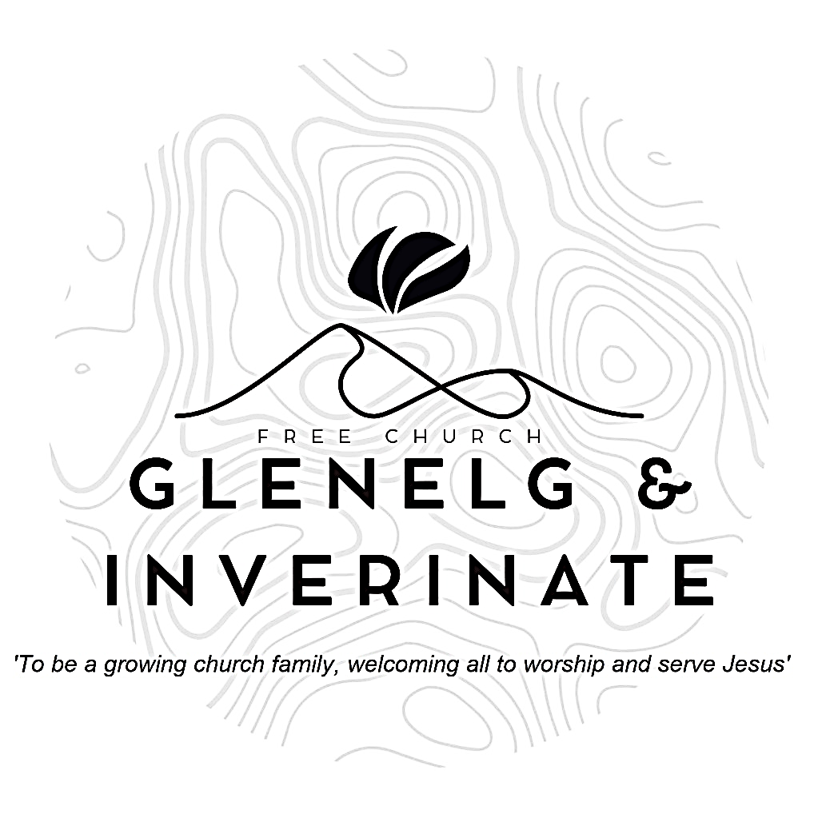

WEEKLY BULLETIN
Sunday 4th October 2026
Service at 12.00 noon in Inverinate Hall and
6.00pm in Glenelg Church of Scotland

We warmly welcome you to this service of worship and would love you to join us for tea, coffee and refreshment

Give praise to the Lord, proclaim his name; make known among the nations what he has done. Sing to him, sing praise to him; tell of all his wonderful acts. Glory in his holy name; let the hearts of those who seek the Lord rejoice. 1 Chronicles 16:8-10

NOTICES

- Today’s Services: We are delighted to welcome Rev Roddy MacRae who will be leading our 12 noon service from 1 Peter 1:1-12, Sermon – “We have a Living Hope.” We will celebrate the Sacrament of Holy Communion during the 12 noon service and there will be a congregational lunch following the service to which all are warmly invited. At our Glenelg 6.00pm service this evening Rev MacRae will lead us from Jonah 1:1-16, Sermon – “God’s Gracious Judgement”. The audio from our services is recorded and is accessible on our website.
- Praise:
Sing Psalms 23:1-6 (page 28) – The LORD is my shepherd
Hymn – Thine be the Glory
Hymn – In Christ Alone
Scottish Psalter 72:17-19 (314) – His name for ever shall endure
- Sunday School: Sunday School will run as usual today during our service. There is also a creche for the very little ones.
- Online Study Groups: The Men’s Group will be continuing our study on Luke’s Gospel – Jesus’ Words. The Women’s ‘Through the New Testament’ group read is coming to an end and after the October school holidays we are starting a new 6 week study. We’re going to read “Heart Songs for Every Saint”, by William J.U. Philip, which takes six psalms and shows how they can be prayed in different situations of life. We meet in a Messenger group and are happy to accept new members at any time.
- Bible Study: Our Glenelg Study Group are meeting as usual this Wednesday at 7.30pm at Jon and Megan's home. The Dornie Bible study will also meet on Wednesday.
- Church Prayer Meeting: Please remember that our Church Prayer Meeting is now held every Sunday at 11.15am before the Sunday Service. So please do come along and join us in prayer to our Heavenly Father.
- Dornie Playgroup: The Dornie Playgroup has been a huge success, God has blessed it to bear fruit for our witness as a congregation and seeing new folks coming to church. But as numbers increase it would be a blessing and an encouragement to have some more volunteers to join our team and help out at our weekly sessions. The Playgroup runs every Monday from 10am to 12 noon in Dornie Hall. If you can give some time to come along and help out on a regular basis or even if it’s just one session every now and again, please speak to Claire.
- Glenelg Singing Group: Are inviting everyone to come along for a series of six evenings of Psalm Singing, where we can learn the harmonies for some of the more familiar psalms tunes. These sessions will continue on Thursday at 7.30pm at Glenelg Church of Scotland. All are warmly welcome.

- Dates for your Diaries:
Wednesday 4th November - COOL Area Prayer Meeting in the Chocolates of Glenshiel Cafe at 7.30pm
Saturday 7th November - Coffee Morning on Glenelg Hall in aid of Help for Heroes and SASRA.
Sunday 8th November - Remembrance Sunday
- Praying for One Another: Please add the following points to your prayer diaries:
Tearfund: Nepal: For the last month, Tearfund partners have been supporting those affected by the flash flooding in Nepal. As relief effort continues, pray for wisdom and endurance for our staff and local partners as they seek to bring relief, hope and care to those most in need.
North Uist: Pray for good engagement with our community, both those with a historic connection and those without. Pray that the Lord would help us to identify and train up new leaders within the congregation. Pray for our young people; thank God for those who attend and pray that they would come to know the Lord.
UFM: Iran: Please pray for peace and stability amid rising tensions. Pray for the Lord’s justice, mercy, and freedom for those facing oppression. Remember Iranian believers, and pray for courage and protection for them. Pray also for those seeking truth to encounter Jesus Christ, and for future freedom to openly worship and share faith.
Big Free Rally: Over 250 young people gathered yesterday at the Big Free Rally for a time of friendship, fellowship, and learning from God’s word. Give thanks for our young people who gathered from across Scotland, and pray that each one would continue to grow in knowledge and love for the Lord.
COOL: Please pray for the SOLAS Bible Study Group that meets on a Thursday lunchtime at Plockton High School. A number of the core group of young people who previously came along to the group have now left school, so please pray that a new group of young people would come along to the group. Also for Friday youth club in Kyle. Please pray for plans for these sessions, as well as more volunteers to be able to make these sessions run.

