Open Doors: World Watch List 2026
The World Watch List is Open Doors’ annual ranking of the 50 countries where Christians face the most extreme persecution. Explore the country profiles to find information, stories and prayers for each of the countries, along with ways to pray and stand with your persecuted church family.
More than 380 million Christians face persecution and discrimination because they love Jesus. Where faith looks impossible, God is doing the impossible. The church continues to grow.
Ethiopia: World Watch List #36
The Ethiopian Orthodox Church (EOC) does not recognise Protestant groups as true Christianity. Its factions often depict Evangelical Christians as enemies of the country, leading to increased pressure and stigmatisation of believers.

Threats also arise from Muslim-majority communities who often discriminate against converts from Islam. Such treatment can range from social rejection to physical violence, and Ethiopia has seen many mob attacks and church burnings in 2025. The EOC has a long-standing influence on national identity and so likely shapes the perspectives of many citizens on Protestant and evangelical Christians.

A link to the World Watch Map can be found below or scan the QR code
https://www.opendoorsuk.org/persecution/world-watch-list/

Minister: Rev. James Blackwell 07596 299970
01599 537223
Elders: Ken MacDonald 07895 678496
Colin MacDonald 01599 522719
Finlay MacDonald 07445 646444
Finance Committee: Donnie Lamont
Ronnie Lamont
Moira Lane
Craig Scobie 07502 485998
Safeguarding Co-ordinators: Barbara MacDonald 01599 522719
Moira Lane 01599 522709

Glenelg Inverinate Free Church, Acc. No. 00218787, Sort code 83 24 09
Scottish Charity Number - SC038152

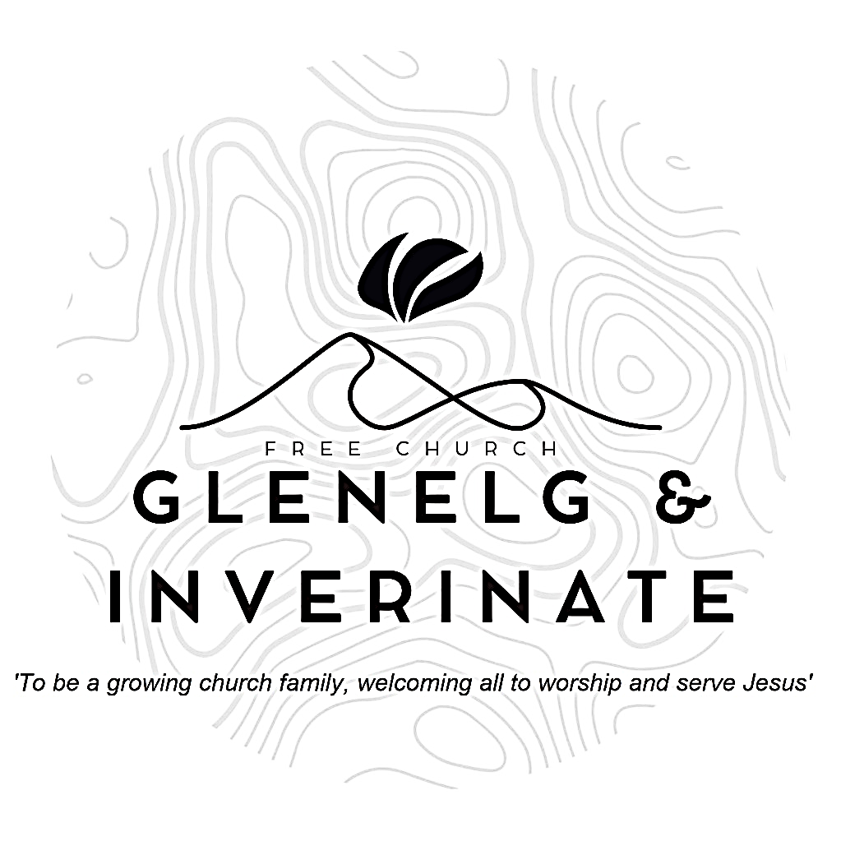

WEEKLY BULLETIN
Sunday 25th October 2026
Service at 12.00 noon in Inverinate Hall and
6.00pm in Glenelg Church of Scotland

We warmly welcome you to this service of worship and would love you to join us for tea, coffee and refreshment

You, God, are my God, earnestly I seek you; I thirst for you, my whole being longs for you, in a dry and parched land where there is no water. I have seen you in the sanctuary and beheld your power and your glory. Psalm 63:1-2

NOTICES

- Today’s Services: We are delighted to have Mr Willie Fraser from Kyle Free Church leading our 12 noon worship from Luke 24:9-49 & John 20:19-23, Sermon – “Jesus dispenses his gifts”. At our Glenelg 6.00pm service this evening we will look at Hebrews 10:11-25, Sermon – “A salad bowl of encouragement”. The audio from our services is recorded and is accessible on our website.
- Praise:
Sing Psalms 148:1-14 (page 194) – O praise, O praise the Lord!
Sing Psalms 27:1-5 (page 31) – The Lord’s my saviour and my light
Hymn – My hope is built on nothing less
Hymn – When peace like a river attendeth my way
- Sunday School: The Sunday School are taking a break for the School Holidays. There will be crèche for the very little ones.
- Online Study Groups: The Men’s Group will be continuing our study on Luke’s Gospel – Jesus’ Words. The Women’s Group are continuing their 6 week study reading “Heart Songs for Every Saint”, by William J.U. Philip. We meet in a Messenger group and are happy to accept new members at any time.
- Bible Study: Our Glenelg Study Group are meeting as usual this Wednesday at 7.30pm at Jon and Megan's home. The Dornie Bible study will also meet on Wednesday.
- Church Prayer Meeting: Please remember that our Church Prayer Meeting is now held every Sunday at 11.15am before the Sunday Service. So please do come along and join us in prayer to our Heavenly Father.
- Dornie Playgroup: The Dornie Playgroup has been a huge success, God has blessed it to bear fruit for our witness as a congregation and seeing new folks coming to church. But as numbers increase it would be a blessing and an encouragement to have some more volunteers to join our team and help out at our weekly sessions. The Playgroup runs every Monday from 10am to 12 noon in Dornie Hall. If you can give some time to come along and help out on a regular basis or even if it’s just one session every now and again, please speak to Claire.
- Remembrance Coffee Morning: Saturday 7th November at 12 noon in Glenelg Hall in aid of 'Help for Heroes' and 'SASRA'. If you are able to contribute to this coffee morning, can we please request some home baking for the Baking Stall, some bric-a-brac and the Community Council will be running a raffle, so any donations of raffle prizes will be greatly appreciated. If you can bring them along on the day please, that would be fantastic. Thank you.

- Dates for your Diaries:
Wednesday 4th November - COOL Area Prayer Meeting in the Chocolates of Glenshiel Cafe at 7.30pm
Saturday 7th November - Coffee Morning on Glenelg Hall in aid of Help for Heroes and SASRA.
Saturday 7th November – The COOL team who were in Uganda are holding a Reflection and Update evening (more details to follow).
Sunday 8th November - Remembrance Sunday
Wednesday 18th November – National Day of Prayer- Each year, we set aside a day to pray for our nation and the work of our denomination in sharing the gospel. We would be delighted if you were able to join us. More details coming soon!
Wednesday 25th November: Faith Mission service and Bookstall with Jeff Townend in Glenelg Hall at 7.30pm.
- Mission International: “Thank You for Your Generous Support”
On behalf of Mission International, I would like to extend our sincere thanks for the generous donation of £527 received on 8 October.
We are very grateful to Glenelg and Inverinate Free Church of Scotland for your support, particularly following Roddy’s recent visit and the fundraising efforts of the congregation. It is always encouraging to see churches getting involved in the work of Mission International, and we truly appreciate the time, effort and generosity that go into raising funds to support our partners overseas
Your gift will help us continue working alongside local partners to share God’s love and provide practical support to communities facing hardship around the world.
We would also love to keep you updated on how your support is making a difference. If you aren't already receiving our newsletter, you can sign up here to receive news, stories and prayer points from our projects around the world at https://mailchi.mp/050cd860e647/newsletter
Thank you again for your kindness and continued support. Please pass on our appreciation to everyone involved in the fundraising.
With sincere thanks and every blessing,
Gillian Stephenson, Mission International
Mission International is a registered Scottish Charitable Incorporated Organisation (SCIO) No. SC038645

- If you have any announcements or prayer points to add to the Sunday Bulletin please let Craig Scobie have them by Friday evening.

