Open Doors: World Watch List 2026
The World Watch List is Open Doors’ annual ranking of the 50 countries where Christians face the most extreme persecution. Explore the country profiles to find information, stories and prayers for each of the countries, along with ways to pray and stand with your persecuted church family.
More than 380 million Christians face persecution and discrimination because they love Jesus. Where faith looks impossible, God is doing the impossible. The church continues to grow.
Turkmenistan: World Watch List #35
Most people in Turkmenistan are Muslims. Those who take the courageous step of leaving Islam to follow Jesus can face immense opposition from their own families and communities.
Women who decide to become Christians are particularly vulnerable to beatings, house arrest, verbal abuse, threats, rejection, abduction and forced marriage.
Christian women can also face sexual violence, often with the aim of intimidating and distressing their husband, families and churches. Given the stigma and shame of such incidents, they are rarely reported, deepening the pain of our sisters and giving impunity to the perpetrators.
Christians also face monitoring and restrictions from the totalitarian state, who particularly see Protestant Christians as extremists for going against government restrictions. Christians who run businesses can face discrimination and opposition in their work.

A link to the World Watch Map can be found below or scan the QR code
https://www.opendoorsuk.org/persecution/world-watch-list/

Minister: Rev. James Blackwell 07596 299970
01599 537223
Elders: Ken MacDonald 07895 678496
Colin MacDonald 01599 522719
Finlay MacDonald 07445 646444
Finance Committee: Donnie Lamont
Ronnie Lamont
Moira Lane
Craig Scobie 07502 485998
Safeguarding Co-ordinators: Barbara MacDonald 01599 522719
Moira Lane 01599 522709

Glenelg Inverinate Free Church, Acc. No. 00218787, Sort code 83 24 09
Scottish Charity Number - SC038152

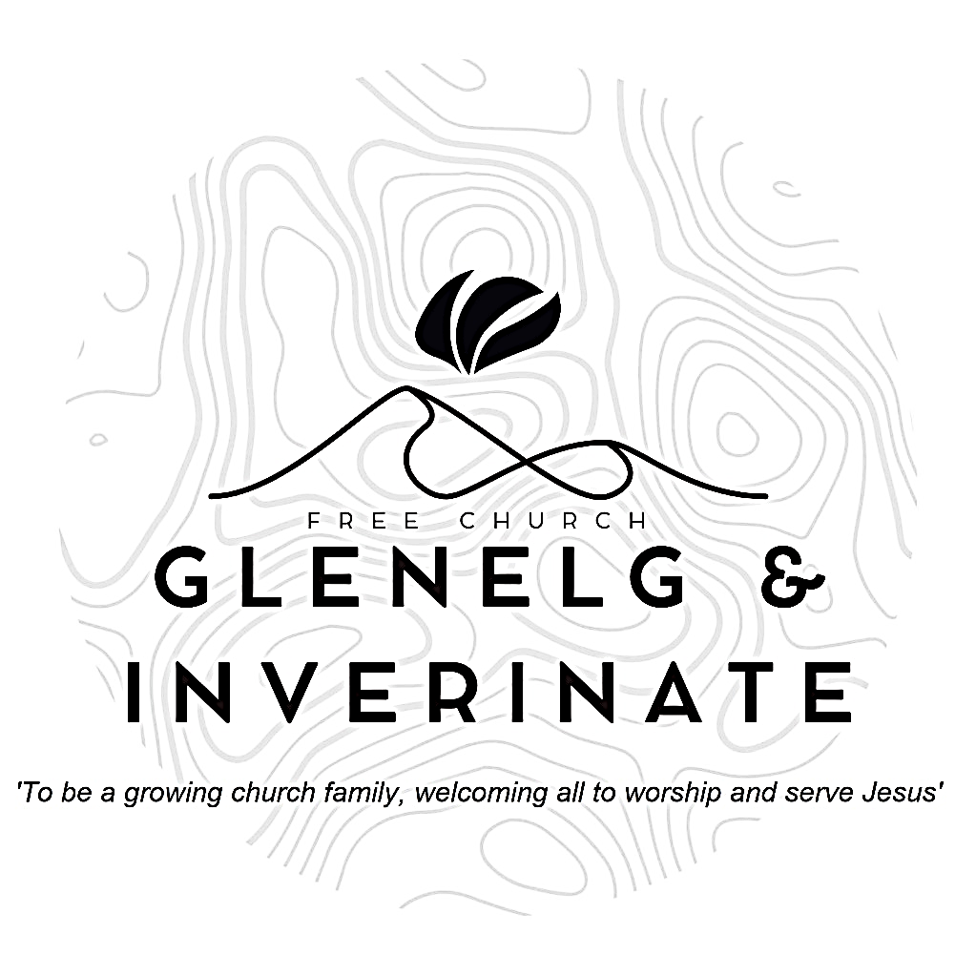

WEEKLY BULLETIN
Sunday 18th October 2026
Service at 12.00 noon in Inverinate Hall and
6.00pm in Glenelg Church of Scotland

We warmly welcome you to this service of worship and would love you to join us for tea, coffee and refreshment

Therefore, since we are receiving a kingdom that cannot be shaken, let us be thankful, and so worship God acceptably with reverence and awe, for our God is a consuming fire. Hebrews 12:28-29

NOTICES

- Today’s Services: We are delighted to have Mr. William Mackenzie from Christian Focus Publications leading our 12 noon worship from Hebrews 12:1-17, Sermon – “Considering Him”. At our Glenelg 6.00pm service this evening we will look at 1 Kings 22:1-28, Sermon – “Conviction of Opposition”. The audio from our services is recorded and is accessible on our website.
- Praise:
Sing Psalms 147:1-8 (page 192) – O praise the Lord! How good it is
Hymn – How deep the Father’s love for us
Hymn – In Christ alone
Scottish Psalter 72:17-19 (page 314) – His name forever shall endure
- Sunday School: The Sunday School are taking a break for the School Holidays. There will be crèche for the very little ones.
- Annual leave: The minister will be away on holiday for the next two weeks. The preacher on the 25th will be Mr Willie Fraser from Kyle Free Church remember him in prayer as he prepares to come. In the event of any pastoral emergencies, the Rev. Roddie Rankin will be available.
- Online Study Groups: The Men’s Group will be continuing our study on Luke’s Gospel – Jesus’ Words. The Women’s Group are starting a new 6 week study. We’re going to read “Heart Songs for Every Saint”, by William J.U. Philip, which takes six psalms and shows how they can be prayed in different situations of life. We meet in a Messenger group and are happy to accept new members at any time.
- Bible Study: Our Glenelg Study Group are meeting as usual this Wednesday at 7.30pm at Jon and Megan's home. The Dornie Bible study will also meet on Wednesday.
- Church Prayer Meeting: Please remember that our Church Prayer Meeting is now held every Sunday at 11.15am before the Sunday Service. So please do come along and join us in prayer to our Heavenly Father.
- Dornie Playgroup: The Dornie Playgroup has been a huge success, God has blessed it to bear fruit for our witness as a congregation and seeing new folks coming to church. But as numbers increase it would be a blessing and an encouragement to have some more volunteers to join our team and help out at our weekly sessions. The Playgroup runs every Monday from 10am to 12 noon in Dornie Hall. If you can give some time to come along and help out on a regular basis or even if it’s just one session every now and again, please speak to Claire.

- Dates for your Diaries:
Wednesday 4th November - COOL Area Prayer Meeting in the Chocolates of Glenshiel Cafe at 7.30pm
Saturday 7th November - Coffee Morning on Glenelg Hall in aid of Help for Heroes and SASRA.
Sunday 8th November - Remembrance Sunday
Wednesday 18th November – National Day of Prayer- Each year, we set aside a day to pray for our nation and the work of our denomination in sharing the gospel. We would be delighted if you were able to join us. More details coming soon!
Wednesday 25th November: Faith Mission service and Bookstall with Jeff Townend in Glenelg Hall at 7.30pm.
- Praying for One Another: Please add the following points to your prayer diaries:
Rosskeen: We’ve had conversions as a prayer point as a congregation throughout this year and we’d ask you to join us in praying that we would see people coming to know the LORD. Pray for our young folks. We are so blessed and we would pray for our young folks to be engaged with, and passionate for, the LORD. Pray too for the school chaplaincy work in our community - 8 primary schools and two academies. Pray that we would continue to know the presence of the LORD in our gatherings and that we would grow as a congregation in the knowledge of the LORD. Pray with us as we seek as a Church leadership to plan for the future. Pray that we would know the LORD’s guidance.
Winchburgh: SU groups: Give Thanks for the 18 children attending the local primary SU group and their eagerness to learn God's Word.
Pray For wisdom, open doors, and resources as we look to launch a second group in the new primary school and a third group in the secondary school. Baby Café: Give thanks For the strong weekly turnout of local parents and babies every Monday. Pray that God would build genuine trust and friendships, opening up natural opportunities for Gospel-centered conversations.
New Team / Community Members: Give Thanks: For Dillon and Cody Bennett’s arrival in Scotland from just outside Atlanta, Georgia. Pray For a smooth transition and settling-in period, and that God would fruitfully work in and through them in Winchburgh
Muriel Macleod, Cambodia: Please pray for the youth returning to the dorms. Pray for us all as we adjust to living together again, remembering us as we worship together each evening. Pray that God would use the youth and myself as witnesses in the school and community.

