Open Doors: World Watch List 2026
The World Watch List is Open Doors’ annual ranking of the 50 countries where Christians face the most extreme persecution. Explore the country profiles to find information, stories and prayers for each of the countries, along with ways to pray and stand with your persecuted church family.
More than 380 million Christians face persecution and discrimination because they love Jesus. Where faith looks impossible, God is doing the impossible. The church continues to grow.
Bhutan: World Watch List #34

Most people in Bhutan are Buddhists, and those who decide to become Christians are treated with suspicion at best.
No churches are officially recognised by the state, so Christians must meet secretly in their homes. These small gatherings are ‘illegal’, leaving the Christians vulnerable to criminal penalties.
No Christian groups are allowed to worship publicly, own property, raise funds, conduct outreach activities or import Christian literature.
Evangelistic activities are banned and can lead to imprisonments of up to three years.
In Bhutan, village authorities have the power to administer a ‘non-objection certificate’ to confirm that the individual in question is a good citizen. This certificate is needed for things like loan and job applications. Christians may be denied this, which can add to the discrimination and isolation they experience.

A link to the World Watch Map can be found below or scan the QR code
https://www.opendoorsuk.org/persecution/world-watch-list/

Minister: Rev. James Blackwell 07596 299970
01599 537223
Elders: Ken MacDonald 07895 678496
Colin MacDonald 01599 522719
Finlay MacDonald 07445 646444
Finance Committee: Donnie Lamont
Ronnie Lamont
Moira Lane
Craig Scobie 07502 485998
Safeguarding Co-ordinators: Barbara MacDonald 01599 522719
Moira Lane 01599 522709

Glenelg Inverinate Free Church, Acc. No. 00218787, Sort code 83 24 09
Scottish Charity Number - SC038152

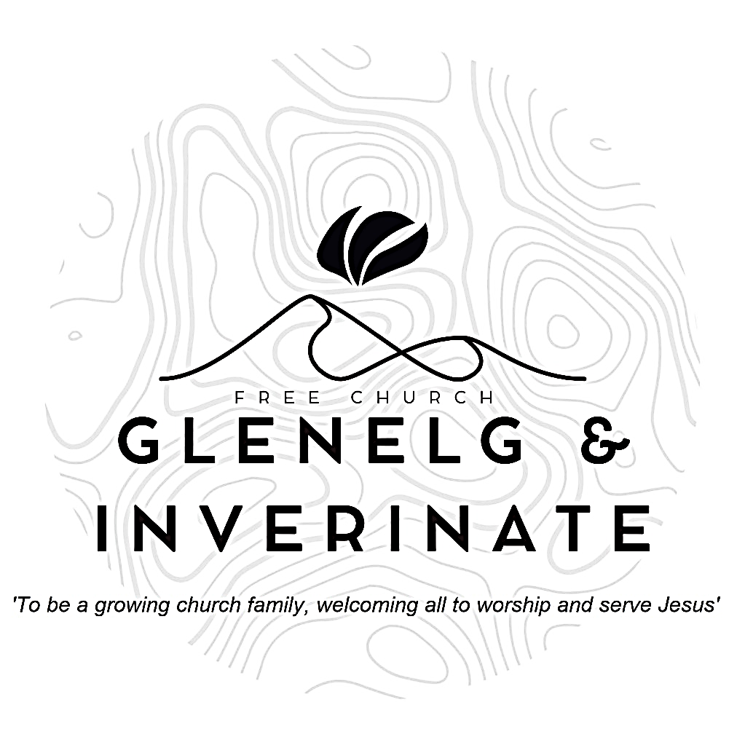

WEEKLY BULLETIN
Sunday 11th October 2026
Service at 12.00 noon in Inverinate Hall and
6.00pm in Glenelg Church of Scotland

We warmly welcome you to this service of worship and would love you to join us for tea, coffee and refreshment

You who fear him, trust in the Lord— he is their help and shield. The Lord remembers us and will bless us: He will bless his people Israel, he will bless the house of Aaron, he will bless those who fear the Lord—
small and great alike. 1 Chronicles 16:8-10

NOTICES

- Today’s Services: We are delighted to have Rev James Blackwell leading our 12 noon worship from Matthew 8:28-34, Sermon – “The King of all realms”. At our Glenelg 6.00pm service this evening we will look at Genesis 15:7-21, Sermon – “The Covenant of God”. The audio from our services is recorded and is accessible on our website.
- Praise:
Sing Psalms 103:1-14 (page 135) – Praise God, my soul! With all my heart
Hymn – Come, Let us to the Lord our God
Hymn – Man of Sorrows what a name
Sing Psalms 118:19-29 (156) – Throw wide the gates of righteousness
- Sunday School: Sunday School will run as usual today during our service. There is also a creche for the very little ones.
- Annual leave: The minister will be away on holiday for the next two weeks. The preachers will be Mr. William Mackenzie from Christian Focus Publications on the 18th and Mr Willie Fraser from Kyle Free Church on the 25th remember these men in prayer as they prepare to come. In the event of any pastoral emergencies, the Rev. Roddie Rankin will be available.
- Online Study Groups: The Men’s Group will be continuing our study on Luke’s Gospel – Jesus’ Words. The Women’s Group are starting a new 6 week study. We’re going to read “Heart Songs for Every Saint”, by William J.U. Philip, which takes six psalms and shows how they can be prayed in different situations of life. We meet in a Messenger group and are happy to accept new members at any time.
- Bible Study: Our Glenelg Study Group are meeting as usual this Wednesday at 7.30pm at Jon and Megan's home. The Dornie Bible study will also meet on Wednesday.
- Church Prayer Meeting: Please remember that our Church Prayer Meeting is now held every Sunday at 11.15am before the Sunday Service. So please do come along and join us in prayer to our Heavenly Father.
- Collection for Mission International: Following Rev Roddy MacRae's visit last Sunday, the total raised from the Coffee Morning on Saturday and the Retiring Collection following our Sunday services was £527. Many thanks to everyone for their support of the event, generous contributions, helping with the coffee morning, donating baking and bric-a-brac and praying for these events. This fantastic total will be sent to Mission International to help with their continuing work.

- Dornie Playgroup: The Dornie Playgroup has been a huge success, God has blessed it to bear fruit for our witness as a congregation and seeing new folks coming to church. But as numbers increase it would be a blessing and an encouragement to have some more volunteers to join our team and help out at our weekly sessions. The Playgroup runs every Monday from 10am to 12 noon in Dornie Hall. If you can give some time to come along and help out on a regular basis or even if it’s just one session every now and again, please speak to Claire.
- Dates for your Diaries:
Wednesday 4th November - COOL Area Prayer Meeting in the Chocolates of Glenshiel Cafe at 7.30pm
Saturday 7th November - Coffee Morning on Glenelg Hall in aid of Help for Heroes and SASRA.
Sunday 8th November - Remembrance Sunday
Wednesday 18th November – National Day of Prayer- Each year, we set aside a day to pray for our nation and the work of our denomination in sharing the gospel. We would be delighted if you were able to join us. More details coming soon!
- Praying for One Another: Please add the following points to your prayer diaries:
Dumisani: We give thanks for the commitment of Dr David Galletta who has been coming now for several years as a visiting lecturer to Dumisani Institute in the Eastern Cape from the USA. We prayer for his travels and that he be granted strength and health as he teaches the first half of October at Dumisani.
Pray for the class on homiletics which has 35 students which Dr Galletta will be teaching this month at Dumisani, SA. Several practical assignments are incorporated into the class work and so we pray also that each student will benefit greatly.
Pray for Dr Galletta as he also is out doing preaching in local churches while he is at Dumisani in the Eastern Cape. This is a wonderful way of connecting and bringing unity of purpose and mission.
Back: Prayer for our Teens Group which has grown this year with a good leadership team engaging the Teens (S2-S5) with a variety of Gospel focused meetings.
We are thankful to be able to run two Sunday Schools during term time in Back and Tong. Please pray for the children and teachers.
Pray for our Hope Explored course which is scheduled for this November.
Rebecca Tait, OM: Please continue to pray for stability in the teaching team and the provision of a new teacher.

