Open Doors: World Watch List 2026
The World Watch List is Open Doors’ annual ranking of the 50 countries where Christians face the most extreme persecution. Explore the country profiles to find information, stories and prayers for each of the countries, along with ways to pray and stand with your persecuted church family.
More than 380 million Christians face persecution and discrimination because they love Jesus. Where faith looks impossible, God is doing the impossible. The church continues to grow.
Tunisia: World Watch List #31
Tunisian Christians face increasing pressure in the form of government surveillance on church and daily activity. Those who are monitored can be arrested, interrogated and their homes searched.
Many believers from a Muslim background feel deep isolation due to community pressures which encourage them into silence about their faith.
The government in Tunisia is increasingly authoritarian and controlled by President Kais Saied who secured power in 2021. The religious freedoms of Tunisian citizens thus depend on the President, making Christians highly vulnerable in the Muslim-majority nation.

A link to the World Watch Map can be found below or scan the QR code
https://www.opendoorsuk.org/persecution/world-watch-list/

Minister: Rev. James Blackwell 07596 299970
01599 537223
Elders: Ken MacDonald 07895 678496
Colin MacDonald 01599 522719
Finlay MacDonald 07445 646444
Finance Committee: Donnie Lamont
Ronnie Lamont
Moira Lane
Craig Scobie 07502 485998
Safeguarding Co-ordinators: Barbara MacDonald 01599 522719
Moira Lane 01599 522709

Glenelg Inverinate Free Church, Acc. No. 00218787, Sort code 83 24 09
Scottish Charity Number - SC038152

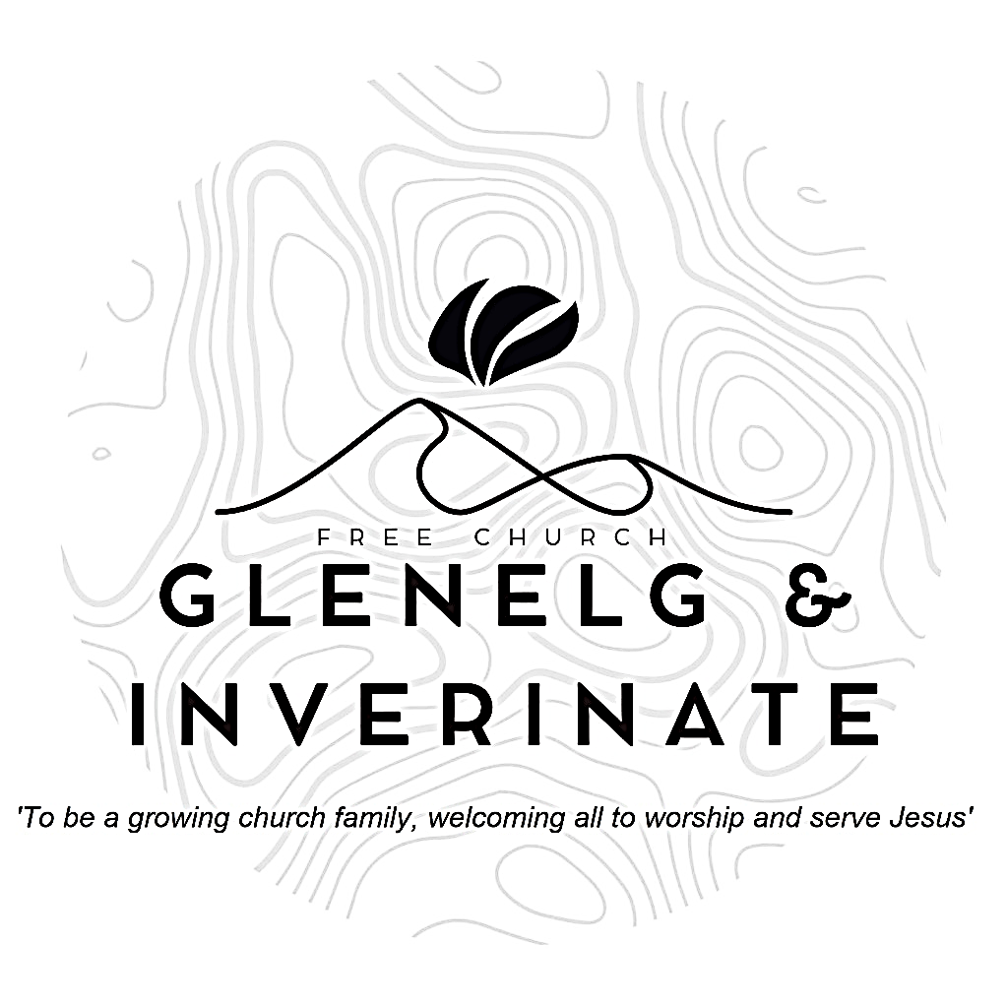

WEEKLY BULLETIN
Sunday 20th September 2026
Service at 12.00 noon in Inverinate Hall and
6.00pm in Glenelg Church of Scotland

We warmly welcome you to this service of worship and would love you to join us for tea, coffee and refreshment

I will praise the Lord, who counsels me; even at night my heart instructs me. I keep my eyes always on the Lord. With him at my right hand, I shall not be shaken. Psalm 16:7-8

NOTICES

- Today’s Services: We are delighted to have Rev James Blackwell leading our 12 noon worship from Matthew 8:14-22, Sermon – “Compassion and Cost”. At our Glenelg 6.00pm service this evening we will look at Genesis 14:17-24, Sermon – “Abram meets Melchizedek”. The audio from our services is recorded and is accessible on our website.
- Praise:
Sing Psalms 23:1-6 (page 28) – The Lord is my shepherd; no want shall I know
Hymn – Here is Love vast as the ocean
Sing Psalms 17:1-9 (page 17) – Lord, hear my righteous plea
Hymn – Amazing Grace
- Sunday School: Sunday School will run as usual today during our service. There is also a creche for the very little ones.
- Online Study Groups: The Men’s Group will be continuing our study on Luke’s Gospel – Jesus Words.
The Women’s through the New Testament group read is coming to an end and after the October school holidays we are starting a new 6 week study. We’re going to read “Heart Songs for Every Saint”, by William J.U. Philip, which takes six psalms and shows how they can be prayed in different situations of life. We meet in a Messenger group and are happy to accept new members at any time.
- Bible Study: Our Glenelg Study Group are meeting as usual this Wednesday at 7.30pm at Jon and Megan's home. The Dornie Bible study will also meet on Wednesday. Speak to Ken if you are interested in coming
- Church Prayer Meeting: Please remember that our Church Prayer Meeting is now held every Sunday at 11.15am before the Sunday Service. So please do come along and join us in prayer to our Heavenly Father.
- Dornie Playgroup: The Dornie Playgroup has been a huge success, God has blessed it to bear fruit for our witness as a congregation and seeing new folks coming to church. But as numbers increase it would be a blessing and an encouragement to have some more volunteers to join our team and help out at our weekly sessions. The Playgroup runs every Monday from 10am to 12 noon in Dornie Hall. If you can give some time to come along and help out on a regular basis or even if its just one session every now and again, please speak to Claire.
- Glenelg Singing Group: Are inviting everyone to come along for a series of six evenings of Psalm Singing, where we can learn the harmonies for some of the more familiar psalms tunes. These sessions will continue on Thursday 24th September at 7.30pm at Glenelg Church of Scotland. All are warmly welcome.

- Dates for your Diaries:
Saturday 3rd October - Coffee Morning in Glenelg Hall at 11am in aid of Mission International. Rev Roddy (Barvas) MacRae will give a short talk on the work of Mission international.
Sunday 4th October - Communion Service and Congregational Lunch. Rev Roddy MacRae will lead the communion services in Inverinate and Glenelg
Wednesday 4th November - COOL Area Prayer Meeting in the Chocolates of Glenshiel Cafe at 7.30pm
Saturday 7th November - Coffee Morning on Glenelg Hall in aid of Help for Heroes and SASRA.
Sunday 8th November - Remembrance Sunday
- Praying for One Another: Please add the following points to your prayer diaries:
Golspie: Please pray for conversions through the preaching of the Word, and for believers to grow in love for and obedience to Christ. Pray that the Lord would continue to bless and establish the congregation as a faithful gospel witness, bringing more people in the community to saving faith in Christ.

Turkey: Pray for a group bringing together Turkish churches. They are organising a conference later this year to discuss the current needs of the Church and to plan for the future. Ask that the Holy Spirit would be at work to bring unity, clarity, and wisdom, and pray that this meeting would bear much fruit in the years to come.
Dumisani: Pray for the Dumisani Institute Board of Governors who will meet in September. May they be granted the Lord's wisdom and guidance as they oversee Dumisani and may they be granted hearts of ongoing love and concern for this ministry. We pray with thanksgiving for the strong Third Term and seek the Lord's favour and mercies as Dumisani commences its Fourth Term this September. May lecturers and students be granted a real spirit of diligence in their respective callings.
Mission Board: Pray for the Mission Board as they meet today, that the Lord would give the Board wisdom and unity as they meet, guiding their discussions and decisions according to His will and for His glory.

- The Big Free Rally – Saturday 3rd October. The Big Free Rally and camp reunion takes place on Saturday 3rd October in Smithton Church, Inverness. This year we will be celebrating the 30th anniversary of the Big Free Rally. We are looking forward to having lots of young people coming along to reconnect with friends, make new ones and of course learn about Jesus. Matty Guy and Scott Hamilton will be joining us as our speakers. Please pray for them as they prepare and pray for us as we continue to organise the logistics of the day.

