Open Doors: World Watch List 2026
The World Watch List is Open Doors’ annual ranking of the 50 countries where Christians face the most extreme persecution. Explore the country profiles to find information, stories and prayers for each of the countries, along with ways to pray and stand with your persecuted church family.
More than 380 million Christians face persecution and discrimination because they love Jesus. Where faith looks impossible, God is doing the impossible. The church continues to grow.
Mexico: World Watch List #30
The pervasive and widespread presence of criminal groups in Mexico puts many Christians in danger, particularly those who bravely stand up to them. Christians can face threats, abduction and even murder at the hands of criminal gangs.
Persecution also affects believers living in indigenous communities. Those who stop following local beliefs and rituals to follow Jesus are exposed to fines, discrimination, beatings, imprisonment and displacement. Sadly, Christians can’t rely on the state for protection.
Why are Christians persecuted in Mexico?
Efforts by the authorities to address the problem of criminal gangs have largely been ineffective, leaving vulnerable believers unprotected and without justice.
In many places, cartels operate with near impunity, even infiltrating or replacing local authorities.

A link to the World Watch Map can be found below or scan the QR code
https://www.opendoorsuk.org/persecution/world-watch-list/

Minister: Rev. James Blackwell 07596 299970
01599 537223
Elders: Ken MacDonald 07895 678496
Colin MacDonald 01599 522719
Finlay MacDonald 07445 646444
Finance Committee: Donnie Lamont
Ronnie Lamont
Moira Lane
Craig Scobie 07502 485998
Safeguarding Co-ordinators: Barbara MacDonald 01599 522719
Moira Lane 01599 522709

Glenelg Inverinate Free Church, Acc. No. 00218787, Sort code 83 24 09
Scottish Charity Number - SC038152

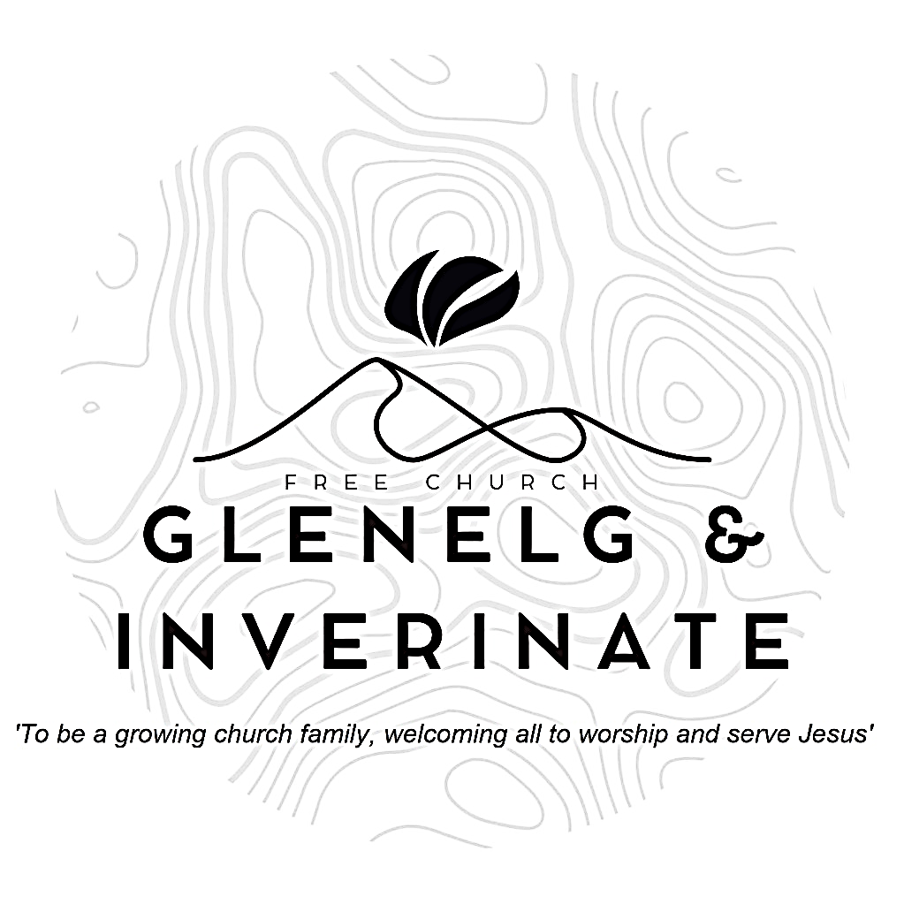

WEEKLY BULLETIN
Sunday 13th September 2026
Service at 12.00 noon in Inverinate Hall and
6.00pm in Glenelg Church of Scotland

We warmly welcome you to this service of worship and would love you to join us for tea, coffee and refreshment

Let the heavens rejoice, let the earth be glad; let them say among the nations, ‘The Lord reigns!’ Let the sea resound, and all that is in it; let the fields be jubilant, and everything in them! 1 Chronicles 16:31-32

NOTICES

- Today’s Services: We are delighted to have Rev James Blackwell leading our 12 noon worship from Matthew 8:5-13, Sermon – “A Gentile Believes”. At our Glenelg 6.00pm service this evening we will look at Genesis 14:1-16, Sermon – “Lot’s plight & Abram’s war”. The audio from our services is recorded and is accessible on our website.
- Praise:
Sing Psalms 67:1-7 (page 84) – God be merciful and bless us
Sing Psalms 91:1-12 (page 121) – The one whose dwelling is with God Most High
Hymn – Be Thou my vision
Hymn – Come thou fount of every blessing
- Sunday School: Sunday School will run as usual today during our service. There is also a creche for the very little ones.
- Online Studies: The Men's Study Group will be continuing our study on Luke’s Gospel – Jesus Words. Our Ladies Study Group will continue their study called ‘Love Death and Resurrection’ from the Scottish Bible Society.
- Bible Study: Our Glenelg Study Group are meeting as usual this Wednesday at 7.30pm at Jon and Megan's home. The Dornie Bible study will also meet on Wednesday. Speak to Ken if you are interested in coming
- Church Prayer Meeting: Please remember that our Church Prayer Meeting is now held every Sunday at 11.15am before the Sunday Service. So please do come along and join us in prayer to our Heavenly Father.
- Gift Aid: If you're a UK tax payer and are not already signed up to the Gift Aid scheme, please consider doing so. There is a simple form available in the church. It costs you nothing extra, but we can claim an extra 25% of any gift aided donation from the government, so every £10 given becomes £12.50. To give you an idea of how that adds up, we received £2384 from donations given between January and March this year. Please do remember to review your gift aid status if you stop paying tax.
- Glenelg Singing Group: Are inviting everyone to come along for a series of six evenings of Psalm Singing, where we can learn the harmonies for some of the more familiar psalms tunes. These sessions will continue on Thursday 17th September at 7.30pm at Glenelg Church of Scotland. All are warmly welcome.
- Altnacriche Baking: Any donations of baking for the Altnacriche weekend would be most welcome. These should be passed to either Fiona or Barbara before 1pm on Friday 18th September.

- Praying for One Another: Please add the following points to your prayer diaries:
Tearfund - Nepal
Pray for those people affected, those grieving lost loved ones, those who are displaced, and those waiting for news of missing people. Pray for the rescue workers, first responders and local leaders as they try to reach the most vulnerable. Pray for wisdom and endurance for our staff and local partners as they seek to bring relief, hope and care to those most in need.
Bonar Bridge and Lairg

Give thanks to God for the ministry in Bonar Bridge and Lairg, and pray that the Lord would strengthen each of the congregations. Pray that the Lord would use the preaching and witness of both of the congregations to bring people throughout Bonar Bridge and Lairg, to faith in Christ.
Rebecca Tait, OM

Give thanks for the teachers who are onboard and will start in school officially on 8 September. Pray for their inductions over the next two weeks that they will go into the new school year feeling as prepared as possible. Praise the Lord for His provision! Please continue to pray for one more teacher to serve with us from the beginning of October.

- Women for Mission Conference – Saturday 12th September
When Strivings Cease: Learning to pause in a world of unrest. The WfM Conference will be held at Smithton Free Church on Saturday 12th September, 9:30am-3:30pm. Our main speakers on the topic of rest are Cathy Steed and Mairi Smith. Throughout the day, we'll hear from our main speakers as well as a Q&A, lunch and craft stalls and a bookstall hosted by Christian Focus Publishing.
Alongside the bookstall, we're facilitating a number of craft stalls to sell goods at the event. In previous years, these have included handcrafted decorations, cards, artwork, knitwear and jams - we'd love to have a variety of things on offer. contact@womenformission.org.
- The Big Free Rally – Saturday 3rd October. The Big Free Rally and camp reunion takes place on Saturday 3rd October in Smithton Church, Inverness. This year we will be celebrating the 30th anniversary of the Big Free Rally. We are looking forward to having lots of young people coming along to reconnect with friends, make new ones and of course learn about Jesus. Matty Guy and Scott Hamilton will be joining us as our speakers. Please pray for them as they prepare and pray for us as we continue to organise the logistics of the day.

