Open Doors: World Watch List 2026
The World Watch List is Open Doors’ annual ranking of the 50 countries where Christians face the most extreme persecution. Explore the country profiles to find information, stories and prayers for each of the countries, along with ways to pray and stand with your persecuted church family.
More than 380 million Christians face persecution and discrimination because they love Jesus. Where faith looks impossible, God is doing the impossible. The church continues to grow.
DRC: World Watch List #29
In eastern Democratic Republic of the Congo (DRC), Christians must live with the constant fear of violence breaking out in their communities because of religious extremist groups.
One such group is the Allied Democratic Forces, which has ties to so-called Islamic State and has been known to purposefully target Christian communities. Believers are victims of massacres, abductions and the razing of churches.
Social pressures also burden Christians, taking the forms of rejection from community life, exclusion from inheritance and pressure to revoke their faith.
Church activities are regularly disrupted and clergy publicly denounced, fostering a climate of fear in which calls for justice are systematically silenced.

A link to the World Watch Map can be found below or scan the QR code
https://www.opendoorsuk.org/persecution/world-watch-list/

Minister: Rev. James Blackwell 07596 299970
01599 537223
Elders: Ken MacDonald 07895 678496
Colin MacDonald 01599 522719
Finlay MacDonald 07445 646444
Finance Committee: Donnie Lamont
Ronnie Lamont
Moira Lane
Craig Scobie 07502 485998
Safeguarding Co-ordinators: Barbara MacDonald 01599 522719
Moira Lane 01599 522709

Glenelg Inverinate Free Church, Acc. No. 00218787, Sort code 83 24 09
Scottish Charity Number - SC038152

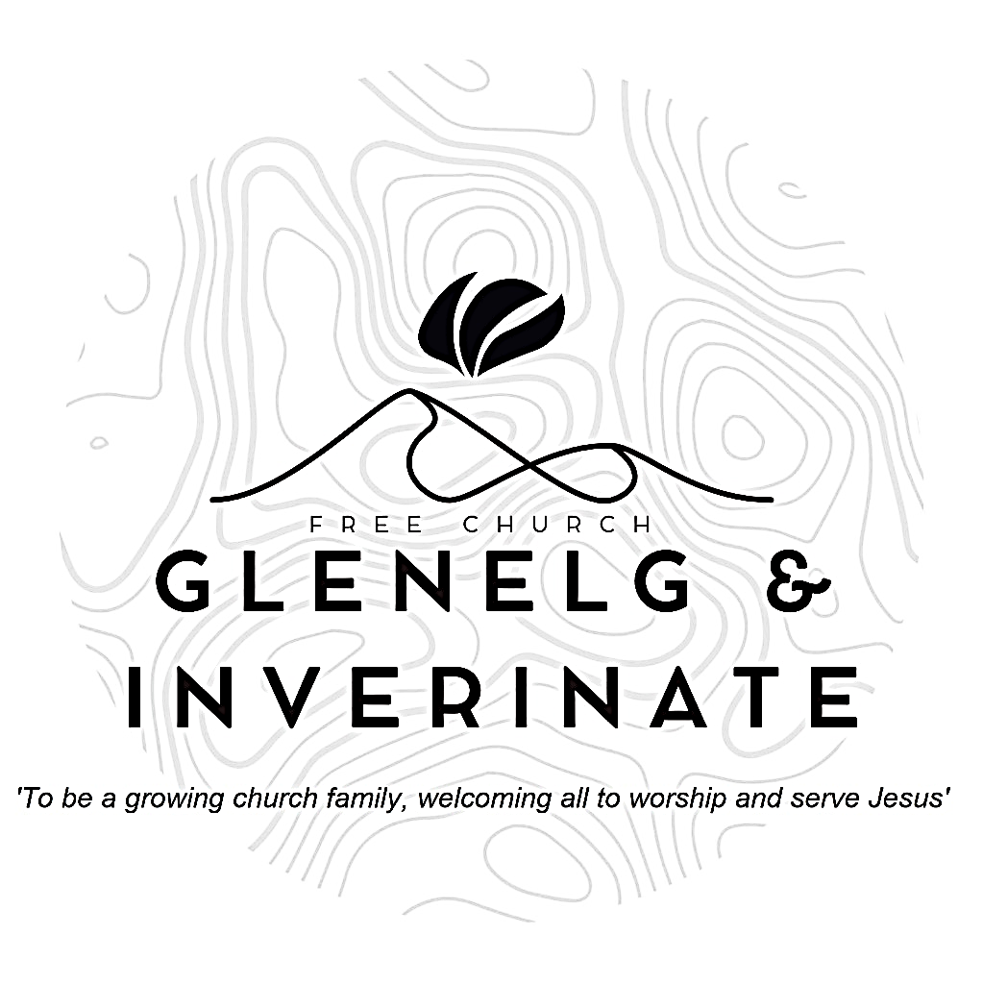

WEEKLY BULLETIN
Sunday 6th September 2026
Service at 12.00 noon in Inverinate Hall and
6.00pm in Glenelg Church of Scotland

We warmly welcome you to this service of worship and would love you to join us for tea, coffee and refreshment

The Lord is my strength and my defence; he has become my salvation.
He is my God, and I will praise him, my father’s God, and I will exalt him. Exodus 15:2

NOTICES

- Today’s Services: We are delighted to have Rev Roddie Rankin leading our 12 noon worship from Luke 7:36-50. Our Glenelg 6.00pm service this evening will be led by DJ Stewart from Matthew 26:36-45. The audio from our services is recorded and is accessible on our website.
- Praise:
Sing Psalms 113:1-9 (page 151) – O praise, you servants of the Lord
Hymn – Wide, wide as the ocean
Sing Psalms 103:1-11 (page 135) – Praise God, my soul! With all my heart
Hymn – Come people of the risen King
- Sunday School: Sunday School will run as usual today during our service. There is also a creche for the very little ones.
- Online Studies: The Men's Study Group will be continuing our study on Luke’s Gospel – Jesus Words. Our Ladies Study Group will continue their study called ‘Love Death and Resurrection’ from the Scottish Bible Society.
- Bible Study: Our Glenelg Study Group are meeting as usual this Wednesday at 7.30pm at Jon and Megan's home. The Dornie Bible study will also meet on Wednesday. Speak to Ken if you are interested in coming
- Church Prayer Meeting: Please remember that our Church Prayer Meeting is now held every Sunday at 11.15am before the Sunday Service. So please do come along and join us in prayer to our Heavenly Father.
- Gift Aid: If you're a UK tax payer and are not already signed up to the Gift Aid scheme, please consider doing so. There is a simple form available in the church. It costs you nothing extra, but we can claim an extra 25% of any gift aided donation from the government, so every £10 given becomes £12.50. To give you an idea of how that adds up, we received £2384 from donations given between January and March this year. Please do remember to review your gift aid status if you stop paying tax.
- The Big Free Rally – Saturday 3rd October. The Big Free Rally and camp reunion takes place on Saturday 3rd October in Smithton Church, Inverness. This year we will be celebrating the 30th anniversary of the Big Free Rally. We are looking forward to having lots of young people coming along to reconnect with friends, make new ones and of course learn about Jesus. Matty Guy and Scott Hamilton will be joining us as our speakers. Please pray for them as they prepare and pray for us as we continue to organise the logistics of the day.
- Glenelg Singing Group: Are inviting everyone to come along for a series of six evenings of Psalm Singing, where we can learn the harmonies for some of the more familiar psalms tunes. These sessions begin on Thursday 10th September at 7.30pm at Glenelg Church of Scotland. All are warmly welcome.

- Praying for One Another: Please add the following points to your prayer diaries:
Fort William and Kilmonivaig: Please pray for the congregation, that as a church we would faithfully proclaim the gospel and that many in the local community would hear and respond to the good news of Jesus Christ.
Give thanks to God for his faithfulness, and pray that the Lord would strengthen and mature the congregation, growing in maturity in faith and love for Christ as they seek to serve him
Sashko, Poland: We praise God for a summer that, even in its quieter weeks, brought a steady stream of new people through our doors.
Please pray for me as I step into the role of MTW team leader, for wisdom, humility, and stamina as our team goes through a smaller season before growing again next year.
Dumisani: We give thanks to the Lord for the wonderful donation of furnishings which has been received for the new male, student house complex at Dumisani Theological Institute, South Africa.
Pray for the visit from America by AIM representatives, Colin and Rebecca, to Dumisani Institute, SA. May this be a most blessed and fruitful opportunity for students, staff, and the AIM representatives.

- Women for Mission Conference – Saturday 12th September
When Strivings Cease: Learning to pause in a world of unrest. The WfM Conference will be held at Smithton Free Church on Saturday 12th September, 9:30am-3:30pm. Our main speakers on the topic of rest are Cathy Steed and Mairi Smith. Throughout the day, we'll hear from our main speakers as well as a Q&A, lunch and craft stalls and a bookstall hosted by Christian Focus Publishing.
Alongside the bookstall, we're facilitating a number of craft stalls to sell goods at the event. In previous years, these have included handcrafted decorations, cards, artwork, knitwear and jams - we'd love to have a variety of things on offer. contact@womenformission.org.

