Open Doors: World Watch List 2026
The World Watch List is Open Doors’ annual ranking of the 50 countries where Christians face the most extreme persecution. Explore the country profiles to find information, stories and prayers for each of the countries, along with ways to pray and stand with your persecuted church family.
More than 380 million Christians face persecution and discrimination because they love Jesus. Where faith looks impossible, God is doing the impossible. The church continues to grow.
Nicaragua: World Watch List #32
Believers who raise their voice against the government over issues including human rights violations have been met with surveillance, intimidation, imprisonment and even exile.
Church leaders can be a particular target for the regime.
Legal recognition is essential for any church wishing to operate lawfully in Nicaragua. However, the government has increasingly used the denial or revocation of this status as a tool to control and restrict religious institutions.

A link to the World Watch Map can be found below or scan the QR code
https://www.opendoorsuk.org/persecution/world-watch-list/

Minister: Rev. James Blackwell 07596 299970
01599 537223
Elders: Ken MacDonald 07895 678496
Colin MacDonald 01599 522719
Finlay MacDonald 07445 646444
Finance Committee: Donnie Lamont
Ronnie Lamont
Moira Lane
Craig Scobie 07502 485998
Safeguarding Co-ordinators: Barbara MacDonald 01599 522719
Moira Lane 01599 522709

Glenelg Inverinate Free Church, Acc. No. 00218787, Sort code 83 24 09
Scottish Charity Number - SC038152

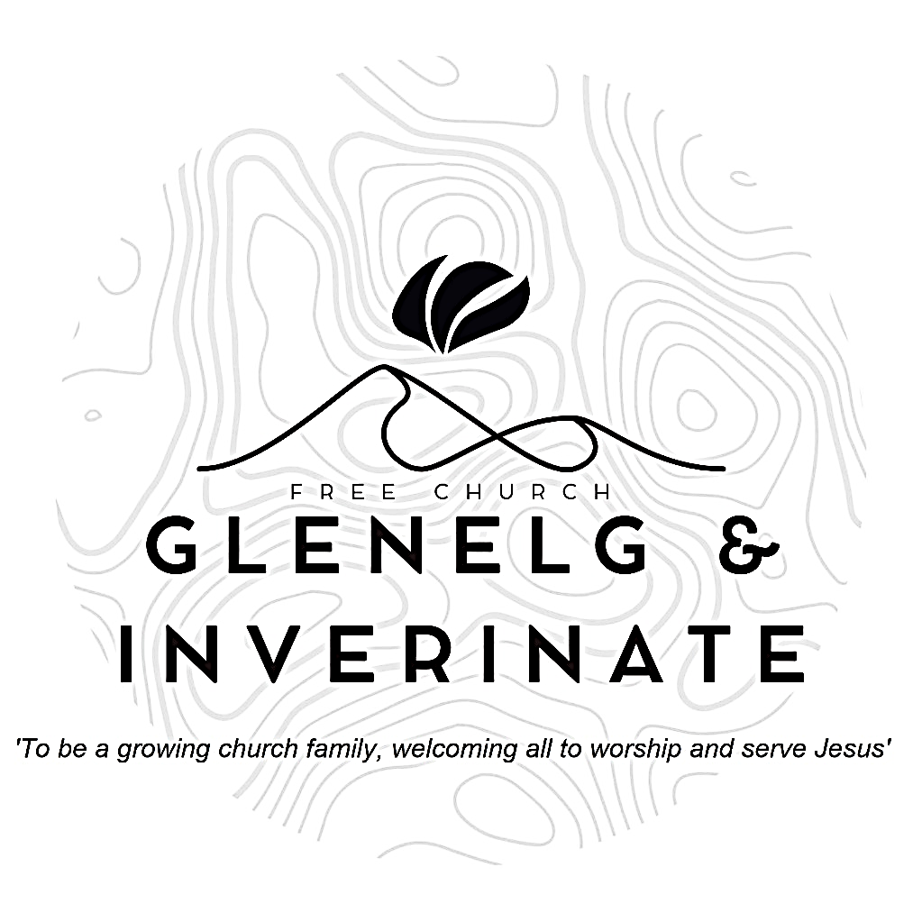

WEEKLY BULLETIN
Sunday 27th September 2026
Service at 12.00 noon in Inverinate Hall and
6.00pm in Glenelg Church of Scotland

We warmly welcome you to this service of worship and would love you to join us for tea, coffee and refreshment

He said in a loud voice, ‘Fear God and give him glory, because the hour of his judgment has come. Worship him who made the heavens, the earth, the sea and the springs of water. Revelation 14:7

NOTICES

- Today’s Services: We are delighted to have Rev James Blackwell leading our 12 noon worship from Matthew 8:23-27, Sermon – “The King of the Storm”. At our Glenelg 6.00pm service this evening we will look at Genesis 15:1-6, Sermon – “Abram’s faith and righteousness”. The audio from our services is recorded and is accessible on our website.
- Praise:
Sing Psalms 146:1-10 (page 191) – Praise the Lord, my soul! Praise him!
Hymn – My heart is filled with thankfulness
Hymn – Before the throne of God above
Scottish Psalter 107:29-32 (page 384) – The storm is changed into a calm
- Sunday School: Sunday School will run as usual today during our service. There is also a creche for the very little ones.
- Saturday 3rd October - Coffee Morning in Glenelg Hall at 11.00am in aid of Mission International. Rev Roddy (Barvas) MacRae will give a short talk on the work of Mission international.
- Sunday 4th October - Communion Service and Congregational Lunch. Rev Roddy MacRae will lead the communion services in Inverinate and Glenelg. There will be a retiring collection for Mission International following the 12 noon service in Inverinate.
- Online Study Groups: The Men’s Group will be continuing our study on Luke’s Gospel – Jesus Words. The Women’s through the New Testament group read is coming to an end and after the October school holidays we are starting a new 6 week study. We’re going to read “Heart Songs for Every Saint”, by William J.U. Philip, which takes six psalms and shows how they can be prayed in different situations of life. We meet in a Messenger group and are happy to accept new members at any time.
- Bible Study: Our Glenelg Study Group are meeting as usual this Wednesday at 7.30pm at Jon and Megan's home. The Dornie Bible study will also meet on Wednesday.
- Church Prayer Meeting: Please remember that our Church Prayer Meeting is now held every Sunday at 11.15am before the Sunday Service. So please do come along and join us in prayer to our Heavenly Father.
- Dornie Playgroup: The Dornie Playgroup has been a huge success, God has blessed it to bear fruit for our witness as a congregation and seeing new folks coming to church. But as numbers increase it would be a blessing and an encouragement to have some more volunteers to join our team and help out at our weekly sessions. The Playgroup runs every Monday from 10am to 12 noon in Dornie Hall. If you can give some time to come along and help out on a regular basis or even if its just one session every now and again, please speak to Claire.

- Glenelg Singing Group: Are inviting everyone to come along for a series of six evenings of Psalm Singing, where we can learn the harmonies for some of the more familiar psalms tunes. These sessions will continue on Thursday at 7.30pm at Glenelg Church of Scotland. All are warmly welcome.
- Dates for your Diaries:
The Big Free Rally – Saturday 3rd October. The Big Free Rally and camp reunion takes place on Saturday 3rd October in Smithton Church, Inverness. This year we will be celebrating the 30th anniversary of the Big Free Rally. We are looking forward to having lots of young people coming along to reconnect with friends, make new ones and of course learn about Jesus. Matty Guy and Scott Hamilton will be joining us as our speakers. Please pray for them as they prepare and pray for us as we continue to organise the logistics of the day.
Wednesday 4th November - COOL Area Prayer Meeting in the Chocolates of Glenshiel Cafe at 7.30pm
Saturday 7th November - Coffee Morning on Glenelg Hall in aid of Help for Heroes and SASRA.
Sunday 8th November - Remembrance Sunday
- Praying for One Another: Please add the following points to your prayer diaries:
Broughty Ferry: Pray for God's guidance as we continue to reach out to our community. Give thanks for the different ministries that take place every week. Pray for growth in grace and for wisdom in seeking to connect the people around us, young and old, to the gospel message.

Centre for Rural Ministry: In a Big Country is taking place in the Western Isles. As we explore, ‘Playing to our Strengths: Highlighting the Opportunities God gives us in Island Life’, please pray that those attending would be encouraged to recognise and make the most of the opportunities God has given them to serve him and share the gospel in their communities. Pray that this time is of great blessing to all who attend.
Osamu and Mairi, Japan: We have doubled the number of Christian newspapers for our monthly distribution recently. May they cause the people to get interested in the gospel.
Matt and Maria, Greece: Please keep U in your prayers, that his faith would be strengthened and that he would give each new day to The Lord and remain steadfast against any temptation from alcohol.

