Open Doors: World Watch List 2026
The World Watch List is Open Doors’ annual ranking of the 50 countries where Christians face the most extreme persecution. Explore the country profiles to find information, stories and prayers for each of the countries, along with ways to pray and stand with your persecuted church family.
More than 380 million Christians face persecution and discrimination because they love Jesus. Where faith looks impossible, God is doing the impossible. The church continues to grow.
Laos: World Watch List #28
Christians in Laos face persecution from the Communist government, who see Christianity as a Western religion that threatens their ideals, as well as from local communities who follow traditional religions. The Lao government only recognises three churches: Evangelical, Catholic and Seventh-day Adventist. Other Christian groups must operate unofficially.
Even amongst approved groups, an estimated 75% of congregations lack permanent buildings, and baptisms cannot be held publicly, especially in rural places. Consequently, many Christians are forced to meet underground in ‘illegal’ house churches.
In rural areas, traditional practices – which tend to be a mixture of Buddhism and folk religions – often supersede national laws, with Christians facing surveillance, discrimination and violence from communities, village leaders and families.

A link to the World Watch Map can be found below or scan the QR code
https://www.opendoorsuk.org/persecution/world-watch-list/

Minister: Rev. James Blackwell 07596 299970
01599 537223
Elders: Ken MacDonald 07895 678496
Colin MacDonald 01599 522719
Finlay MacDonald 07445 646444
Finance Committee: Donnie Lamont
Ronnie Lamont
Moira Lane
Craig Scobie 07502 485998
Safeguarding Co-ordinators: Barbara MacDonald 01599 522719
Moira Lane 01599 522709

Glenelg Inverinate Free Church, Acc. No. 00218787, Sort code 83 24 09
Scottish Charity Number - SC038152

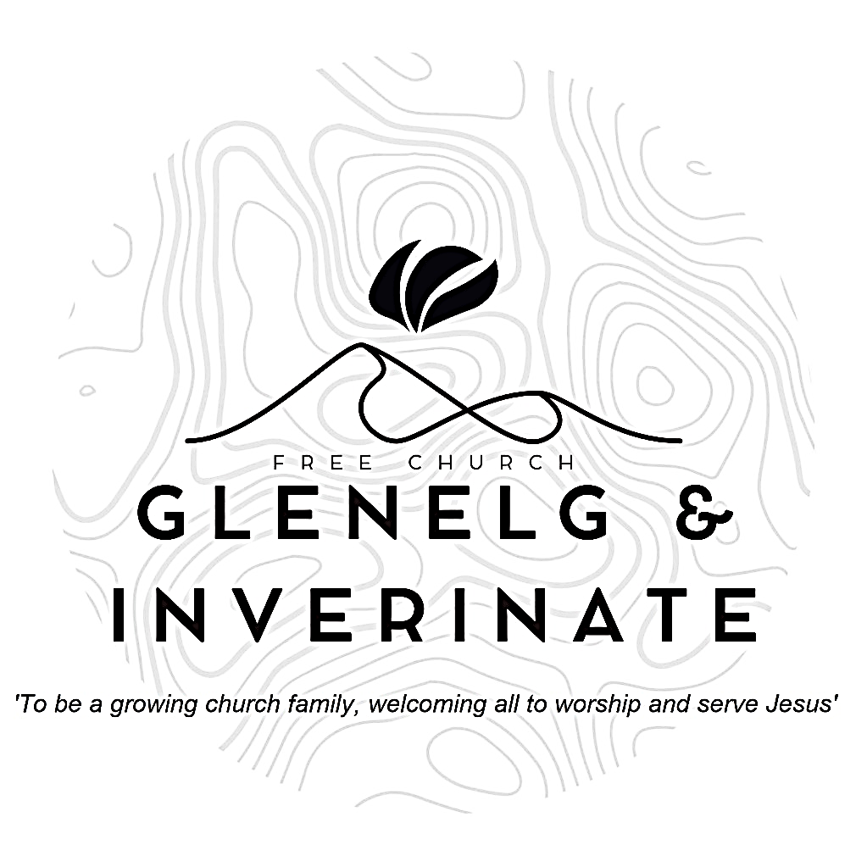

WEEKLY BULLETIN
Sunday 30th August 2026
Service at 12.00 noon in
Loch Duich Primary School
and
6.00pm in Glenelg Church of Scotland

We warmly welcome you to this service of worship and would love you to join us for tea, coffee and refreshment

Who may ascend the mountain of the Lord? Who may stand in his holy place? The one who has clean hands and a pure heart, who does not trust in an idol or swear by a false god. They will receive blessing from the Lord and vindication from God their Saviour. Psalm 24:3-5
NOTICES

- Today’s Services: We are delighted to have Rev James Blackwell leading our 12 noon worship from Matthew 8:1-4, Sermon – ‘The Messiah’s Miracle Signs’. At our Glenelg 6.00pm service this evening we will look at Genesis 13:5-18, Sermon – ‘Setting the Stage’. The audio from our services is recorded and is accessible on our website.
- Praise:
Hymn – Tell out my Soul
Sing Psalms 80(a):1-7 (page 106) – Hear, O Israel’s Shepherd, hear us
Scottish Psalter 85:1-7 (page 339) – O Lord, thou hast been fav’rable
Psalm 130 – From the Depths of Shame and Sorrow
- Sunday School: Sunday School will run as usual today during our service. There is also a creche for the very little ones.
- Next week: Next Sunday (6th): Our minister is away in Kilmallie taking their communion services. Our services will be taken by Roddie Rankin in Inverinate and DJ Stewart in Glenelg.
- Venue: This will be our last Sunday in the School as we return to the Inverinate hall next week. Pray and give thanks to God for his provision of this venue over the summer months.
- Prayer meeting: This Wednesday we will meet in the Chocolates of Glenshiel cafe for our Unified Prayer meeting at 19:30, come and join us as we pray together.
- Online Studies: The Men's Study Group will be continuing our study on Luke’s Gospel – Jesus Words. Our Ladies Study Group will continue their study called ‘Love Death and Resurrection’ from the Scottish Bible Society.
- Bible Study: Our Glenelg Study Group and the Dornie Bible study will not meet this Wednesday due to the Unified Prayer Meeting as above.
- Church Prayer Meeting: Please remember that our Church Prayer Meeting is now held every Sunday at 11.15am before the Sunday Service. So please do come along and join us in prayer to our Heavenly Father.
- Gift Aid: If you're a UK tax payer and are not already signed up to the Gift Aid scheme, please consider doing so. There is a simple form available in the church. It costs you nothing extra, but we can claim an extra 25% of any gift aided donation from the government, so every £10 given becomes £12.50. To give you an idea of how that adds up, we received £2384 from donations given between January and March this year. Please do remember to review your gift aid status if you stop paying tax.

- Praying for One Another: Please add the following points to your prayer diaries:
WfM: Give thanks to God for the ongoing work of Women for Mission, and for the genoristy shown in all of the funds that have been raised. Please pray that the Lord would continue to use WfM encourage women in their faith and support gospel work both in Scotland and globally. Pray for the Women’s Conference being held on the 12th of September, that the Lord would use the teaching to encourage and strengthen those who attend, and that the speakers and panel would be given wisdom as they share. Please pray especially for Mairi Smith, and Cathy Steed as they share from God’s word, that God would speak through them and that it would bless those in attendance.
Trotternish: Pray for the congregation during this time of vacancy, that God would strengthen their unity, and that the Lord would give them wisdom and guidance as they meet. Pray that those in the congregation would be a faithful witness in their community, with opportunities to share the gospel and serve those around them.
Asian Outreach: Please pray for a family that I meet regularly, that they would come to take refuge in the Lord Jesus, and that they would have confidence in Jesus as the Saviour. As I prepare a paper for a conference in a Muslim University, please pray that God would give me wisdom through the processs of studying for and writing the paper. The conference them is ‘Healing a Wounded World’, and the vast majority of attendees will be Muslims from Pakistan. Please pray that as I share on the healing ministry of Jesus, it would be of great benefit and blessing to many.
Dumbarton: Please pray that the Lord would strengthen the congregation and equip each member to serve faithfully and bear witness to Christ in all aspects of their lives. Pray that the congregation would have a strong gospel presence in the community.

- Women for Mission Conference – Saturday 12th September
When Strivings Cease: Learning to pause in a world of unrest. The WfM Conference will be held at Smithton Free Church on Saturday 12th September, 9:30am-3:30pm. Our main speakers on the topic of rest are Cathy Steed and Mairi Smith. Throughout the day, we'll hear from our main speakers as well as a Q&A, lunch and craft stalls and a bookstall hosted by Christian Focus Publishing.
Alongside the bookstall, we're facilitating a number of craft stalls to sell goods at the event. In previous years, these have included handcrafted decorations, cards, artwork, knitwear and jams - we'd love to have a variety of things on offer. contact@womenformission.org.

