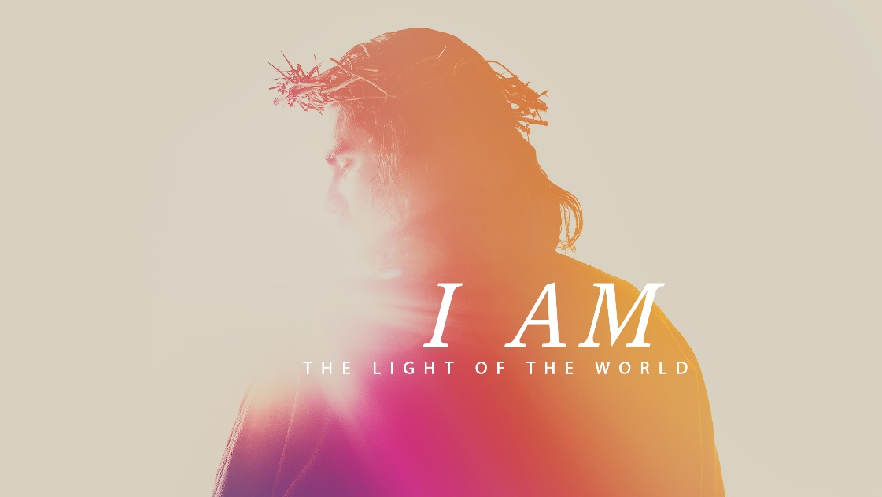

Minister: Rev. James Blackwell 07596 299970
01599 537223
Elders: Ken MacDonald 07895 678496
Colin MacDonald 01599 522719
Finlay MacDonald 07767 179064
Finance Committee: Donnie Lamont
Ronnie Lamont
Moira Lane
Craig Scobie 07502 485998
Safeguarding Co-ordinators: Barbara MacDonald 01599 522719
Moira Lane 01599 522709

Glenelg Inverinate Free Church, Acc. No. 00218787, Sort code 83 24 09
Scottish Charity Number - SC038152



WEEKLY BULLETIN
Sunday 23rd August 2026
Service at 12.00 noon in
Loch Duich Primary School

We warmly welcome you to this service of worship and would love you to join us for tea, coffee and refreshment

But let all who take refuge in you be glad; let them ever sing for joy.
Spread your protection over them, that those who love your name may rejoice in you. Surely, Lord, you bless the righteous; you surround them with your favour as with a shield. Psalm 5:11-12
NOTICES

- Today’s Services: We are delighted to have Finlay Macdonald leading our 12 noon service – sermon “The Bible: 1 Story in 3 Trees”. There will be no Glenelg 6.00pm service this evening. The audio from our services is recorded and is accessible on our website.
- Praise:
Hymn – Grace
Sing Psalms 36:5-9 (page 44) – Your steadfast love is great, O Lord
Sing Psalms 145:1-7 (page 189) – I will exalt you, O my God and King
Hymn – When I survey the wonderous Cross
- Readings:
Genesis 2:4-9, 15-17, 3:1-6, 22-24
Matthew 26:36-39: Luke 23:32-34, 39-46
Revelation 22:1-5, 22:17, 20-21.
- Sunday School: Sunday School will run as usual today during our service. There is also a creche for the very little ones.
- COOL Back To School: There will be no Sunday service in Glenelg this coming Sunday to give us all the opportunity to attend the COOL Back To School with God service at 4.30pm in Kyle Free Church. Please try and get along and support this
vital work with our young people and to pray for our young people and
schools.
James and Claire have very kindly issued an invitation for any Glenelg
folks (or anyone really) who would like to attend the Back to School
with God service to come to the manse for a buffet lunch following our
12 noon service.
- Online Studies: The Men's Study Group will be continuing our study on Luke’s Gospel – Jesus Words. Our Ladies Study Group will continue their study called ‘Love Death and Resurrection’ from the Scottish Bible Society.
- Bible Study: Our Glenelg Study Group are meeting as usual this Wednesday at 7.30pm at Jon and Megan's home. The Dornie Bible study will recommence on Wednesday 19th . Speak to Ken if you are interested in coming
- Church Prayer Meeting: Please remember that our Church Prayer Meeting is now held every Sunday at 11.15am before the Sunday Service. So please do come along and join us in prayer to our Heavenly Father.
- Gift Aid: If you're a UK tax payer and are not already signed up to the Gift Aid scheme, please consider doing so. There is a simple form available in the church. It costs you nothing extra, but we can claim an extra 25% of any gift aided donation from the government, so every £10 given becomes £12.50. To give you an idea of how that adds up, we received £2384 from donations given between January and March this year. Please do remember to review your gift aid status if you stop paying tax.

- Women for Mission Conference – Saturday 12th September
When Strivings Cease: Learning to pause in a world of unrest. The WfM Conference will be held at Smithton Free Church on Saturday 12th September, 9:30am-3:30pm. Our main speakers on the topic of rest are Cathy Steed and Mairi Smith. Throughout the day, we'll hear from our main speakers as well as a Q&A, lunch and craft stalls and a bookstall hosted by Christian Focus Publishing.
Alongside the bookstall, we're facilitating a number of craft stalls to sell goods at the event. In previous years, these have included handcrafted decorations, cards, artwork, knitwear and jams - we'd love to have a variety of things on offer. contact@womenformission.org.

Open Doors: World Watch List 2026
The World Watch List is Open Doors’ annual ranking of the 50 countries where Christians face the most extreme persecution. Explore the country profiles to find information, stories and prayers for each of the countries, along with ways to pray and stand with your persecuted church family.
More than 380 million Christians face persecution and discrimination because they love Jesus. Where faith looks impossible, God is doing the impossible. The church continues to grow.
Tajikistan: World Watch List #27
The country’s secular, dictatorial state has a tight grip on all religions. That very much includes Christians. Since 2015, pressure on ‘unauthorised’ gatherings has increased, bringing a rise in the number of raids on churches and, with it, fines and the confiscation of material.
Church leaders can face interrogation, fines, threats, beatings and imprisonment.
Religious activities involving under-18s are banned, and recent amendments seek to criminalise the ‘underground’ religious education of children, which extends to online activity. With about half the Tajik church believed to be young people, this is a huge obstacle to overcome.
Christian women are at risk of house arrest, beatings, rejection, harassment and forced marriage.

A link to the World Watch Map can be found below or scan the QR code
https://www.opendoorsuk.org/persecution/world-watch-list/

