Open Doors: World Watch List 2026
The World Watch List is Open Doors’ annual ranking of the 50 countries where Christians face the most extreme persecution. Explore the country profiles to find information, stories and prayers for each of the countries, along with ways to pray and stand with your persecuted church family.
More than 380 million Christians face persecution and discrimination because they love Jesus. Where faith looks impossible, God is doing the impossible. The church continues to grow.
Niger: World Watch List #26
The lives of believers in Niger are threatened by jihadist groups – like so-called Islamic State and Al-Qaeda – which enforce Islamic law and punish those who are considered transgressors.
Communities are attacked and church buildings destroyed by extremist groups, and many have lost their lives because of such violence.
Converts from Islam must worship in secret for fear of abduction, being targeted by militants.
Women are vulnerable to sexual abuse, including rape. Many families often do not report such instances for fear of the repercussions on the victim’s marriage prospects, leading to silencing and cycles of injustice.


A link to the World Watch Map can be found below or scan the QR code
https://www.opendoorsuk.org/persecution/world-watch-list/

Minister: Rev. James Blackwell 07596 299970
01599 537223
Elders: Ken MacDonald 07895 678496
Colin MacDonald 01599 522719
Finlay MacDonald 07767 179064
Finance Committee: Donnie Lamont
Ronnie Lamont
Moira Lane
Craig Scobie 07502 485998
Safeguarding Co-ordinators: Barbara MacDonald 01599 522719
Moira Lane 01599 522709

Glenelg Inverinate Free Church, Acc. No. 00218787, Sort code 83 24 09
Scottish Charity Number - SC038152

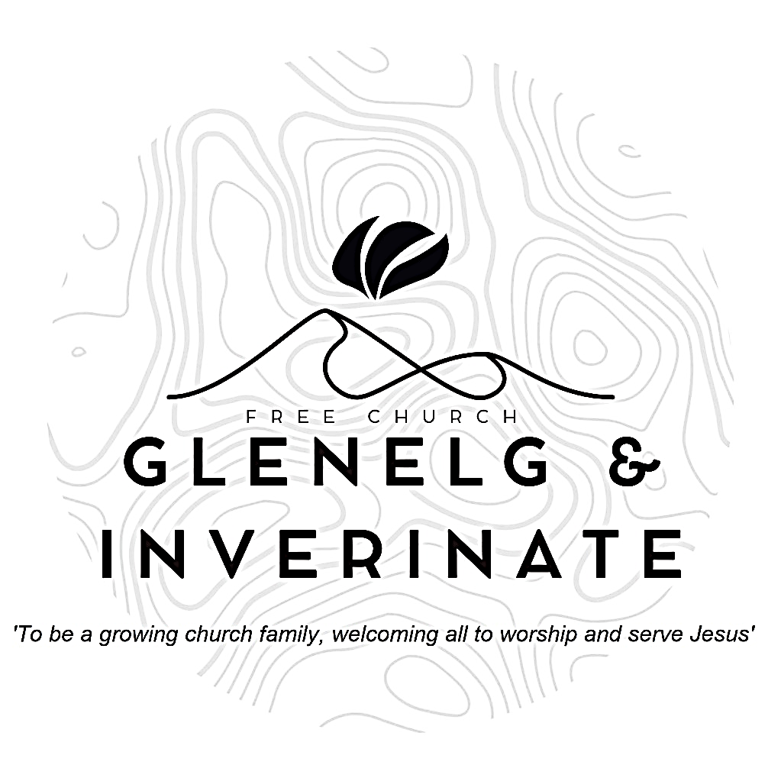

WEEKLY BULLETIN
Sunday 16th August 2026
Service at 12.00 noon in
Loch Duich Primary School
and
6.00pm in Glenelg Church of Scotland

We warmly welcome you to this service of worship and would love you to join us for tea, coffee and refreshment

The Spirit and the bride say, ‘Come!’ And let the one who hears say, ‘Come!’ Let the one who is thirsty come; and let the one who wishes take the free gift of the water of life. Revelation 22:17
NOTICES

- Today’s Services: We are delighted to have Finlay Macdonald leading our 12 noon service – sermon “The Bible: 1 Story in 3 Trees”. The Glenelg 6.00pm service this evening will be led by Arran Macdonald. The audio from our services is recorded and is accessible on our website.
- Praise:
Hymn – Grace
Sing Psalms 1 (page 1) – Blessed is the one who turns away
Sing Psalms 104:24-36 (page 137) – Lord, how many are your wonders
Hymn – It is well with my soul
- Readings:
Talk 1: Genesis 2:4-9, 15-17, 3:1-6, 22-24
Talk 2: Matthew 26:36-39: Luke 23:32-34, 39-46
Talk 3: Revelation 22:1-5
Benediction: Revelation 22:17, 20-21.
- Sunday School: The Sunday School are taking a break for the School Holidays. There will be crèche for the very little ones.
- Next week:
- Online Studies: The Men's Study Group will be continuing our study on Luke’s Gospel – Jesus Words. Our Ladies Study Group will continue their study called ‘Love Death and Resurrection’ from the Scottish Bible Society.
- Bible Study: Our Glenelg Study Group are meeting as usual this Wednesday at 7.30pm at Jon and Megan's home. The Dornie Bible study will recommence on Wednesday 19th . Speak to Ken if you are interested in coming
- Church Prayer Meeting: Please remember that our Church Prayer Meeting is now held every Sunday at 11.15am before the Sunday Service. So please do come along and join us in prayer to our Heavenly Father.
- Thanks: The session would like to once again say thank you to everyone who worked so hard to make Holiday Club and Youth Activity Week a success. We couldn’t do these things without our amazing volunteers and helpers. Please continue to pray for gospel fruit to take hold in the lives of these kids and young people.
- Gift Aid: If you're a UK tax payer and are not already signed up to the Gift Aid scheme, please consider doing so. There is a simple form available in the church. It costs you nothing extra, but we can claim an extra 25% of any gift aided donation from the government, so every £10 given becomes £12.50. To give you an idea of how that adds up, we received £2384 from donations given between January and March this year. Please do remember to review your gift aid status if you stop paying tax.

- Praying for One Another: Please add the following points to your prayer diaries:
Merkinch
Pray for our teens who are finishing high school and starting the next chapter. Ask for them to grow in the grace and knowledge of Jesus, to connect with a new church family if they are moving for uni, and to know the care of God in this next phase of life.
Please pray Psalm 19:7-10 for our church family, asking that we would increasingly treasure the Word of God, finding his instruction perfect, trustworthy, right, pure, reliable, righteous, and more desirable than gold. Pray we would rest in the promises that it brings renewal, wisdom, enlightenment, and joy.
Asian Outreach
Please pray for S and his family – for a clear faith in the Messiah Jesus. And pray that many other Muslims would, like S, read the Scriptures.
Please pray for my Shia friends, that they would come to see Jesus’ death as much more than a martyrdom and to believe that God raised him from the dead.
Centre for Rural Ministry

Pray for the Centre as it supports rural congregations. Pray for wisdom for Rev Ivor MacDonald and others involved as they encourage and resource churches in rural ministry.
Pray that God would raise up ministers, trainees and other leaders willing to serve in rural congregations.

- Women for Mission Conference – Saturday 12th September
When Strivings Cease: Learning to pause in a world of unrest. The WfM Conference will be held at Smithton Free Church on Saturday 12th September, 9:30am-3:30pm. Our main speakers on the topic of rest are Cathy Steed and Mairi Smith. Throughout the day, we'll hear from our main speakers as well as a Q&A, lunch and craft stalls and a bookstall hosted by Christian Focus Publishing.
Alongside the bookstall, we're facilitating a number of craft stalls to sell goods at the event. In previous years, these have included handcrafted decorations, cards, artwork, knitwear and jams - we'd love to have a variety of things on offer. contact@womenformission.org.

