Open Doors: World Watch List 2026
The World Watch List is Open Doors’ annual ranking of the 50 countries where Christians face the most extreme persecution. Explore the country profiles to find information, stories and prayers for each of the countries, along with ways to pray and stand with your persecuted church family.
More than 380 million Christians face persecution and discrimination because they love Jesus. Where faith looks impossible, God is doing the impossible. The church continues to grow.
Burkina Faso: World Watch List #16
ow are Christians persecuted in Burkina Faso?
Christians are targeted by extremist groups, who have kidnapped or killed believers and attacked churches. This leads to an environment of anxiety and fear for believers. Churches are often forced to close or are burnt down, whilst businesses are destroyed and entire livelihoods run aground. Because of the threat of violence, many believers flee their homes and communities.
Burkina Faso has experienced a broad collapse in state authority, giving licence to extremist groups to carry out their violence without repercussions. It is also one of the most underdeveloped countries in the world, which makes it easier for Islamist extremism to control the lives of communities.

A link to the World Watch Map can be found below or scan the QR code
https://www.opendoorsuk.org/persecution/world-watch-list/

Minister: Rev. James Blackwell 07596 299970
01599 537223
Elders: Ken MacDonald 07895 678496
Colin MacDonald 01599 522719
Finlay MacDonald 07445 646444
Finance Committee: Donnie Lamont
Ronnie Lamont
Moira Lane
Craig Scobie 07502 485998
Safeguarding Co-ordinators: Barbara MacDonald 01599 522719
Moira Lane 01599 522709

Glenelg Inverinate Free Church, Acc. No. 00218787, Sort code 83 24 09
Scottish Charity Number - SC038152

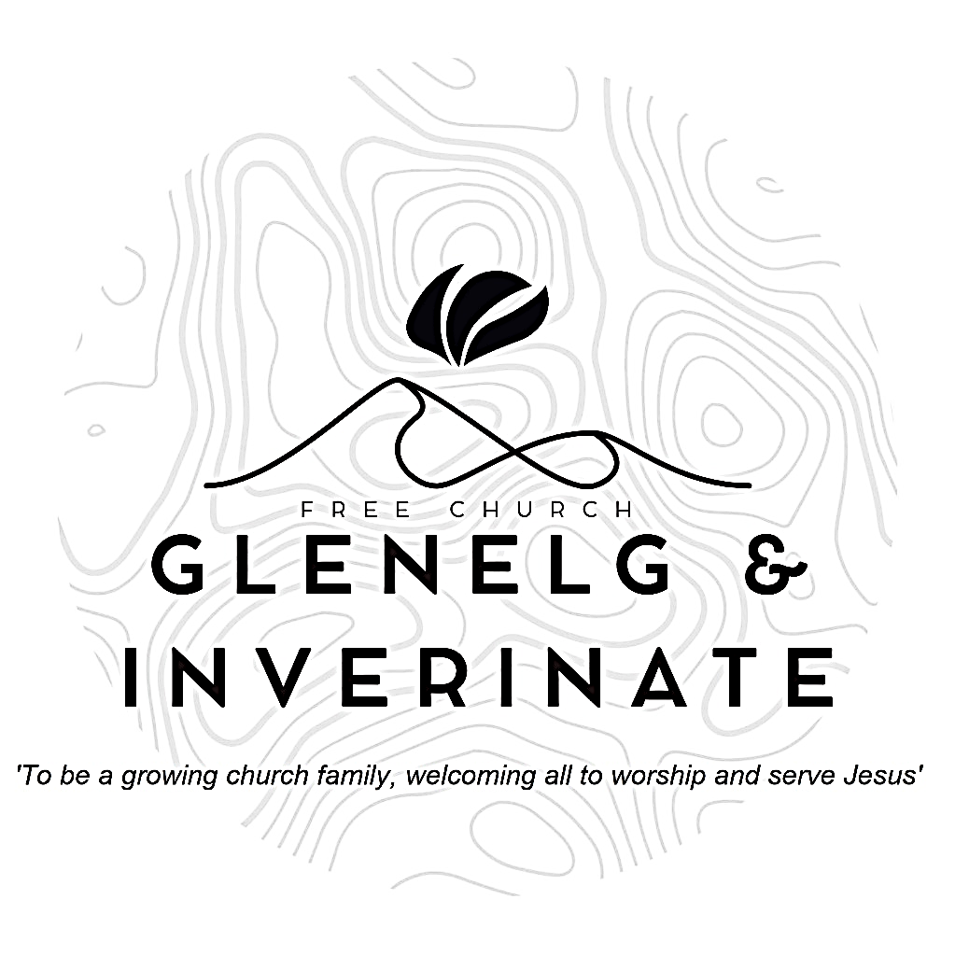

WEEKLY BULLETIN
Sunday 7th June 2026
Service at 12.00 noon in Inverinate Hall and
6.00pm in Glenelg Church of Scotland

We warmly welcome you to this service of worship and would love you to join us for tea, coffee and refreshment

Blessed is the people of whom this is true; blessed is the people whose God is the Lord. Psalm 144:15

NOTICES

• Today’s Services: : We are delighted to have Rev James Blackwell leading our Communion service today. Our 12 noon service today will include the Lord’s Supper, the reading will be from Philippians 2:1-11, Sermon – ‘Be like Christ – Part 2’. This service will be followed by a congregational lunch, please do stay and join us if you can. Our Glenelg 6.00pm service this evening will be led by Finlay Macdonald. The audio from our services is recorded and is accessible on our website.
- Praise:
Sing Psalms 16:1-6 (page 16) – Protect me, O my God
Hymn – I heard the voice of Jesus say
Sing Psalms 16:7-11 (page 17) – I’ll praise the Lord my God
Hymn – Oh, to see the dawn
Scottish Psalter 72:17-19 (page 314) – His name forever shall endure
- Sunday School: Sunday School will run as usual today during our service. There is also a creche for the very little ones.
- New Member: The Kirk Session is delighted to welcome Vivienne MacKenzie into membership of the congregation by profession of faith. Please remember her in your prayers as she makes this pubic commitment to Christ and his Church. Pray that she would grow in the grace and knowledge of our Lord and Saviour Jesus Christ. To him be the glory both now and to the day of eternity. Amen.
- Baptism: The Kirk Session is further delighted to announce the upcoming baptism of Kayleigh, Jennifer and Aaron (JJ) Judge on Sunday 28th June. As well as the admission of Aaron into membership. We invite you to join them in celebrating this blessed occasion as we remember the salvation of Christ and that in him there is one Lord, one faith, one baptism.
- Retiring Collection: The retiring collection for Tearfund to aid with the Ebola crisis in the Democratic Republic of Congo raised £190. Thank you all.
- Online Studies: The Men's Study Group will be continuing our study on Luke’s Gospel – Jesus Words. Our Ladies Study Group will continue their study called ‘Love Death and Resurrection’ from the Scottish Bible Society.
- Bible Study: Our Glenelg Study Group are meeting as usual this Wednesday at 7.30pm at Jon and Megan's home.
- Holiday Club: Dates for this year’s holiday club for all those going in to P1 - S1 this summer will be 27th-31st July. Bookings are now open for this at the link below.
https://coolscotland.org.uk/gkhbc2026/
- Church Prayer Meeting: Please remember that our Church Prayer Meeting is now held every Sunday at 11.15am before the Sunday Service. So please do come along and join us in prayer to our Heavenly Father.

- Serving the church family: We are looking to widen our pool of people serving in the church and to that end, we would like to ask, if you are not currently serving as part of a church team, you would consider taking on any of the following serving opportunities?
  - Praise and Music Co-ordinator - This role would include organising who precents which praise for each Sunday service and also encouraging and facilitating the introduction of musical accompaniment for our praise singing.
  - Livestreaming the Services - Someone with the technical savvy to set up a live link for our Sunday services in Inverinate and Glenelg.
  - Hall Set Up - This would entail arriving at Inverinate Hall about 10.45am on Sunday morning to set out the chairs, tables and projector & screen for the 12 noon service.
  - Welcoming - We have a fantastic team of welcomers, but there is always room for more people to join and serve as the friendly face of our church at the door.
  - PowerPoint Operator - To take on the progression of the PowerPoint slides during the 12 noon service.
If you can offer your service to the church in any of the above roles, please add your name to the sign-up sheet on the table at the door. With the exception of the Praise and Music Co-ordinator, ideally we would have several people for each role and there would be a rota system, so it would not have to be the same people each week.
- Praying for One Another: Please add the following points to your prayer diaries:

Lochgilphead and Tarbert: Our vision as a church is to make Jesus known in our town and district and to do this we need an ongoing Biblical ministry and a suitable building as our base. Please pray that our congregation would be strengthened, both in numbers and in devotion to Jesus. Please pray for continued growth in Lochgilphead, and renewed growth in Tarbert, so that both might be healthy gospel churches for their respective communities.
Blythswood: Prayer has been central to Blythswood from the beginning. 60 years later, our need to depend daily on the Lord in prayer remains unchanged.
- Free Church Youth Camps: Give thanks to God for our team leaders, leaders, cooks, drivers, and chaperones as they prepare for camp. Pray that the Lord would grant them wisdom, strength, and joy in all their planning and service. Over the summer, over 350 young people will attend Free Church Youth Camps. Please pray for each of the young people who will attend camp this summer, that the Lord would prepare their hearts, keep them safe, and use the week to deepen their faith and knowledge of Christ.

