Open Doors: World Watch List 2026
The World Watch List is Open Doors’ annual ranking of the 50 countries where Christians face the most extreme persecution. Explore the country profiles to find information, stories and prayers for each of the countries, along with ways to pray and stand with your persecuted church family.
More than 380 million Christians face persecution and discrimination because they love Jesus. Where faith looks impossible, God is doing the impossible. The church continues to grow.
Afghanistan: World Watch List #11
How are Christians persecuted in Afghanistan?
Afghanistan remains a place of extreme persecution for anyone who dares to follow Jesus under the brutally oppressive rule of the Taliban. Christians keep their faith completely secret. Those who are discovered are likely to be beaten, tortured and possibly killed. Almost all believers are converts from Islam – and apostasy is considered punishable by death under Islamic law.
To preserve their ‘honour’, families, clans and tribes feel obliged to deal harshly with those known to have turned to Christianity. Mere suspicion of conversion – such as avoiding mosque attendance – can trigger catastrophic consequences.
Given the immense risk of meeting with other believers, the church exists only in increasingly fragmented, secretive gatherings.
Despite the terrible risks they face, secret believers are holding on to their faith.

A link to the World Watch Map can be found below or scan the QR code
https://www.opendoorsuk.org/persecution/world-watch-list/

Minister: Rev. James Blackwell 07596 299970
01599 537223
Elders: Ken MacDonald 07895 678496
Colin MacDonald 01599 522719
Finlay MacDonald 07445 646444
Finance Committee: Donnie Lamont
Ronnie Lamont
Moira Lane
Craig Scobie 07502 485998
Safeguarding Co-ordinators: Barbara MacDonald 01599 522719
Moira Lane 01599 522709

Glenelg Inverinate Free Church, Acc. No. 00218787, Sort code 83 24 09
Scottish Charity Number - SC038152

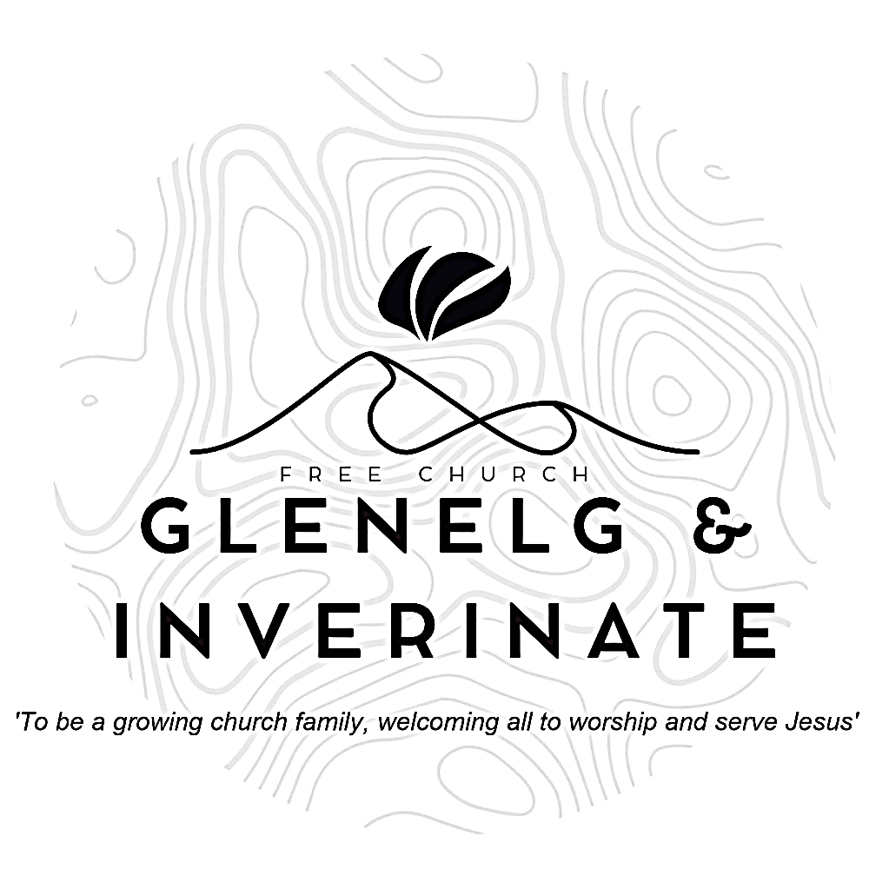

WEEKLY BULLETIN
Sunday 3rd May 2026
Service at 12.00 noon in Inverinate Hall and
6.00pm in Glenelg Church of Scotland

We warmly welcome you to this service of worship and would love you to join us for tea, coffee and refreshment

For in the gospel the righteousness of God is revealed—a righteousness that is by faith from first to last, just as it is written: “The righteous will live by faith.” Romans 1:17

NOTICES

• Today’s Services: We are delighted to have George Barnie from Smithton leading our 12noon worship from Daniel 1, Sermon – ‘Faithful in a Foreign Land’ and our Glenelg 6.00pm service this evening from Psalm 63, Sermon – ‘Adjusting the Lens’. The audio from our services is recorded and is accessible on our website.
- Praise:
Scottish Psalter 19:1-4 & 8-11 (page 223) – The heav’ns God’s glory do declare
Hymn – Before the throne of God above
Sing Psalms 116:1-14 (page 154) – I love the Lord because he heard my voice
Hymn – Be thou my vision
- Sunday School: Sunday School will run as usual today during our service. There is also a creche for the very little ones.
- Congregational Meeting: Intimation is given of a Congregational Meeting, to be held following the 12 noon service on Sunday 10th May. Following a formal offer from the Glenelg Mountain Rescue, the Kirk Session and Finance Committee are seeking the approval of the congregation for the sale of the Glenelg Free Church site.
- Online Studies: The Men's Study Group will be continuing our study on Luke’s Gospel – Jesus Words. Our Ladies Study Group will continue their study called ‘Love Death and Resurrection’ from the Scottish Bible Society.
- Bible Study: Our Glenelg Study Group are meeting as usual this Wednesday at 7.30pm at Jon and Megan's home. We will be continuing our Apostles Creed study.
- Holiday Club: Dates for this year’s holiday club for all those going in to P1 - S1 this summer will be 27th-31st July. Bookings are now open for this at the link below.
https://coolscotland.org.uk/gkhbc2026/
- Plant Sale and Afternoon Tea: On Saturday 16th May from 2.00-4.00pm in Glenelg Hall. In aid of the Holiday Bible Club and Youth Activity Week. Please come along and bring all your friends to stock up on your summer plants.
- Church Prayer Meeting: Please remember that our Church Prayer Meeting is now held every Sunday at 11.15am before the Sunday Service. So please do come along and join us in prayer to our Heavenly Father.
- Psalms & Sausages: The next Psalms & Sausages is scheduled for the afternoon of 23rd May at the manse. All are welcome to come and join us.
- Prayer meeting: The next joint prayer meeting is on 6th May at 7:30pm at the Chocolates of Glenshiel Cafe. This will be in place of our usual home groups. All are invited to come.

- Serving the church family: We are looking to widen our pool of people serving in the church and to that end, we would like to ask, if you are not currently serving as part of a church team, you would consider taking on any of the following serving opportunities?
  - Praise and Music Co-ordinator - This role would include organising who precents which praise for each Sunday service and also encouraging and facilitating the introduction of musical accompaniment for our praise singing.
  - Livestreaming the Services - Someone with the technical savvy to set up a live link for our Sunday services in Inverinate and Glenelg.
  - Hall Set Up - This would entail arriving at Inverinate Hall about 10.45am on Sunday morning to set out the chairs, tables and projector & screen for the 12 noon service.
  - Welcoming - We have a fantastic team of welcomers, but there is always room for more people to join and serve as the friendly face of our church at the door.
  - PowerPoint Operator - To take on the progression of the PowerPoint slides during the 12 noon service.
If you can offer your service to the church in any of the above roles, please add your name to the sign-up sheet on the table at the door. With the exception of the Praise and Music Co-ordinator, ideally we would have several people for each role and there would be a rota system, so it would not have to be the same people each week.
- Praying for One Another: Please add the following points to your prayer diaries:
Dumfries: Pray that while the congregation does not have a minister, they would be strengthened in faith and dependence on the Lord, trusting His wisdom and guidance in all things. Pray that God would sustain those carrying responsibility for leading the church, granting wisdom and perseverance as the church continues to serve and witness faithfully.
Greenock: Please pray the Lord would bless the congregation as they seek to empower Christians to take the good news of Jesus to others, as well as encouraging believers to be lifelong disciples through the preaching and teaching of the word.
Scaladale Youth Camp - Western Isles: Please pray for the Scaladale Youth Camp taking place for S1-S3’s this weekend, that God will continue bless this time together spent together outdoors in God’s creation and in his word, and pray for each of the young people attending that they would continue to grow closer to the Lord. Pray that the church would be effective in reaching Greenock with the gospel, serving with compassion and boldness so that many would come to know and follow Christ.

