Open Doors: World Watch List 2026
The World Watch List is Open Doors’ annual ranking of the 50 countries where Christians face the most extreme persecution. Explore the country profiles to find information, stories and prayers for each of the countries, along with ways to pray and stand with your persecuted church family.
More than 380 million Christians face persecution and discrimination because they love Jesus. Where faith looks impossible, God is doing the impossible. The church continues to grow.
Nigeria: World Watch List #7
Nigeria continues to be the most violent place to live in for believers and much of this comes from Islamist militant groups, such as Boko Haram and Islamic State West Africa Province (ISWAP). They target Christians and church buildings through intense attacks and converts from Islam are especially mistreated.
In northern Nigeria, 12 states have implemented Sharia (Islamic law) which creates a system where Christians are treated as second-class citizens.
Communities fall victim to Fulani militants who hide out in forested areas and launch attacks on schools and churches, kidnapping believers and holding them for ransom. Others are killed and entire communities thrown into deep fear and uncertainty.

A link to the World Watch Map can be found below or scan the QR code
https://www.opendoorsuk.org/persecution/world-watch-list/

Minister: Rev. James Blackwell 07596 299970
01599 537223
Elders: Ken MacDonald 07895 678496
Colin MacDonald 01599 522719
Finlay MacDonald 07445 646444
Finance Committee: Donnie Lamont
Ronnie Lamont
Moira Lane
Craig Scobie 07502 485998
Safeguarding Co-ordinators: Barbara MacDonald 01599 522719
Moira Lane 01599 522709

Glenelg Inverinate Free Church, Acc. No. 00218787, Sort code 83 24 09
Scottish Charity Number - SC038152

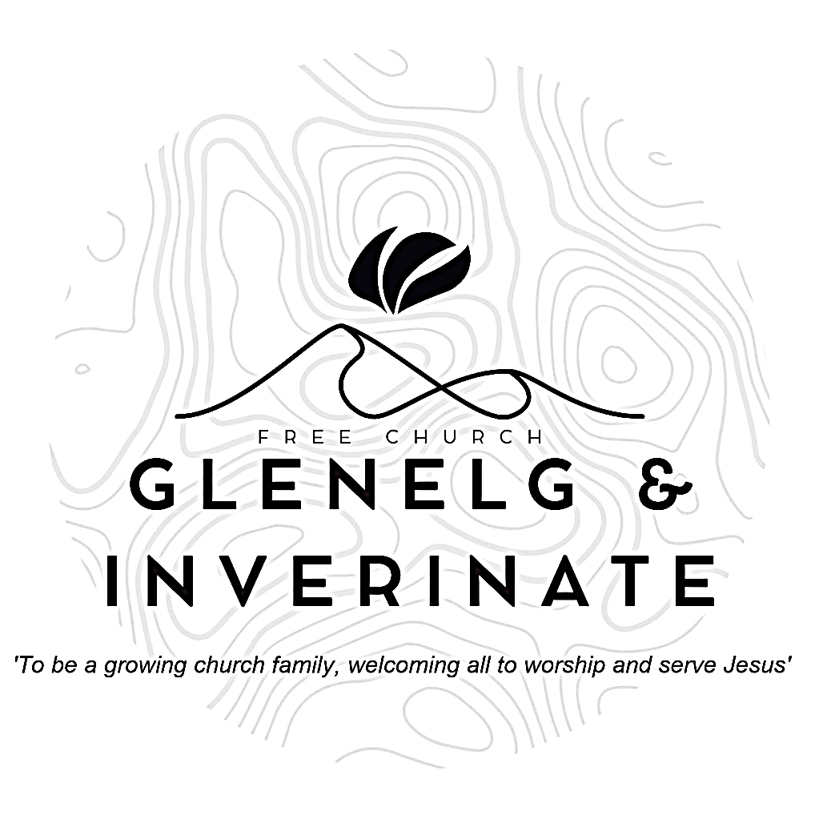

WEEKLY BULLETIN
Sunday 5th April 2026
Service at 12.00 noon in Inverinate Hall
We warmly welcome you to this service of worship and would love you to join us for tea, coffee and refreshment

Since, then, you have been raised with Christ, set your hearts on things above, where Christ is, seated at the right hand of God. Set your minds on things above, not on earthly things. For you died, and your life is now hidden with Christ in God. When Christ, who is your life, appears, then you also will appear with him in glory.
Colossians 3:1-4

NOTICES

• Today’s Services: We are delighted to have Rev James Blackwell leading our 12 noon worship from John 20:1-18, Sermon – ‘Who is it you are looking for?’.
There will be no Glenelg 6.00pm service this evening to allow us to join the Easter Joint Communion Service at 6.00pm in Kyleakin Hall. Please do make every effort to come along and join our brothers and sisters from across the area in worship and communion.
The audio from our service is recorded and is accessible on our website.
- Praise:
Scottish Psalter 89:1-5 (page 344) – God’s mercies I will ever sing
Hymn – Come people of the risen King
Sing Psalms 32:1-7 (page 243) – O blessed is the man to whom
Hymn – Christ the Lord is risen today
- Sunday School: Sunday School will run as usual today during our service. There is also a creche for the very little ones.
- Annual Leave: The Minister will be on annual leave from the 6th - 12th April. Finlay MacKenzie from Dingwall will take both services on the 12^{th.}
- Online Studies: The Men's Study Group will be returning to our study on Luke’s Gospel – Jesus Words. Our Ladies Study Group will continue their study called ‘Love Death and Resurrection’ from the Scottish Bible Society.
- Bible Study: Our Glenelg Study Group are meeting at 7.30pm this Wednesday and will be returning to our study on the Apostle’s Creed.
- Holiday Club: Dates for this year’s holiday club will be 27th-31st July. Booking will open soon and as places will be limited, we advise booking early to avoid disappointment. Thanks!
- Church Prayer Meeting: Please remember that our Church Prayer Meeting is now held every Sunday at 11.15am before the Sunday Service. So please do come along and join us in prayer to our Heavenly Father.
- Bank account: After many months of trying, the church finally has a new bank account which will allow us to use online banking. Everyone who is currently giving by standing order should have been notified by email and asked to change their standing order details to the new account. If you are considering starting to give by standing order then please use the account details below.
The new account details are as follows -
Glenelg Inverinate Free Church
Acc. No. 00218787
Sort code 83 24 09

- Serving the church family: We are looking to widen our pool of people serving in the church and to that end, we would like to ask, if you are not currently serving as part of a church team, you would consider taking on any of the following serving opportunities?
  - Praise and Music Co-ordinator - This role would include organising who precents which praise for each Sunday service and also encouraging and facilitating the introduction of musical accompaniment for our praise singing.
  - Livestreaming the Services - Someone with the technical savvy to set up a live link for our Sunday services in Inverinate and Glenelg.
  - Hall Set Up - This would entail arriving at Inverinate Hall about 10.45am on Sunday morning to set out the chairs, tables and projector & screen for the 12 noon service.
  - Welcoming - We have a fantastic team of welcomers, but there is always room for more people to join and serve as the friendly face of our church at the door.
  - PowerPoint Operator - To take on the progression of the PowerPoint slides during the 12 noon service.
- If you can offer your service to the church in any of the above roles, please add your name to the sign up sheet on the table at the door. With the exception of the Praise and Music Co-ordinator, ideally we would have several people for each role and there would be a rota system, so it would not have to be the same people each week.
- Praying for One Another: Please add the following points to your prayer diaries:
Maryburgh and Killearnan: Please pray that the Lord would bless the witness of the congregation in the community, especially through regular gatherings and outreach opportunities, that Christ would be made known and glorified. Please pray that the congregation would be strengthened by the preaching of the Word, and that it would bear lasting fruit in their lives as they grow in Christ-likeness. Pray also for the weekly drop in cafe, that this would provide opportunity for gospel conversations.
Asian Outreach: Please pray as I continue my research on the divinity of Jesus, that it would be useful in helping others who seek to communicate ‘the boundless riches of Christ’ (Ephesians 3:8) to Muslims. Please pray for ongoing relationships, that conversations would be fruitful and would point to Christ.
General Assembly: Please pray as preparations are underway for the General Assembly, and for the Boards Clerks’ Office as they prepare reports, that they would be given wisdom, diligence, and clarity in all their work.

