Open Doors: World Watch List 2026
The World Watch List is Open Doors’ annual ranking of the 50 countries where Christians face the most extreme persecution. Explore the country profiles to find information, stories and prayers for each of the countries, along with ways to pray and stand with your persecuted church family.
More than 380 million Christians face persecution and discrimination because they love Jesus. Where faith looks impossible, God is doing the impossible. The church continues to grow.
Yemen: World Watch List #3
Christians in Yemen continue to endure a highly unstable condition of life, with threats from both authorities and family. Believers whose faith is discovered by their family could be forced into divorce or separated from their children.
Converts from Islam could face the death penalty for apostasy, creating an environment in which many feel forced to keep their faith secret.
Islamist extremist groups attack Christian communities, meaning that if those who gather in secret are discovered, they face grave consequences.
.
.

A link to the World Watch Map can be found below or scan the QR code
https://www.opendoorsuk.org/persecution/world-watch-list/

Minister: Rev. James Blackwell 07596 299970
01599 537223
Elders: Ken MacDonald 07895 678496
Colin MacDonald 01599 522719
Finlay MacDonald 07445 646444
Finance Committee: Donnie Lamont
Ronnie Lamont
Moira Lane
Craig Scobie 07502 485998
Safeguarding Co-ordinators: Barbara MacDonald 01599 522719
Moira Lane 01599 522709

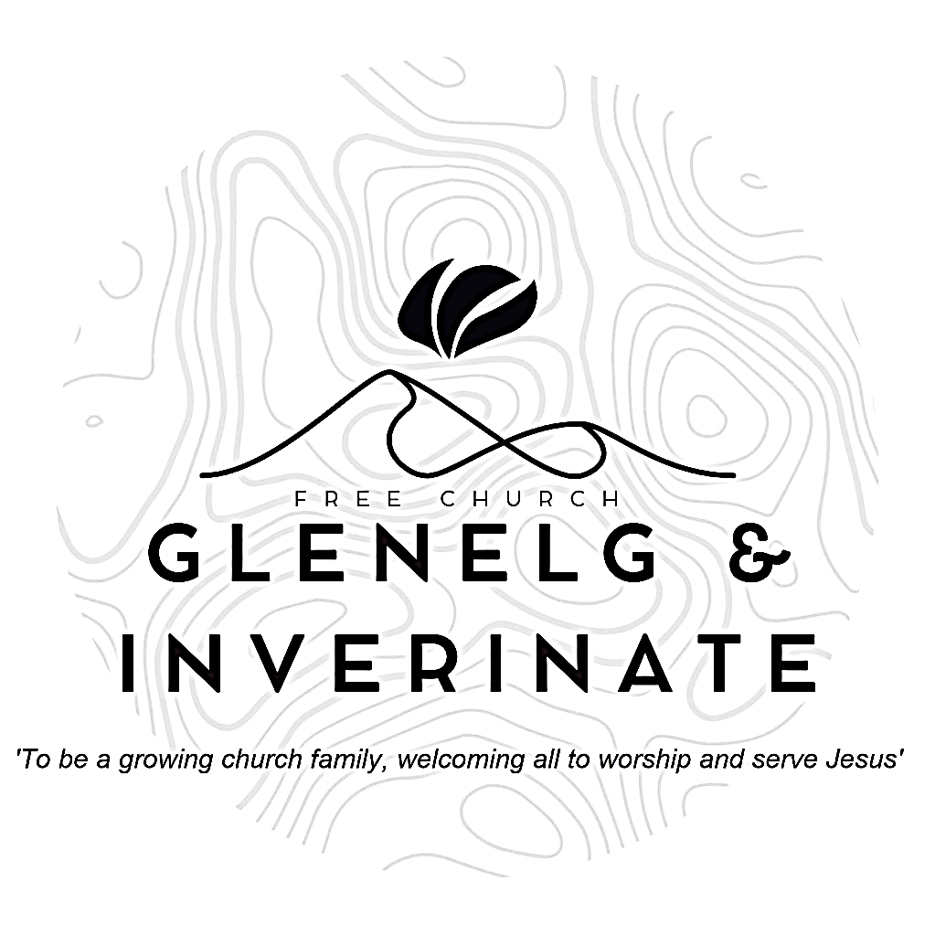

WEEKLY BULLETIN
Sunday 8th March 2026
Service at 12.00 noon in Inverinate Hall and
6.00pm in Glenelg Church of Scotland

We warmly welcome you to this service of worship and would love you to join us for tea, coffee and refreshment

In your unfailing love you will lead the people you have redeemed.
In your strength you will guide them to your holy dwelling.
Exodus 15:13
NOTICES

• Today’s Services: We are delighted to have Rev James Blackwell leading our 12 noon worship from Matthew 7:1-12, Sermon – ‘The King on Judging’.
At our Glenelg 6.00pm service this evening we will look at Psalm 5:1-12, Sermon – ‘Listen to my words’.
The audio from our service is recorded and is accessible on our website.
- Praise:
Sing Psalms 98:1-9 (page 129) – O sing a new song to the Lord
Hymn – Jesus is Lord!
Sing Psalms 119 (21):161-168 (page 167) – Though rulers hound me …….
Hymn – Amazing Grace
- Sunday School: Sunday School will run as usual today during our service. There is also a creche for the very little ones.
- Sunday 15th March: Rev James Blackwell will lead us in worship at the 12.00 noon Service in Inverinate Hall and the 6.00pm service in Glenelg.
- New members: We are delighted to welcome Bethan and Rachel White into membership of the church though transference from another congregation. Remember them in your prayers as the settle into the life and work of the church and area.
- Serving the church family: We are looking to widen our pool of people serving in the church and to that end, we would like to ask, if you are not currently serving as part of a church team, you would consider taking on any of the following serving opportunities?
  - Praise and Music Co-ordinator - This role would include organising who precents which praise for each Sunday service and also encouraging and facilitating the introduction of musical accompaniment for our praise singing.
  - Livestreaming the Services - Someone with the technical savvy to set up a live link for our Sunday services in Inverinate and Glenelg.
  - Hall Set Up - This would entail arriving at Inverinate Hall about 10.45am on Sunday morning to set out the chairs, tables and projector & screen for the 12 noon service.
  - Welcoming - We have a fantastic team of welcomers, but there is always room for more people to join and serve as the friendly face of our church at the door.
  - PowerPoint Operator - To take on the progression of the PowerPoint slides during the 12 noon service.
If you can offer your service to the church in any of the above roles, please add your name to the sign up sheet on the table at the door. With the exception of the Praise and Music Co-ordinator, ideally we would have several people for each role and there would be a rota system, so it would not have to be the same people each week.

- Easter Bible Study - We are holding another Congregational Bible Study for Easter this year. The study we have chosen is 'The Wondrous Cross' by Wil and Lorraine Triggs. It is a daily devotional study, running from Ash Wednesday (18th February) to Easter Sunday (5th April) and we would really encourage everyone to take part.
- Online Studies: The Men's Study Group will be looking at ‘The Wonderous Cross’ Easter study. Our Ladies Study Group will continue their study called ‘Love Death and Resurrection’ from the Scottish Bible Society.
- Wednesday Bible Studies: Our Glenelg Study Group are meeting at 7.30pm this Wednesday beginning our study on “The Wondrous Cross' by Wil and Lorraine Triggs.
- Holiday Club: Dates for this year’s holiday club will be 27th-31st July. Booking will open soon and as places will be limited, we advise booking early to avoid disappointment. Thanks!
- Church Prayer Meeting: Please remember that our Church Prayer Meeting is now held every Sunday at 11.15am before the Sunday Service. So please do come along and join us in prayer to our Heavenly Father.
- Festival of Psalms – Saturday 28th March: The Free North Church in Inverness will host a Festival of Psalms on Saturday 28th March from 2.30pm – 3.45pm. This special occasion will bring people together for an afternoon of heartfelt congregational praise and reflection, exploring Christ in the Psalms – the Songs of Jesus. All welcome.
- The Gathering – April and July: The Centre for Rural Ministry is continuing with The Gathering (crofting and Bible teaching- what more could you want?) This is a long weekend of hard work in Skye, for those in their 20s and 30s who would like to think more about rural ministry or supporting a rural church. The dates are the 15th-19th April and 29th July-2nd August.
- Praying for One Another: Please add the following points to your prayer diaries:
Falkirk: We're greatly encouraged and give thanks to God for a steadily growing congregation, with new faces coming regularly, and coming back again - some from other churches, some are new Christians. We've been able to improve and extend our relationships with other groups and individuals in the community - pray that this will prove significant spiritually, and draw many to Christ through these relationships.
Urray and Strathconon: Pray for our young people and our youth club (P7 to S2) which meets on a Thursday, that the Lord would lead and guide each of these young people, to know Him as their Lord and Saviour.
Pray that God would strengthen our church family, and that we would influence our local community for Christ.

