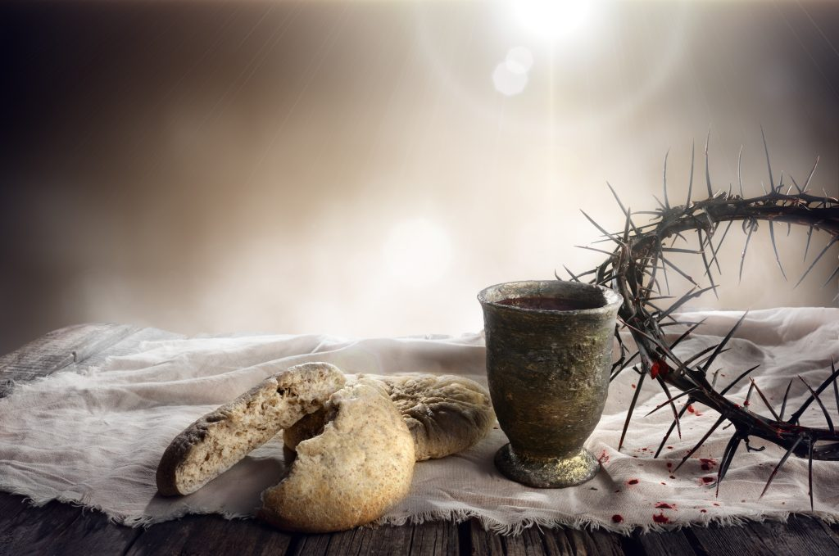

Minister: Rev. James Blackwell 07596 299970
01599 537223
Elders: Ken MacDonald 07895 678496
Colin MacDonald 01599 522719
Finlay MacDonald 07445 646444
Finance Committee: Donnie Lamont
Ronnie Lamont
Moira Lane
Craig Scobie 07502 485998
Safeguarding Co-ordinators: Barbara MacDonald 01599 522719
Moira Lane 01599 522709



WEEKLY BULLETIN
Sunday 8th February 2026
Service at 12.00 noon in Inverinate Hall and
6.00pm in Glenelg Church of Scotland

We warmly welcome you to this service of worship and would love you to join us for tea, coffee and refreshment

In that day they will say, “Surely this is our God; we trusted in him, and he saved us. This is the Lord, we trusted in him; let us rejoice and be glad in his salvation.” Isaiah 25:9

NOTICES

• Today’s Services: We are delighted to have Rev James Blackwell leading our Communion services today. Our 12 noon service today will include the Lord’s Supper, the reading will be from Matthew 6:1-4, the sermon is titled ‘Public Behaviour in the Kingdom’. Our 12 noon service will be followed by a congregational lunch, please do stay and join us if you can. Our Glenelg 6.00pm service this evening we will look at Psalm 1:1-6, Sermon – ‘Blessed is the one’.
The audio from the service is recorded and are accessible on our website.
- Praise:
Hymn – See what a Morning
Hymn – How great thou art
Scottish Psalter 119(18):137-144 (page 411) – O Lord, Thou art most righteous
Scottish Psalter 72:16-19 (page 314) – Of corn an handful in the earth
- Sunday School: Sunday School will run as usual today during our service. There is also a creche for the very little ones.
- Sunday 15th February: Rev James Blackwell will lead us in worship at the 12.00 noon Service in Inverinate Hall and the 6.00pm service in Glenelg.
- Online Studies: The Men's Study Group will continue their study on Luke’s Gospel. Our Ladies Study Group will continue their study called ‘Love Death and Resurrection’ from the Scottish Bible Society. It's always a great time to join up, but especially so if at the start of a New Year. So, if you are interested in joining either group please speak to Moira, Barbara or Colin.
- Holiday Club: Dates for this year’s holiday club will be 27th-31st July. Booking will open soon and as places will be limited, we advise booking early to avoid disappointment. Thanks!
- 'Psalms and Sausages – The next Psalms and Sausages shall take place at the manse on 28th February from 2.00pm. All are welcome.
- Wednesday Bible Studies: Our Glenelg Study Group are meeting at 7.30pm this Wednesday continuing our study on “I Believe – The Apostles’ Creed” by Tim Chester.
- Church Prayer Meeting: Please remember that our Church Prayer Meeting is now held every Sunday at 11.15am before the Sunday Service. So please do come along and join us in prayer to our Heavenly Father.

- Engage 2026: At our National Day of Prayer in November we were delighted to announce Engage 2026. With over 10,000 people in our denomination if each of us prayed for 10 people then over 100,000 lives would be committed to prayer every day. Engage 2026 supports our vision of healthy gospel churches and contributes to the development of a long-term culture of mission, grounded in prayer. We hope to shape habits of prayer and expectation that sustain faithful gospel witness.
We will provide resources like physical and digital bookmarks to write down the ten names, sharing stories of encouragement and answered prayer along with accounts of how God is working. Our prayer is that under God and for his glory, Engage 2026 will see a raising of the evangelistic temperature of our church. As we commit to regular, intentional prayer, we trust that God will provide opportunities for witness and that we will be better equipped to respond to them with grace and courage.
- Praying for One Another: Please add the following points to your prayer diaries:
Dumisani: Pray for all the admin team and lecturers at Dumisani Institute, Eastern Cape as they welcome new students starting classes on February 9th for Term One. Give thanks to the Lord for the provision of Bible commentaries by a publisher for all graduating students at Dumisani Theological Institute next month. Pray that these commentaries will be invaluable to ministry and for personal life. Pray for the registrar Sharon Vera at Dumisani Theological Institute, Eastern Cape who is preparing the transcripts and certificates now for next month's graduation exercises on March 7th
Sleat and Strath: Pray that the Sleat and Strath congregation would be encouraged and strengthened knowing God’s presence and faithful provision in their gathering. Pray that the congregation would be faithful, visible witnesses in their communities, witnessing to Christ in all they do.
Rebecca Tait, OM: Give thanks for the opportunity to have some time of rest and go on adventures with friends from the ship. Being able to have Mondays to reset a bit has been really important for me.
Please pray for school and the provision of long-term teachers. Pray for the children on board that they won’t be too impacted by the regular transitions in the team and pray for the team who are staying as our timetables are constantly changing right now because we are so short staffed.

