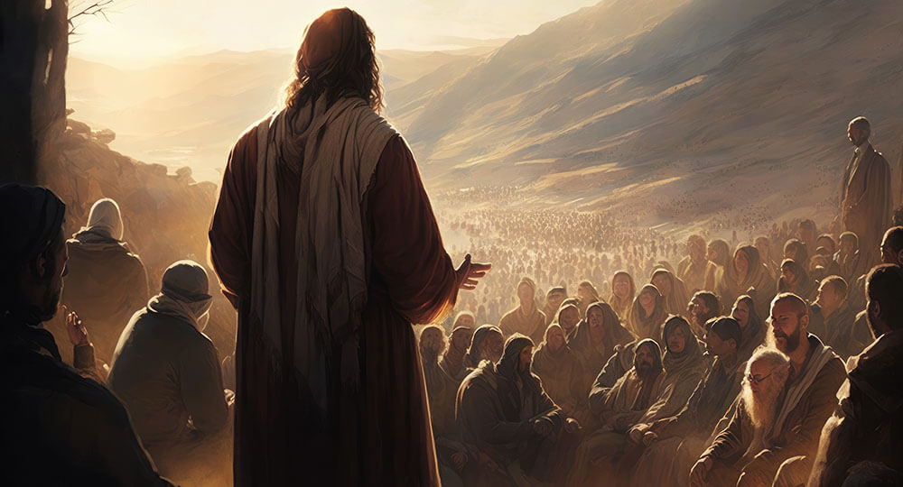

Minister: Rev. James Blackwell 07596 299970
01599 537223
Elders: Ken MacDonald 07895 678496
Colin MacDonald 01599 522719
Finlay MacDonald 07445 646444
Finance Committee: Donnie Lamont
Ronnie Lamont
Moira Lane
Craig Scobie 07502 485998
Safeguarding Co-ordinators: Barbara MacDonald 01599 522719
Moira Lane 01599 522709

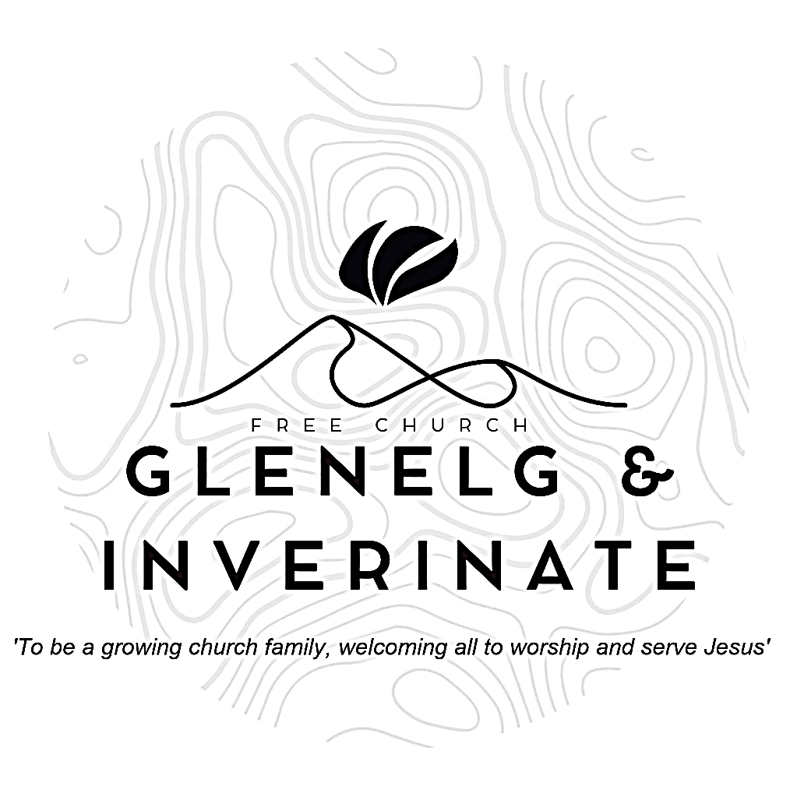

WEEKLY BULLETIN
Sunday 15th February 2026
Service at 12.00 noon in Inverinate Hall and
6.00pm in Glenelg Church of Scotland

We warmly welcome you to this service of worship and would love you to join us for tea, coffee and refreshment

Praise be to the Lord, the God of Israel, because he has come to his people and redeemed them. He has raised up a horn of salvation for us in the house of his servant David Luke 1:68-69

NOTICES

• Today’s Services: We are delighted to have Rev James Blackwell leading our 12 noon worship from Matthew 6:5-14, Sermon – ‘The King’s guide to prayer’.
Our Glenelg 6.00pm service this evening we will look at Psalm 2:1-12, Sermon – ‘Why do nations rage?’.
The audio from our service is recorded and is accessible on our website.
- Praise:
Hymn – 10,000 Reasons (Bless the Lord o my soul)
Sing Psalms 17:3-8 (page 18) – Though you examine me
Hymn – Come People of the Risen King
Sing Psalms 18:1-6 (page 19) – I love you Lord! You are my strength
- Sunday School: Sunday School will run as usual today during our service. There is also a creche for the very little ones.
- Sunday 22nd February: Rev James Blackwell will lead us in worship at the 12.00 noon Service in Inverinate Hall and the 6.00pm service in Glenelg.
- Easter Bible Study - We are holding another Congregational Bible Study for Easter this year. The study we have chosen is 'The Wondrous Cross' by Wil and Lorraine Triggs. It is a daily devotional study, running from Ash Wednesday (18th February) to Easter Sunday (5th April) and we would really encourage everyone to take part. Copies of the study guide are available at the door, please do take a copy and join in.
- Retiring Collection - The retiring collection taken for 'Good News for Everyone,' when they visited us a couple of weeks ago, raised £125. Many thanks for your generosity to this very good cause.
- Online Studies: The Men's Study Group will continue their study on Luke’s Gospel. Our Ladies Study Group will continue their study called ‘Love Death and Resurrection’ from the Scottish Bible Society. It's always a great time to join up, but especially so if at the start of a New Year. So, if you are interested in joining either group please speak to Moira, Barbara or Colin.
- Holiday Club: Dates for this year’s holiday club will be 27th-31st July. Booking will open soon and as places will be limited, we advise booking early to avoid disappointment. Thanks!
- 'Psalms and Sausages – The next Psalms and Sausages shall take place at the manse on 28th February from 2.00pm. All are welcome.
- Wednesday Bible Studies: Our Glenelg Study Group are meeting at 7.30pm this Wednesday continuing our study on “I Believe – The Apostles’ Creed” by Tim Chester.
- Church Prayer Meeting: Please remember that our Church Prayer Meeting is now held every Sunday at 11.15am before the Sunday Service. So please do come along and join us in prayer to our Heavenly Father.

- Engage 2026: At our National Day of Prayer in November we were delighted to announce Engage 2026. With over 10,000 people in our denomination if each of us prayed for 10 people then over 100,000 lives would be committed to prayer every day. Engage 2026 supports our vision of healthy gospel churches and contributes to the development of a long-term culture of mission, grounded in prayer. We hope to shape habits of prayer and expectation that sustain faithful gospel witness.
We will provide resources like physical and digital bookmarks to write down the ten names, sharing stories of encouragement and answered prayer along with accounts of how God is working. Our prayer is that under God and for his glory, Engage 2026 will see a raising of the evangelistic temperature of our church. As we commit to regular, intentional prayer, we trust that God will provide opportunities for witness and that we will be better equipped to respond to them with grace and courage.
Praying for One Another: Please add the following points to your prayer diaries:
Badenoch: Please pray that the Lord would strengthen the Badenoch congregation in faithful worship, unity, and spiritual growth. Pray that God would bless the congregation’s witness in the community, that there would be a strong gospel presence, and that the Lord would draw many to saving faith in Jesus Christ.
Asian Outreach: I am leading a seminar at the annual Free Church Youth Conference 13th-15th March on ‘Engaging with Muslims’. The conference is for 18–30-year-olds, and many of these young folk will have classmates, work colleagues, neighbours and friends who are Muslim. Please pray that the seminar will encourage and equip people better to reach out to Muslims with love and with the Gospel. This year, the Islamic month of fasting begins on/around 18th February. Muslims across the world will abstain from food and drink during daylight hours and break the fast, often communally, as night falls each day. Usually in Ramadhan there are opportunities to join Muslim friends for iftar (breaking the fast), often in mosques. Please pray for fruitful contact and conversation.
Engage 2026: Pray that God would deepen faithful, persistent prayer across our churches for those who do not yet know Christ. As we pray for ten people who do not yet know Jesus, pray that the Lord would open opportunities for gracious witness and bring many to saving faith in Jesus.
Central Office: Pray that the Lord would provide the right Finance Officer to assist the Central Finance team, and that they would be able to use their skills to support wisely the work and mission of the Church.

