

Minister: Rev. James Blackwell 07596 299970
01599 537223
Elders: Ken MacDonald 07895 678496
Colin MacDonald 01599 522719
Finlay MacDonald 07445 646444
Finance Committee: Donnie Lamont
Ronnie Lamont
Moira Lane
Craig Scobie 07502 485998
Safeguarding Co-ordinators: Barbara MacDonald 01599 522719
Moira Lane 01599 522709

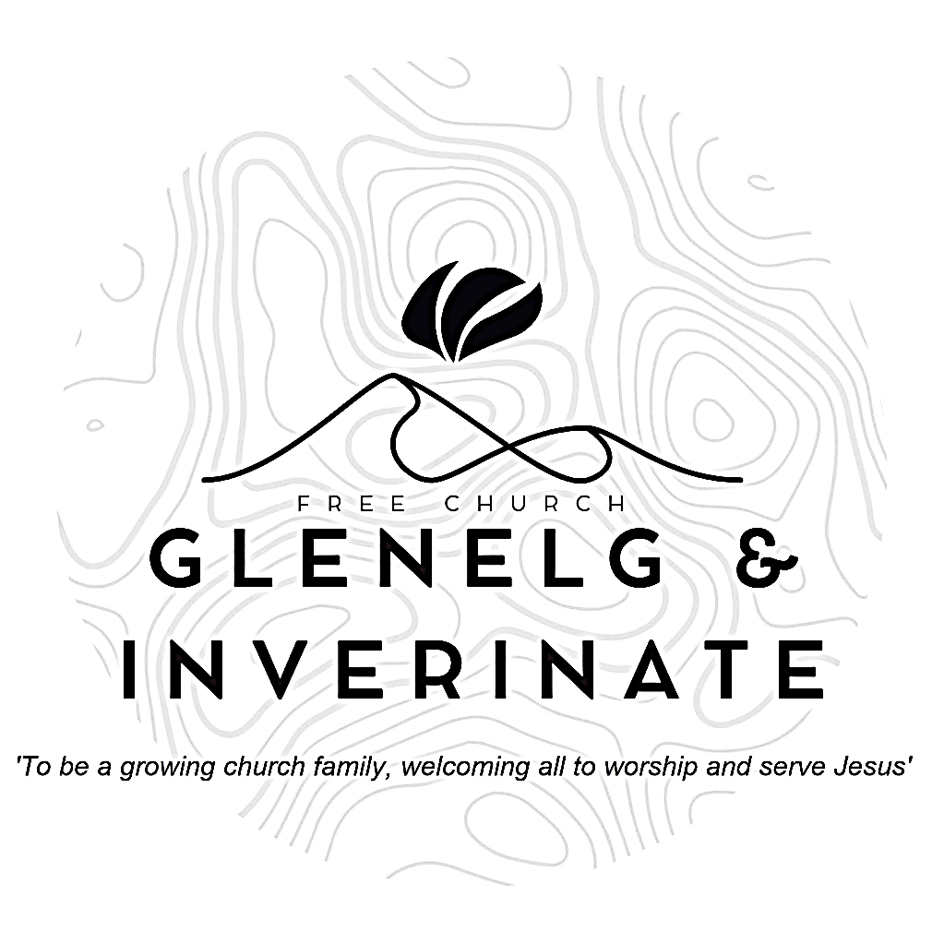

WEEKLY BULLETIN
Sunday 18th January 2026
Service at 12.00 noon in Inverinate Hall and
6.00pm in Glenelg Church of Scotland

We warmly welcome you to this service of worship and would love you to join us for tea, coffee and refreshment

“Come to me, all you who are weary and burdened, and I will give you rest. Take my yoke upon you and learn from me, for I am gentle and humble in heart, and you will find rest for your souls. Matthew 11:28-29

NOTICES

• Today’s Services: We are delighted to have Rev James Blackwell leading our 12 noon worship from Mark 4:35-41, Sermon – ‘Who is this?’.
DJ Stewart will lead our 6.00pm service in Glenelg from 2 Chronicles 20:1-29.
The audio from our service is recorded and is accessible on our website.
- Praise:
Sing Psalms 8:1-9 (page 7) – In all the earth, O Lord our Lord
Sing Psalms 22:22-26 (page 27) – Now to my brothers I’ll declare
Hymn – It is well with my soul
Hymn – In Christ alone
- Sunday School: Sunday School will run as usual today during our service. There is also a creche for the very little ones.
- Sunday 25th January: Next week we are delighted to welcome Rev. Alasdair Macleod who will lead both our services. Alasdair is the minister of Smithton Free Church in Inverness and the current Moderator of the Free Church. Remember him in prayer in his duties and as he prepares to come.
- Sunday 1st February: We shall welcome a speaker from GOOD NEWS for Everyone! (Formerly Gideons) who will preach in Inverinate and tell us about their work. There will be a retiring collection for the work of 'Good News for Everyone' at this service.
- Online Studies: The Men's Study Group will continue their study on Luke’s Gospel. Our Ladies Study Group will continue their study called ‘Love Death and Resurrection’ from the Scottish Bible Society. It's always a great time to join up, but especially so if at the start of a New Year. So, if you are interested in joining either group please speak to Moira, Barbara or Colin.
- Engage 2026: At our National Day of Prayer in November we were delighted to announce Engage 2026. With over 10,000 people in our denomination if each of us prayed for 10 people then over 100,000 lives would be committed to prayer every day. Engage 2026 supports our vision of healthy gospel churches and contributes to the development of a long-term culture of mission, grounded in prayer. We hope to shape habits of prayer and expectation that sustain faithful gospel witness.
We will provide resources like physical and digital bookmarks to write down the ten names, sharing stories of encouragement and answered prayer along with accounts of how God is working. Our prayer is that under God and for his glory, Engage 2026 will see a raising of the evangelistic temperature of our church. As we commit to regular, intentional prayer, we trust that God will provide opportunities for witness and that we will be better equipped to respond to them with grace and courage.

- Wednesday Bible Studies: Our Glenelg Study Group are meeting at 7.30pm this Wednesday.
- Church Prayer Meeting: Please remember that our Church Prayer Meeting is now held every Sunday at 11.15am before the Sunday Service. So please do come along and join us in prayer to our Heavenly Father.
- Finance Committee Meeting: The Finance Committee is due to meet on Monday 19th January at 7.30pm. If you have any items that you would like to add to the agenda, please let Craig Scobie know.
- Praying for One Another: Please add the following points to your prayer diaries:
Helensburgh: Pray that the Lord would continue to build Hope Community Church in Helensburgh as a Bible-centred congregation that bears witness to the hope of the gospel in the local community. Pray that God would strengthen the church’s ministry and outreach, guiding its leaders and members in faithful service and growth in Christ.
Engage 2026: Engage 2026 is a prayer initiative calling 10,000 believers to commit to praying for ten people each to come to know Christ, bringing 100,000 lives across our nation before God in intentional, sustained prayer. For more information please keep an eye on the Free Church of Scotland Website and Social Media for updates in the coming weeks.
Pray that the Lord would help each of us to faithfully commit to praying for ten specific individuals in our lives, asking that they might come to know the Lord Jesus Christ, and that we would persevere in prayer.
Pray that, through Engage 2026, God would deepen our culture of prayer and mission, raising the evangelistic temperature of our churches and drawing many across Scotland to saving faith for His glory.
Bishopbriggs: Pray that the Lord would uphold the congregation during this period of vacancy and continue His work among the congregation. Please pray that God would guide and strengthen the congregation in the coming months, granting wisdom and clarity as they continue witnessing to Christ in Bishopbriggs.
Dumisani: Pray for the commencement of classes for Term One on February 9th at Dumisani Theological Institute in the Eastern Cape. Pray for returning and also for new students that many friendships will be made and close bonds for ministry labours will be formed.

