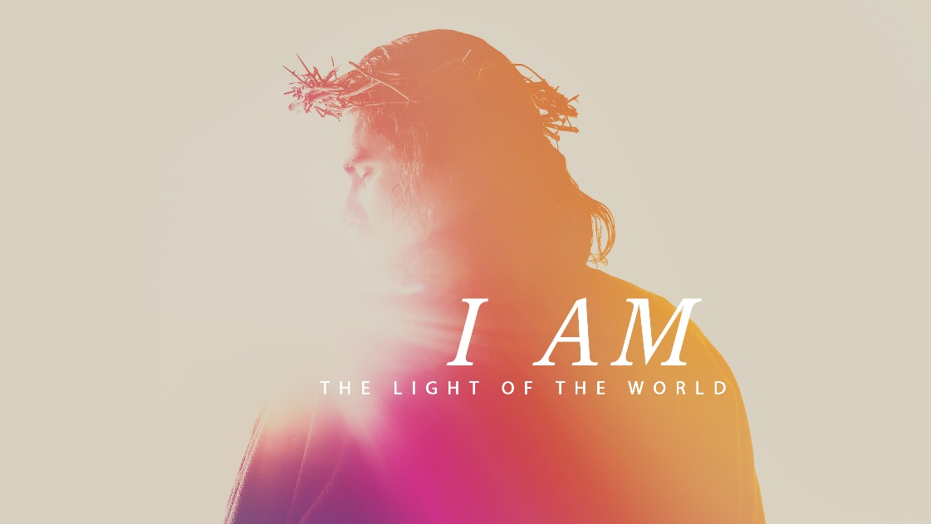

Minister: Rev. James Blackwell 07596 299970
01599 537223
Elders: Ken MacDonald 07895 678496
Colin MacDonald 01599 522719
Finlay MacDonald 07445 646444
Finance Committee: Donnie Lamont
Ronnie Lamont
Moira Lane
Craig Scobie 07502 485998
Safeguarding Co-ordinators: Barbara MacDonald 01599 522719
Moira Lane 01599 522709

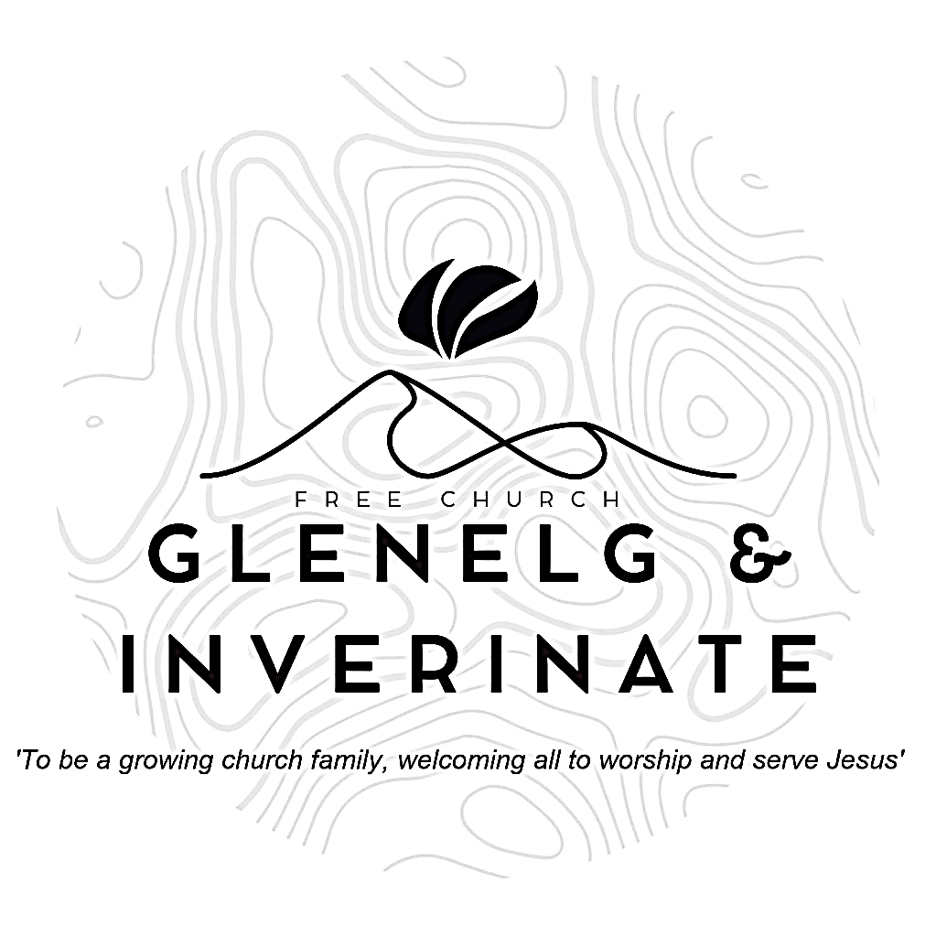

WEEKLY BULLETIN
Sunday 11th January 2026
Service at 12.00 noon in Inverinate Hall and
6.00pm in Glenelg Church of Scotland

We warmly welcome you to this service of worship and would love you to join us for tea, coffee and refreshment

When Jesus spoke again to the people, he said, “I am the light of the world. Whoever follows me will never walk in darkness, but will have the light of life.” John 8:12

NOTICES

• Today’s Services: We are delighted to have Rev James Blackwell leading our 12 noon worship from Matthew 5:33-48, Sermon – ‘The King corrects abuses’.
Our Glenelg 6.00pm service this evening we will look at James 4:13-5:6, Sermon – ‘Now listen’.
The audio from our service is recorded and is accessible on our website.
- Praise:
Hymn - Come people of the risen king
Scottish Psalter 119(17):129-136 (page 411) – Thy statutes, Lord, are wonderful
Scottish Psalter 12:1-8 (page 213) – Help, Lord, because the godly man …….
Hymn – Take my life and let it be
- Sunday School: Sunday School will run as usual today during our service. There is also a creche for the very little ones.
- Next Sunday 18th January: Rev James Blackwell will lead us in worship at the 12.00 noon Back to Church Sunday Service in Inverinate Hall and DJ Stewart will take the 6.00pm service in Glenelg.
- Please Note: The minister shall be away in Edinburgh for training from Monday-Thursday of next week. For any pastoral issues please contact one of the elders.
- Online Studies: The Men's Study Group will continue their study on Luke’s Gospel. Our Ladies Study Group are starting their study called ‘Love Death and Resurrection’ from the Scottish Bible Society. It's always a great time to join up, but especially so if at the start of a New Year. So, if you are interested in joining either group please speak to Moira, Barbara or Colin.
- Engage 2026: At our National Day of Prayer in November we were delighted to announce Engage 2026. With over 10,000 people in our denomination if each of us prayed for 10 people then over 100,000 lives would be committed to prayer every day. Engage 2026 supports our vision of healthy gospel churches and contributes to the development of a long-term culture of mission, grounded in prayer. We hope to shape habits of prayer and expectation that sustain faithful gospel witness.
We will provide resources like physical and digital bookmarks to write down the ten names, sharing stories of encouragement and answered prayer along with accounts of how God is working. Our prayer is that under God and for his glory, Engage 2026 will see a raising of the evangelistic temperature of our church. As we commit to regular, intentional prayer, we trust that God will provide opportunities for witness and that we will be better equipped to respond to them with grace and courage.

- Wednesday Bible Studies: Our Glenelg Study Group are meeting at 7.30pm this Wednesday. We are completing our study Advent study on the book ‘Let Earth Receive Her King’.
- Church Prayer Meeting: Please remember that our Church Prayer Meeting is now held every Sunday at 11.15am before the Sunday Service. So please do come along and join us in prayer to our Heavenly Father.
- Praying for One Another: Please add the following points to your prayer diaries:
Muriel Macleod, Cambodia: Please continue to pray that the Holy Spirit will ignite hearts to worship and to make God known throughout Cambodia.
Recently there has been a significant increase in hostilities between Thailand and Cambodia. More intense fighting and many more casualties, including five young men from the village. They were sent back home to the district medical centre to be near family as they recover.Pray for those reaching out to the increasing numbers of refugees. Pray for a peaceful resolution.
Galashiels: Join with us in thanking God for our offer being accepted on a building. Please pray that the title issue can be resolved soon and we can get in next month.
We had our first joint Borders Youth Night in December and it was a huge success, far better than we anticipated. Please pray that this continues and specifically that Scripture Union Scotland can appoint a worker for the Borders who can take this on.
Please ask that the Lord might provide more mature Christians to the church plant. Specifically families and musicians.
Sashko, Poland: Our church in Kraków occupies a unique position: close enough to understand Ukraine's needs, stable enough to focus on long-term spiritual infrastructure, and connected enough to distribute literature effectively across the region. This is where Ukrainian Reformation was born. Operating from Poland, we're able to provide the sound theological resources Ukrainian believers desperately need while their own churches are necessarily focused on immediate crisis response. Please pray that the Lord would continue to bless and grow this work.
Our distribution infrastructure is already operational and reaching deep into Ukraine. Ministry partners we've carefully vetted are carrying our books directly to seminaries, churches, orphanages, displaced families and soldiers at the frontline — into bomb shelters, military hospitals, and refugee housing where theological resources are desperately needed. Please pray God’s protection over this much needed distribution infrastructure.

