

Minister: Rev. James Blackwell 07596 299970
01599 537223
Elders: Ken MacDonald 07895 678496
Colin MacDonald 01599 522719
Finlay MacDonald 07445 646444
Finance Committee: Donnie Lamont
Ronnie Lamont
Moira Lane
Craig Scobie 07502 485998
Safeguarding Co-ordinators: Barbara MacDonald 01599 522719
Moira Lane 01599 522709

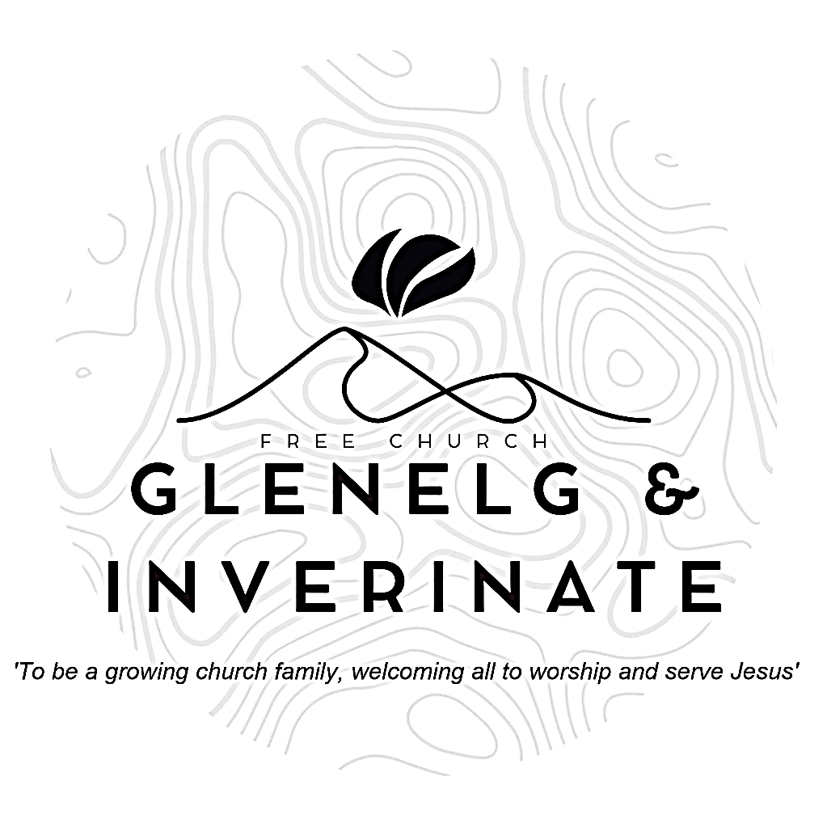

WEEKLY BULLETIN
Sunday 28th December 2025
Service at 12.00 noon in Inverinate Hall and
6.00pm in Glenelg Church of Scotland

We warmly welcome you to this service of worship and would love you to join us for lunch after the 12 noon service

Shout for joy to God, all the earth! Sing the glory of his name; make his praise glorious. Say to God, “How awesome are your deeds! So great is your power that your enemies cringe before you. Psalm 66:1-3

NOTICES

• Today’s Services: We are delighted to have Rev James Blackwell leading our 12 noon worship from Revelation 11:15-19 & 21:1-7, Sermon – ‘Awaiting a New Advent’. This evening in Glenelg will be a Praise & Prayer Service.
The audio from both services is recorded and are accessible on our website.
- Praise:
Sing Psalms 66: 1-6 (page 83) – Shout loud with joy to God
Hymn - Come O long expected Jesus
Hymn – Praise to the Lord, the Almighty, the King of creation
Sing Psalms 99(a): 1-9 (page 130) – The Lord reigns from his throne on high
- Sunday School: There will be no Sunday School as it is the school holidays, but there will be the crèche for the wee ones.
- Next Sunday 4th January: Rev James Blackwell will lead us in worship at the 12.00 noon Service in Inverinate Hall. There will be no 6.00pm service in Glenelg as we have our joint communion service at Kyleakin hall at 18:00.
- Community New Years Day Service: Our New Year's Day Service will be held at 12 noon in Kyle Free Church as we join with our brothers and sisters to celebrate the New Year and to begin the year in praise and worship of our God and Saviour.
- Hymns on Hogmanay: All are invited to the manse on New Year's Eve for some singing, nibbles and Colin's quiz. From 20:30 - late.
- Back to Church Sunday: The Kirk session are planning on having a ‘Back to Church Sunday’ on the 18th January. The idea is that we will send a personalised invitation to someone who used to come to church but hasn’t been in a long while. If you have someone in mind please fill in a card with their name and address (if you know it) so we can get in touch with them by the 4th January at the latest. Please pray that those who are invited will come. Thanks.
- Online Studies: The Men's Study Group will begin a new study early in
the New Year. Our Ladies Study Group are continuing their Two-Year Bible Read Through study. This series is coming to an end soon and it is planned to use material from the Scottish Bible society next year. If anyone new would like to join in speak to Barbara or Moira. It's always a great time to join up so if you are interested in joining either group please speak to Moira, Barbara or Colin.

- Church Prayer Meeting: Please remember that our Church Prayer Meeting is now held every Sunday at 11.15am before the Sunday Service. So please do come along and join us in prayer to our Heavenly Father.
- Praying for One Another: Please add the following points to your prayer diaries:
Osamu and Mairi: Thank you for your prayers for our children’s Christmas party. We were not sure at all if any of the invited would come. We had 5 children and 3 parents!! They drove to get to our church 20 minutes. Please pray that we will be able to continue the connection with them in the coming months.
Healthy Gospel Church: Pray that each one of us becomes more intentional in sharing the Gospel. We pray for boldness, an assurance of our beliefs and opportunities to share the good news with our loved ones, colleagues and neighbours, and in our communities.
St Columbas: Pray that the Lord would bless our annual Weekend Away (9th-11th January) as a time of rest and fellowship together, that we would enjoy one another’s company, be strengthened as a church family, and be helped to meet with God through His Word; and pray for Daniel Sladek, as he joins us as our guest speaker.
Sashko, Poland: 25 books published in 2025 - Thank God for the publishing breakthrough this year and for the Reformation Study Bible translation being nearly complete

