

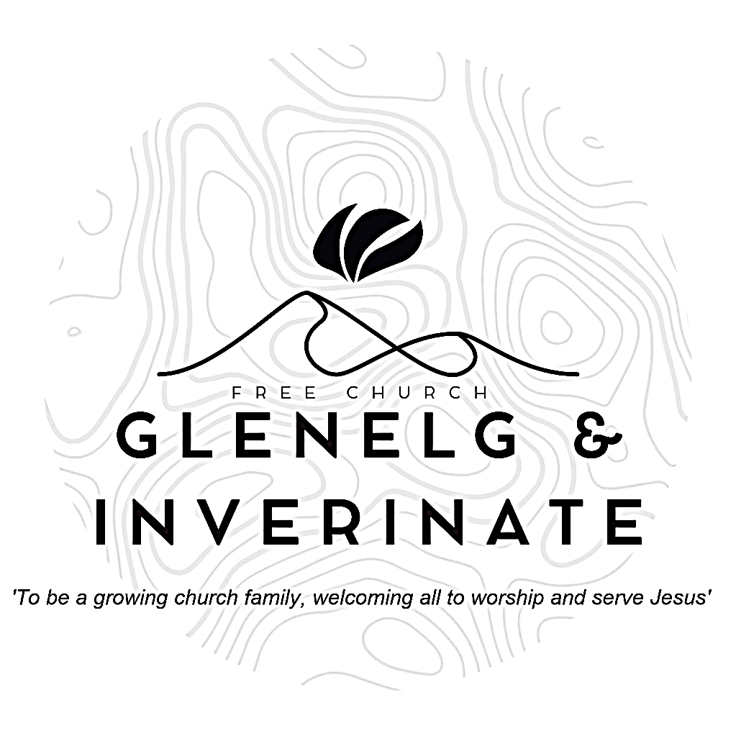

WEEKLY BULLETIN
Sunday 7th December 2025
Service at 12.00 noon in Inverinate Hall and
6.00pm in Glenelg Church of Scotland

We warmly welcome you to this service of worship and would love you to join us for lunch after the 12 noon service

When I consider your heavens, the work of your fingers, the moon and the stars, which you have set in place, what is mankind that you are mindful of them, human beings that you care for them? You have made them a little lower than the angels and crowned them with glory and honour. Psalm 8: 3-5

NOTICES

• Today’s Services: We are delighted to have Rev James Blackwell leading our Communion services this weekend. Our 12 noon service today will include the Lord’s Supper, the sermon is titled ‘Second Sunday of Advent: Christmas in the Land’. Our 12 noon service will be followed by a church family lunch, please do stay and join us if you can. Our Glenelg 6.00pm service this evening we will look at James 3:13-18, Sermon – ‘A choice of wisdom’. The audio from the service is recorded and are accessible on our website.
- Praise:
Sing Psalms 104: 1-9 (page 136) – Praise the Lord, my soul, O praise him!
Hymn – O come, O come, Emmanuel
Hymn – Once in Royal David City
Scottish Psalter 72: 16-19 (page 314) – Of corn an handful in the earth
- Sunday School: Sunday School will run as usual today during our service. There is also a creche for the very little ones.
- Next Sunday 14th December: Rev James Blackwell will lead us in worship at the 12.00 noon Service in Inverinate Hall, there will be no 6.00pm service in Glenelg as it is the Carols in the Castle Service. An evening of Christmas Carols and Worship Inside the Banquet Hall of the Castle at 4.30pm. (See back page)
- Congregational Advent Bible Study: This year our congregational Advent study will be ‘Let earth receive her King’ by Alistair Begg. It will run all the way up until Christmas. We would urge everyone to take part in the daily devotional study. Books are available at the door, please do take one.
- Church Prayer Meeting: Please remember that our Church Prayer Meeting is now held every Sunday at 11.15am before the Sunday Service. So please do come along and join us in prayer to our Heavenly Father.
- Bible Studies: The Glenelg Bible Study will be not be meeting this week as it is the Primary School Christmas concert. This week the ‘Dornie’ Bible study is meeting at Iain and Anne Fraser’s in Inverinate on Tuesday at 7.30pm. All are warmly invited to either meeting.
- Online Studies: Our Men's Study Group are continuing their study on ‘Let earth receive her King’ by Alistair Begg. Our Ladies Study Group are continuing their Two-Year Bible Read Through study. This series is coming to an end soon and it is planned to use material from the Scottish Bible society next year. If anyone new would like to join in speak to Barbara or Moira. The book needed for the study can be ordered here for a cost of £6:
https://www.scottishbiblesociety.org/shop/book/love-death-resurrection
It's always a great time to join up so if you are interested in joining either group please speak to Moira, Barbara or Colin.

- Praying for One Another: Please add the following points to your prayer diaries:
Grace Church Leith: Please pray for our Candlelit Carol Service and Nativity taking place on the 14th of December. Pray that it will be an opportunity for many to hear the gospel, and that those in the congregation would invite friends and family to hear the gospel shared clearly. Pray that many from the community would come and learn about why we celebrate Christmas.
Dumisani: Give thanks to the Lord for the two additional lecturers, Lwandiso and Marten, at Dumisani Theological Institute, SA who were available throughout 2025 and also for the increase in enrolment. As we reflect upon the past academic year 2025 at Dumisani Theological Institute, SA we are humbled by the fact that every course module planned was able to be taught. Also, we rejoice in the Lord's provisions through many faithful donations to the ministry of Dumisani in 2025. We rejoice that finally after a difficult year of many attempts to resolve the housing needs, now at year's end a well-maintained facility has been secured which will be able to accommodate 14 men within close walking distance to the Dumisani Institute campus. We rejoice in this news and anticipate using this new facility as we look to 2026.
Sashko, Poland: Please pray that God would provide for our urgent needs through raising up new monthly and annual partners to join our missionary support team. Praise God: For fruitful Family & Parenting and Worship conferences that equipped our congregation and leaders.
Grace Church Leith: Pray for the Conversation Café, that it would be an opportunity to build community, while practicing English, and be of great blessing those who attend. Pray also for the optional Bible study, that those attending the cafe would join, and that God’s Word would be taught and received with understanding

Minister: Rev. James Blackwell 07596 299970
01599 537223
Elders: Ken MacDonald 07895 678496
Colin MacDonald 01599 522719
Finlay MacDonald 07445 646444
Finance Committee: Donnie Lamont
Ronnie Lamont
Moira Lane
Craig Scobie 07502 485998
Safeguarding Co-ordinators: Barbara MacDonald 01599 522719
Moira Lane 01599 522709

