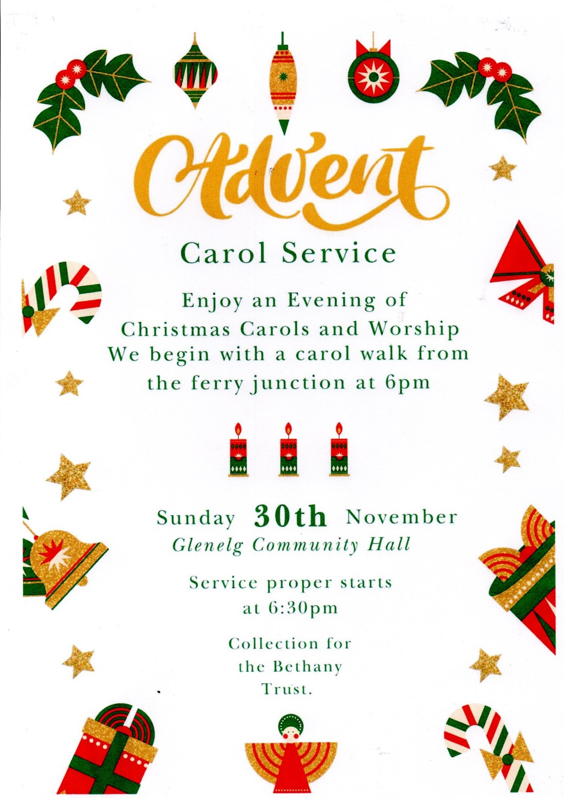

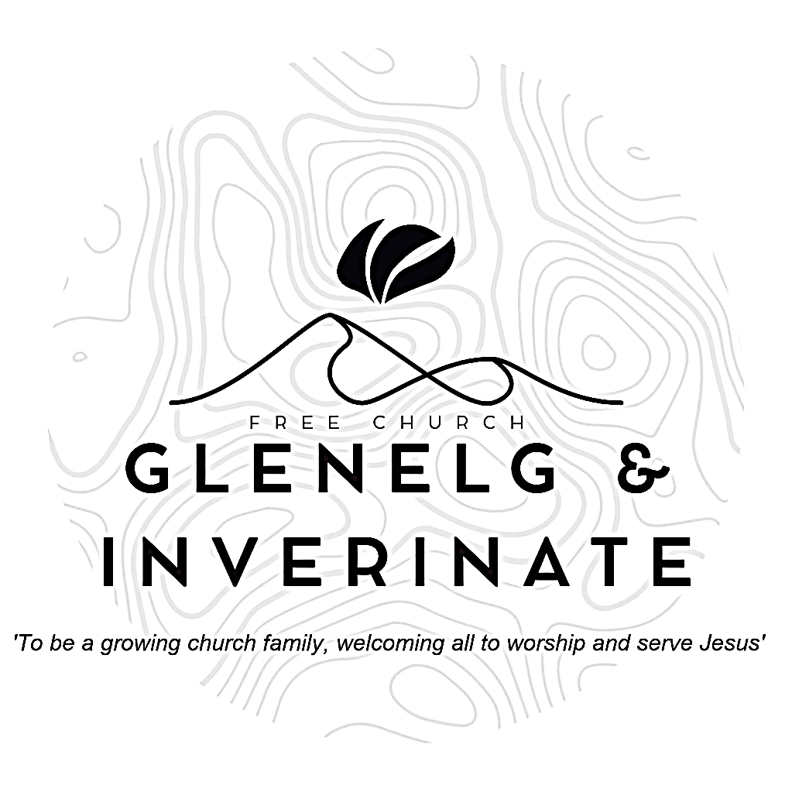

WEEKLY BULLETIN
Sunday 23rd November 2025
Service at 12.00 noon in Inverinate Hall

We warmly welcome you to this service of worship and would love you to join us for tea, coffee and refreshment

In your unfailing love you will lead the people you have redeemed. In your strength you will guide them to your holy dwelling. Exodus 15:13

NOTICES

• Today’s Services: We are delighted to have Rev James Blackwell leading our 12 noon worship from Genesis, Sermon – ‘First Sunday of Advent’. The audio from the service is recorded and are accessible on our website. It is our Community Advent Carol Service in Glenelg this evening - details on the back of the Bulletin.
- Praise:
Hymn – Thine be the Glory
Scottish Psalter 119(14): 105-112 (page 409) – Thy word is to me feet a lamp
Sing Psalms 3: 1-8 (page 3) – O Lord, how many are my foes!
Hymn – Of the Fathers love begotten
- Sunday School: Sunday School will run as usual today during our service. There is also a creche for the very little ones.
- Next Sunday 7th December: Rev James Blackwell will lead us in worship at the 12.00 noon Service in Inverinate Hall and our 6.00pm service in Glenelg.
- Congregational Advent Bible Study: This year our congregational Advent study will be ‘Let earth receive her King’ by Alistair Begg. It will begin on 1st December and run all the way up until Christmas. We would urge everyone to take part in the daily devotional study. Books are available at the door, please do take one.
- Church Prayer Meeting: Please remember that our Church Prayer Meeting is now held every Sunday at 11.15am before the Sunday Service. So please do come along and join us in prayer to our Heavenly Father.
- Wednesday Bible Studies: The Glenelg Bible Study will be meeting at Jon and Megan's this coming Wednesday and will be studying ‘Let earth receive her King’ by Alistair Begg. Our Dornie group meets at Colin and Vivienne MacKenzie’s home at 7.30pm on Tuesday. All are warmly invited to either meeting.
- Online Studies: Our Men's Study Group are also studying ‘Let earth receive her King’ by Alastair Begg. Our Ladies Study Group are continuing their Two-Year Bible Read Through study. This series is coming to an end soon and it is planned to use material from the Scottish Bible society next year. If anyone new would like to join in speak to Barbara or Moira. The book needed for the study can be ordered here for a cost of £6:
https://www.scottishbiblesociety.org/shop/book/love-death-resurrection
It's always a great time to join up so if you are interested in joining either group please speak to Moira, Barbara or Colin.

- Advent Carol Service: Enjoy an evening of Christmas Carols and Worship Today Sunday 30th November in Glenelg Community Hall at 6.30pm. All Welcome.
- Praying for One Another: Please add the following points to your prayer diaries:
Matt and Maria, Greece: Please pray for continued opportunities for us to have Jesus-centred conversations in all aspects of our work and life in Greece. Please remember N in your prayers for his continued spiritual growth.
Callanish: Please pray for the congregation during this time of vacancy, that God would grant wisdom and discernment in the calling of a minister. Please pray for the elders and office-bearers, as they lead the congregation, that they would be strengthened in wisdom and gospel unity. Pray that the congregation would be a witness to Christ in all they do.
Mission Board: Please pray as the Mission Board meets today, that the Lord would give them wisdom in all decisions, and that they would continually focus on the gospel vision for the years ahead in their decisions and planning.
Open Doors – Afghanistan: Christians are among a wave of Afghans deported back to their homeland by the authorities in Tajikistan, putting them in danger of imprisonment and even execution. Pray for protection and resilience.

Minister: Rev. James Blackwell 07596 299970
01599 537223
Elders: Ken MacDonald 07895 678496
Colin MacDonald 01599 522719
Finlay MacDonald 07445 646444
Finance Committee: Donnie Lamont
Ronnie Lamont
Moira Lane
Craig Scobie 07502 485998
Safeguarding Co-ordinators: Barbara MacDonald 01599 522719
Moira Lane 01599 522709

