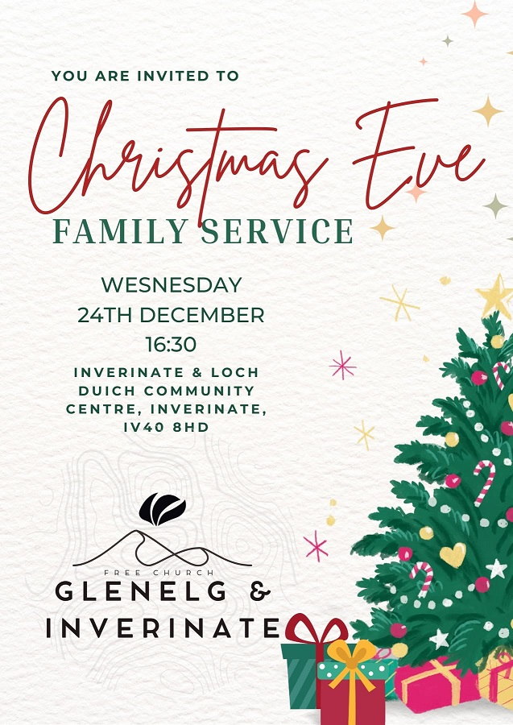

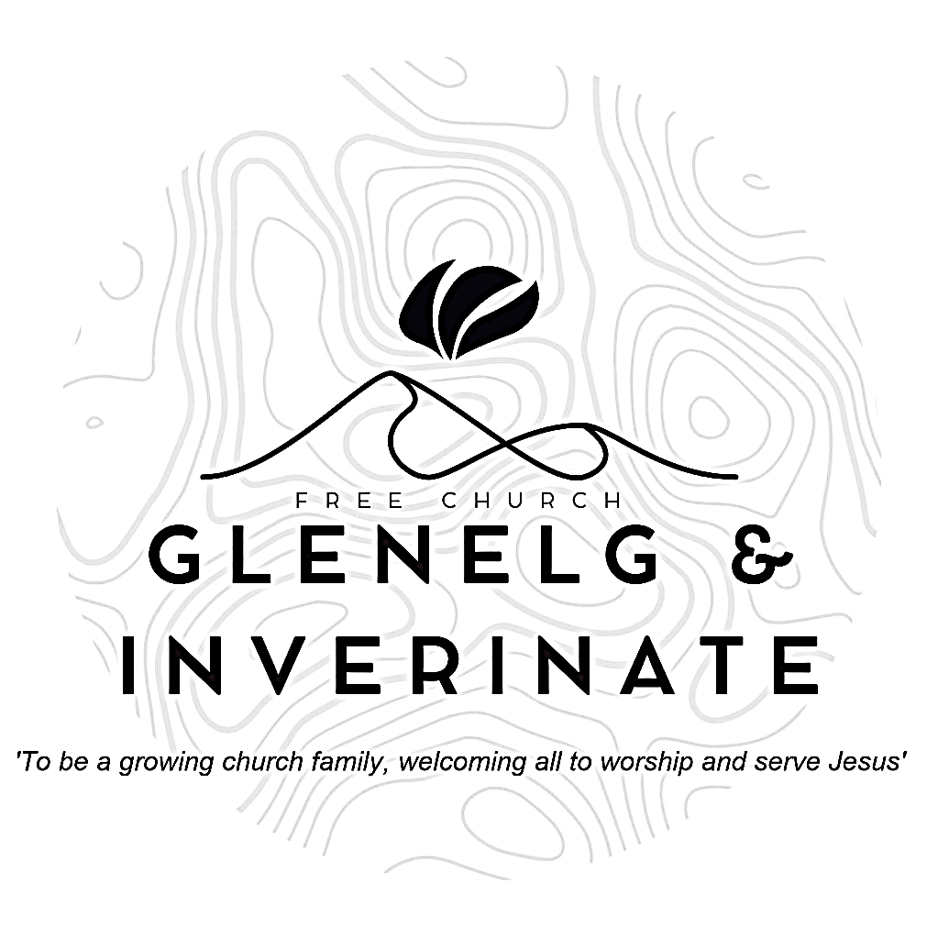

WEEKLY BULLETIN
Sunday 21st December 2025
Service at 12.00 noon in Inverinate Hall and
6.00pm in Glenelg Church of Scotland

We warmly welcome you to this service of worship and would love you to join us for lunch after the 12 noon service

His mercy extends to those who fear him, from generation to generation. He has performed mighty deeds with his arm; he has scattered those who are proud in their inmost thoughts. Luke 1:50-51

NOTICES

• Today’s Services: We are delighted to have Rev James Blackwell leading our 12 noon worship from Galatians 4:4-7, Titus 2:11 & 1 John 4:10, Sermon – ‘Fourth Sunday in Advent – Christmas in the Letters’. Then from James 4:1-12, Sermon – ‘Submit yourselves then to God’, this evening in Glenelg.
The audio from both services is recorded and are accessible on our website.
- Praise:
Sing Psalms 96(a): 1-8 (page 126) – O sing a new song to the Lord
Hymn – We Three Kings
Scottish Psalter 119(16): 121-128 (page 410) – To all men I have judgement….
Hymn – Blessed Assurance
- Sunday School: Sunday School will run as usual today during our service. There is also a creche for the very little ones.
- Next Sunday 28th December: Rev James Blackwell will lead us in worship at the 12.00 noon Service in Inverinate Hall and our 6.00pm service in Glenelg.
- Community New Years Day Service: Our New Year's Day Service will be held at 12 noon in Kyle Free Church as we join with our brothers and sisters to celebrate the New Year and to begin the year in praise and worship of our God and Saviour.
- Carol Evening - This evening (Sunday 21st) following the Glenelg evening service (around 7.30pm) everyone is warmly invited to Colin and Barbara's home for an evening of carol singing and festive snacks and drinks. Please do come along and join us.
- Hymns on Hogmanay: All are invited to the manse on New Year's Eve for some singing, nibbles and Colin's quiz. From 20:30 - late.
- Back to Church Sunday: The Kirk session are planning on having a ‘Back to Church Sunday’ on the 18th January. The idea is that we will send a personalised invitation to someone who used to come to church but hasn’t been in a long while. If you have someone in mind please fill in a card with their name and address (if you know it) so we can get in touch with them by the 4th January at the latest. Please pray that those who are invited will come. Thanks.
- Congregational Advent Bible Study: This year our congregational Advent study is ‘Let earth receive her King’ by Alistair Begg. We would urge everyone to take part in the daily devotional study. Books are available at the door.
- Online Studies: Our Men's Study Group are continuing their study on ‘Let earth receive her King’ by Alistair Begg. Our Ladies Study Group are continuing their Two-Year Bible Read Through study. This series is coming to an end soon and it is planned to use material from the Scottish Bible society next year. If anyone new would like to join in speak to Barbara or Moira. It's always a great time to join up so if you are interested in joining either group please speak to Moira, Barbara or Colin.

- Church Prayer Meeting: Please remember that our Church Prayer Meeting is now held every Sunday at 11.15am before the Sunday Service. So please do come along and join us in prayer to our Heavenly Father.
- Praying for One Another: Please add the following points to your prayer diaries:
Open Doors - Central Asia: This Christmas, local partners in Central Asia are sharing God’s love through various festive initiatives, including the distribution of thousands of Christmas gifts. Praise God for the wonderful impact of these events, and pray for many more precious encounters over the coming festive period. Please pray for the local partners – for safety in travel, good health and renewed energy for each event. Please pray that the events will be kept from the prying eyes and ears of those who might be opposed to them.
Turkey: Pray for a ministry producing indigenous, Turkish-language Bible Study materials. Give thanks for the way these are being used by churches all across Turkey and ask God to give wisdom about the future development of the ministry. Ask God to refresh and renew Christian leaders in Turkey. Most are overworked, because of the small size of the Church in the country, and some are in danger of burnout. Pray that the Lord would provide them with all the resources they need for their ministries.
Free Church Youth Camps: Give thanks for the work of Free Church Youth Camps. The FCYC team been working hard behind the scenes for summer 2026, and have worked on various changes to improve and update the current booking system. There will be 12 camps next summer, including Junior Adventure and Kincraig Seniors! Bookings go live in January, please pray that all goes smoothly with the new booking system, and for many children to have the opportunity to attend a camp.

Minister: Rev. James Blackwell 07596 299970
01599 537223
Elders: Ken MacDonald 07895 678496
Colin MacDonald 01599 522719
Finlay MacDonald 07445 646444
Finance Committee: Donnie Lamont
Ronnie Lamont
Moira Lane
Craig Scobie 07502 485998
Safeguarding Co-ordinators: Barbara MacDonald 01599 522719
Moira Lane 01599 522709

