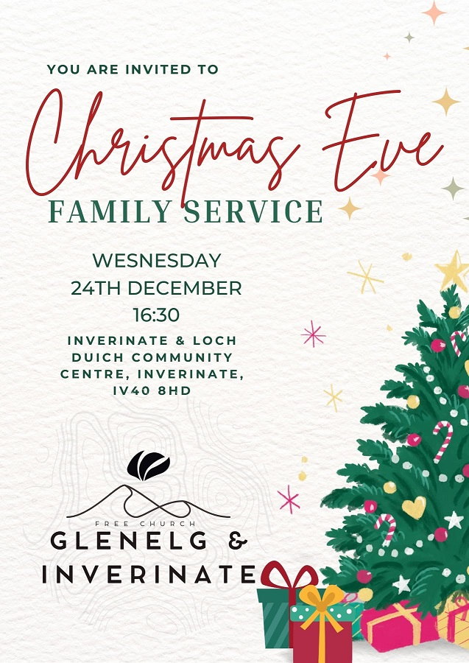

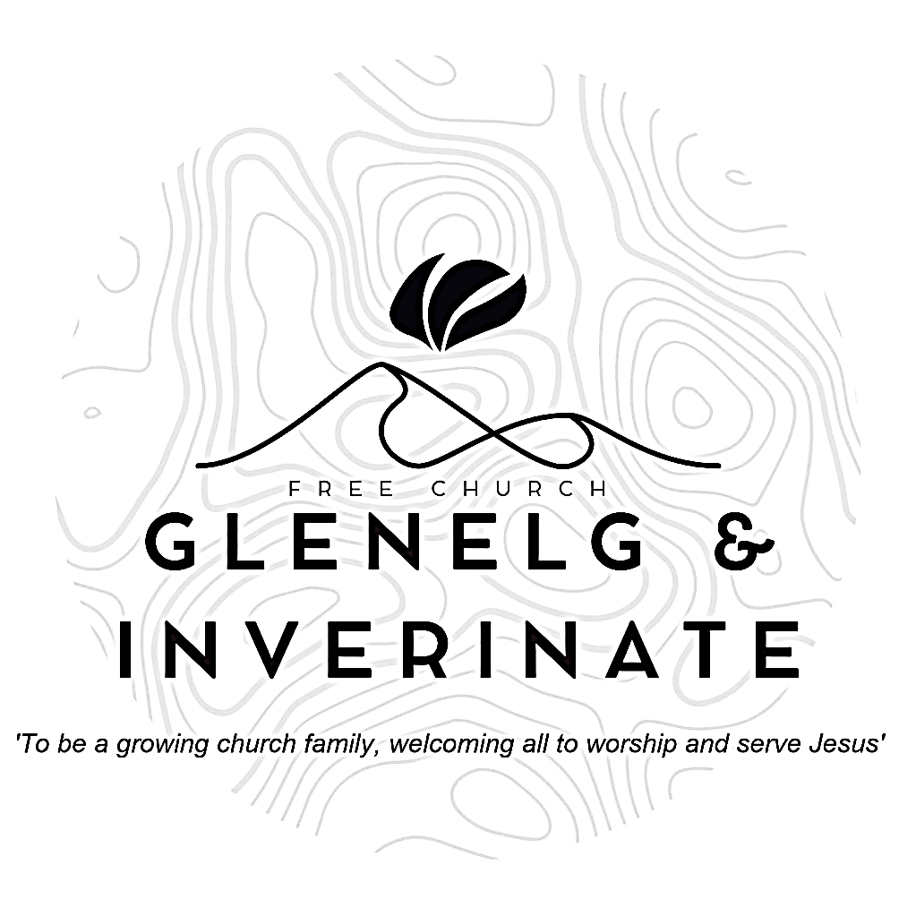

WEEKLY BULLETIN
Sunday 14th December 2025
Service at 12.00 noon in Inverinate Hall

We warmly welcome you to this service of worship and would love you to join us for lunch after the 12 noon service

I remain confident of this: I will see the goodness of the Lord in the land of the living. Wait for the Lord; be strong and take heart and wait for the Lord. Psalm 27:13-14

NOTICES

• Today’s Services: We are delighted to have Rev James Blackwell leading our 12 noon worship from Luke 1:31-38, Matthew 1:20-23, John 1:1-5, Sermon – ‘Third Sunday of Advent: Christmas in the Gospels’. The audio from the service is recorded and are accessible on our website.
There will be no 6.00pm service in Glenelg as it is the Carols in the Castle Service. An evening of Christmas Carols and Worship Inside the Banquet Hall of the Castle at 4.30pm.
- Praise:
Sing Psalms 75: 1-10 (page 98) – We give you thanks, O God
Hymn – Majesty, worship His Majesty!
Scottish Psalter 119(15): 113-120 (page 409) – I hate the thoughts of vanity
Hymn – Holy, Holy, Holy!
- Sunday School: Sunday School will run as usual today during our service. There is also a creche for the very little ones.
- Next Sunday 21st December: Rev James Blackwell will lead us in worship at the 12.00 noon Service in Inverinate Hall and our 6.00pm service in Glenelg.
- Advance Notice - Our New Year's Day Service will be held at 12 noon in Kyle Free Church as we join with our brothers and sisters to celebrate the New Year and to begin the year in praise and worship of our God and Saviour.
- Back to Church Sunday: The Kirk session are planning on having a ‘Back to Church Sunday’ on the 18th January. The idea is that we will send a personalised invitation to someone who used to come to church but hasn’t been in a long while. If you have someone in mind please fill in a card with their name and address (if you know it) so we can get in touch with them by the 4th January at the latest. Please pray that those who are invited will come. Thanks.
- Congregational Advent Bible Study: This year our congregational Advent study is ‘Let earth receive her King’ by Alistair Begg. We would urge everyone to take part in the daily devotional study. Books are available at the door, please do take one.
- Bible Studies: The Glenelg Bible Study will run as usual on Wednesday at 7.30pm in Jon and Megan MacDonald's home.
- Online Studies: Our Men's Study Group are continuing their study on ‘Let earth receive her King’ by Alistair Begg. Our Ladies Study Group are continuing their Two-Year Bible Read Through study. This series is coming to an end soon and it is planned to use material from the Scottish Bible society next year. If anyone new would like to join in speak to Barbara or Moira. The book needed for the study can be ordered here for a cost of £6:
https://www.scottishbiblesociety.org/shop/book/love-death-resurrection
It's always a great time to join up so if you are interested in joining either group please speak to Moira, Barbara or Colin.

- Church Prayer Meeting: Please remember that our Church Prayer Meeting is now held every Sunday at 11.15am before the Sunday Service. So please do come along and join us in prayer to our Heavenly Father.
- Praying for One Another: Please add the following points to your prayer diaries:
Stirling: Please pray for the congregation in this time of vacancy, that the Lord would strengthen and uphold the members during this time, and that the Lord would provide wisdom and guidance in this season. Pray that as a congregation, and as people of God we would daily turn to God’s Word for clear direction, remain obedient to Scripture despite cultural pressures, and walk with strength and courage.
Board of Ministry: Pray for the Board of Ministry as they meet on Tuesday, for wisdom and guidance in all their remits as they assess candidates, oversee training, and support ministers and their families. Pray for wisdom and clarity in all decisions they make, and give thanks for the work of the Student and Ministry teams.
Osamu and Mairi, Japan: Drop-In-Cafe is planned on 11th and 18th of this month. Last month a lady who is the mother of Micah’s classmate came to this. Pray that invitations distributed bring some to come. Children’s Christmas party is planned for 13th. Naomi’s children are inviting their Japanese classmates to this. Pray that some of them will come. For most of them this would be the first time to be in a church building. On 21st we hold Christmas family service. We will have distributed invitations to our neighborhood. (1500) May the name of our Savior uplifted in Tagajo city!!
Board of Trustees: Pray for the Board of Trustees who meet today. Pray that God would grant them great wisdom as they oversee governance, finance, property, and compliance for the Church. Pray for wisdom as they support other boards and congregations, and work toward the vision of a healthy gospel church for every community in Scotland.

Minister: Rev. James Blackwell 07596 299970
01599 537223
Elders: Ken MacDonald 07895 678496
Colin MacDonald 01599 522719
Finlay MacDonald 07445 646444
Finance Committee: Donnie Lamont
Ronnie Lamont
Moira Lane
Craig Scobie 07502 485998
Safeguarding Co-ordinators: Barbara MacDonald 01599 522719
Moira Lane 01599 522709

