BE THOU MY VISION
Be Thou my vision, O Lord of my heart;
naught be all else to me, save that Thou art –
Thou my best thought, by day or by night,
waking or sleeping, Thy presence my light.
Be Thou my wisdom, Thou my true Word;
I ever with Thee, Thou with me, Lord;
Thou my great Father, I Thy true son;
Thou in me dwelling and I with Thee one.
Be Thou my battle shield, sword for the fight,
be Thou my dignity, Thou my delight,
Thou my soul’s shelter, Thou my high tower:
raise Thou me heavenward, O Power of my power.
Riches I heed not, nor man’s empty praise,
Thou mine inheritance, now and always:
Thou and Thou only, first in my heart,
High King of heaven, my treasure Thou art.
High King of heaven, after victory won,
may I reach heaven’s joys, O bright heaven’s Sun!
Heart of my own heart, whatever befall,
still be my vision, O ruler of all.
(CCLI No. 30639 – Public Domain)

Minister: Rev. James Blackwell 07596 299970
01599 537223
Elders: Ken MacDonald 07895 678496
Colin MacDonald 01599 522719
Finlay MacDonald 07445 646444
Finance Committee: Donnie Lamont
Ronnie Lamont
Moira Lane
Craig Scobie 07502 485998
Safeguarding Co-ordinators: Barbara MacDonald 01599 522719
Moira Lane 01599 522709
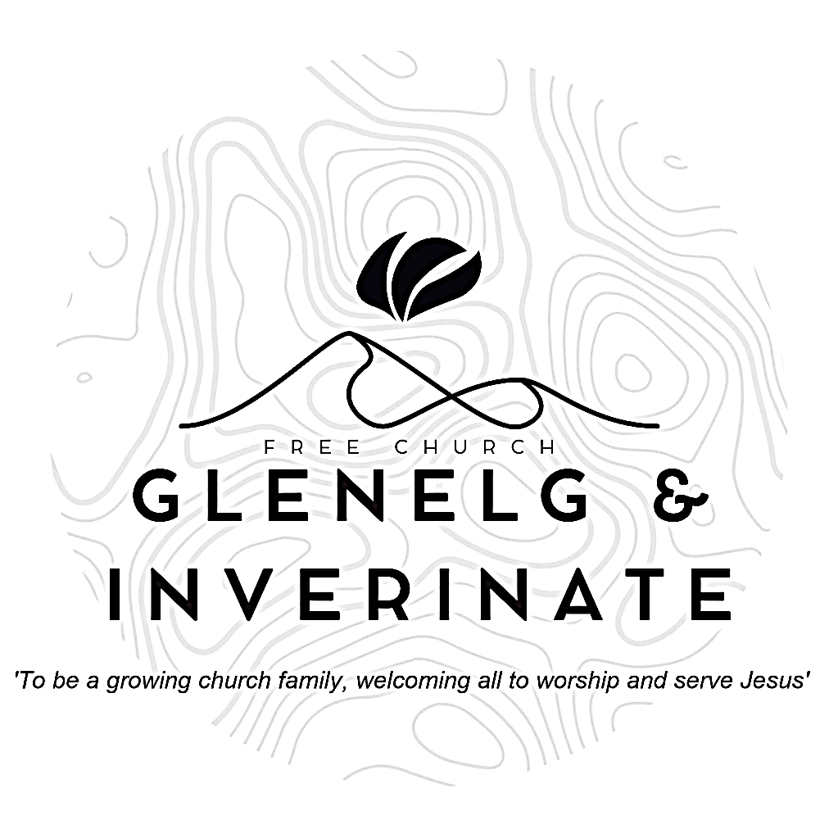

WEEKLY BULLETIN
Sunday 23rd November 2025
Service at 12.00 noon in Inverinate Hall and
6.00pm in Glenelg Church of Scotland

We warmly welcome you to this service of worship and would love you to join us for tea, coffee and refreshment

“As for God, his way is perfect: The Lord’s word is flawless; he shields all who take refuge in him.” 2 Samuel 22:31
NOTICES
• Today’s Services: We are delighted to have Ken Macdonald, leading our 12 noon worship from Psalm 63, Sermon – ‘A sermon of 8 words’. This evening in Glenelg will be a recorded service, Rev Alasdair Macleod from Smithton Free Church will be preaching on Psalm 73 - 'The Reality of Doubt'. The audio from both services is recorded and are accessible on our website.
- Praise:
Sing Psalms 63: 1-11 (page 80) – O God, you are my God alone
Scottish Psalter 84: 1-6 (page 338) – How lovely is thy dwelling-place
Sing Psalms 42: 1-7 (page 53) – As pants the deer for flowing streams
Hymn – Be Thou my vision – words on the back of the Bulletin.
- Sunday School: Sunday School will run as usual today during our service. There is also a creche for the very little ones.
- Next Sunday 30th November: Rev James Blackwell will lead us in worship at the 12.00 noon Service in Inverinate Hall and our Advent Carol Service at 6.30pm in Glenelg Community Hall.
- Free Church of Scotland National Day of Prayer: Will be on Wednesday 26th November this year. Join us for our National Day of Prayer! There will be an online lunchtime prayer meeting at 12.30pm. https://fb.me/e/5xYww48ZO and we will meet for a joint prayer meeting at 7.30pm in the Chocolates of Glenshiel Café. Please do make every effort to come along to be part of this day of prayer.
- Carol Singing Practice. We will meet in Glenelg Church of Scotland on
Monday 24th November to practice for the Carol Service in Glenelg Hall on Sun 30th November and for Carols In the Castle on Sunday 14th December. All very welcome!
- Advent Carol Service: Enjoy an evening of Christmas Carols and Worship on Sunday 30th November in Glenelg Community Hall. There will be a ‘Carol Walk’ from the ferry junction to the Hall at 6.00pm and the service will begin at 6.30pm.
- Congregational Advent Bible Study: This year our congregational Advent study will be ‘Let earth receive her King’ by Alistair Begg. It will begin on 1st December and run all the way up until Christmas. We would urge everyone to take part in the daily devotional study. Books are available at the door, please do take one.
- Online Studies: Our Men's Study Group are continuing their study on “Psalms, Hymns and Spiritual Songs”. Our Ladies Study Group are continuing their Two-Year Bible Read Through study. This series is coming to an end soon and it is planned to use material from the Scottish Bible society next year. If anyone new would like to join in speak to Barbara or Moira. The book needed for the study can be ordered here for a cost of £6:
https://www.scottishbiblesociety.org/shop/book/love-death-resurrection
It's always a great time to join up so if you are interested in joining either group please speak to Moira, Barbara or Colin.

- Church Prayer Meeting: Please remember that our Church Prayer Meeting is now held every Sunday at 11.15am before the Sunday Service. So please do come along and join us in prayer to our Heavenly Father.
- Wednesday Bible Studies: The Glenelg Bible Study will not meet this week to allow attendance at the Free Church of Scotland National Day of Prayer joint prayer meeting at 7.30pm in the Chocolates of Glenshiel Café.
- Praying for One Another: Please add the following points to your prayer diaries:
Hope Church Coatbridge: Please pray for God’s guidance, and provision of minister for Hope Church Coatbridge. Please pray that the congregation would be strengthened during this period of vacancy, and that the Lord would continue to help and bolden the church as they witness into their community.
- Dumisani: Pray for the annual Summer School held at Dumisani Theological Institute in the Eastern Cape, SA from 17 through 28 of November. Marten Boersema will be teaching Calvin's Institutes. Pray for the chairman of the governors of Dumisani Theological Institute, SA who is negotiating a recent prospect for additional property and male accommodations with the property west of the Dumisani Library. Please pray that a clear path may be found as it has been a very trying time with many proposals being considered. May the governors be granted patience and much wisdom. Give thanks to the Lord for the doubling of the number of certificate level students at Dumisani Theological Institute, Eastern Cape in Term Four. Pray that they will preserve and find much enrichment through their studies.
Church Planting: Give thanks to God for the appointment of Tom Muir as Church Planting Director, and please remember Tom and his family in prayer, and pray for them in all the practical arrangements ahead and as they transition into this new season of ministry. Pray that God will use Tom in his role to strengthen and support existing plants, raise up new leaders, and encourage the growth of gospel communities across Scotland.
Tearfund: Compounded crises have placed extreme pressure on communities in Yemen, South Sudan, Myanmar and Afghanistan. These crises are often overlooked by the world. Pray for God’s peace to overflow in these countries, and his restoring power to reign in communities. Pray for the staff of Tearfund’s partners in these areas - for their protection, encouragement and perseverance

