**Praying for One Another:** Please add the following points to your prayer diaries:

**Haddington:** Give thanks to God for His provision in the recent purchase of a church building in Haddington. Pray for continued unity among the congregation and for wisdom as they move forward in continuing to establish a faithful gospel witness in the community. Praise God for his faithfulness over the last 7 years as the church has grown. Over the summer, we read Side by Side by Ed Welch as a congregation. Pray that in light of this, the church family would grow in walking with one another in humility and love, learning to live side by side—encouraging, supporting, and pointing each other to Christ in everyday life.

**Turkey:** Pray for congregational retreats taking place in Turkey this month. Ask the Lord to use them to build up relationships, to encourage and strengthen these congregations, and to make them even more effective in their outreach to their communities. The main staff member of an important Christian publishing company in Turkey has been battling ongoing health issues. Pray for full healing for him, and for continued blessing on the work of Christian publishing in the country.

**Ayr and Kilwinning:** A new weekly Bible study for the ladies is due start on Wednesday morning at 10 am in the church hall where we will be looking at the book of Esther. Please pray for this new venture that it will be beneficial to all those who attend. Give thanks for the good attendance at the Ayr prayer meeting taken by Larry Piedt. Larry spoke on GRACE – God’s Riches At Christ’s Expense. This was a meeting that involved participation and some training in evangelising as well as a time of prayer. Pray that this time would bear great fruit as the congregation witnesses to their community.

**Mission Board:** Pray for the Mission Board as they meet today, asking for the Lord’s guidance, wisdom, and clarity in their discussions and decisions, and pray that all they do would serve the advance of the gospel across the nations.

Minister: Rev. James Blackwell 07596 299970

01599 537223

Elders: Ken MacDonald 07895 678496

Colin MacDonald 01599 522719

Finlay MacDonald 07445 646444

Finance Committee: Donnie Lamont

Ronnie Lamont

Moira Lane

Craig Scobie

Safeguarding Co-ordinators: Barbara MacDonald 01599 522719

Moira Lane 01599 522709

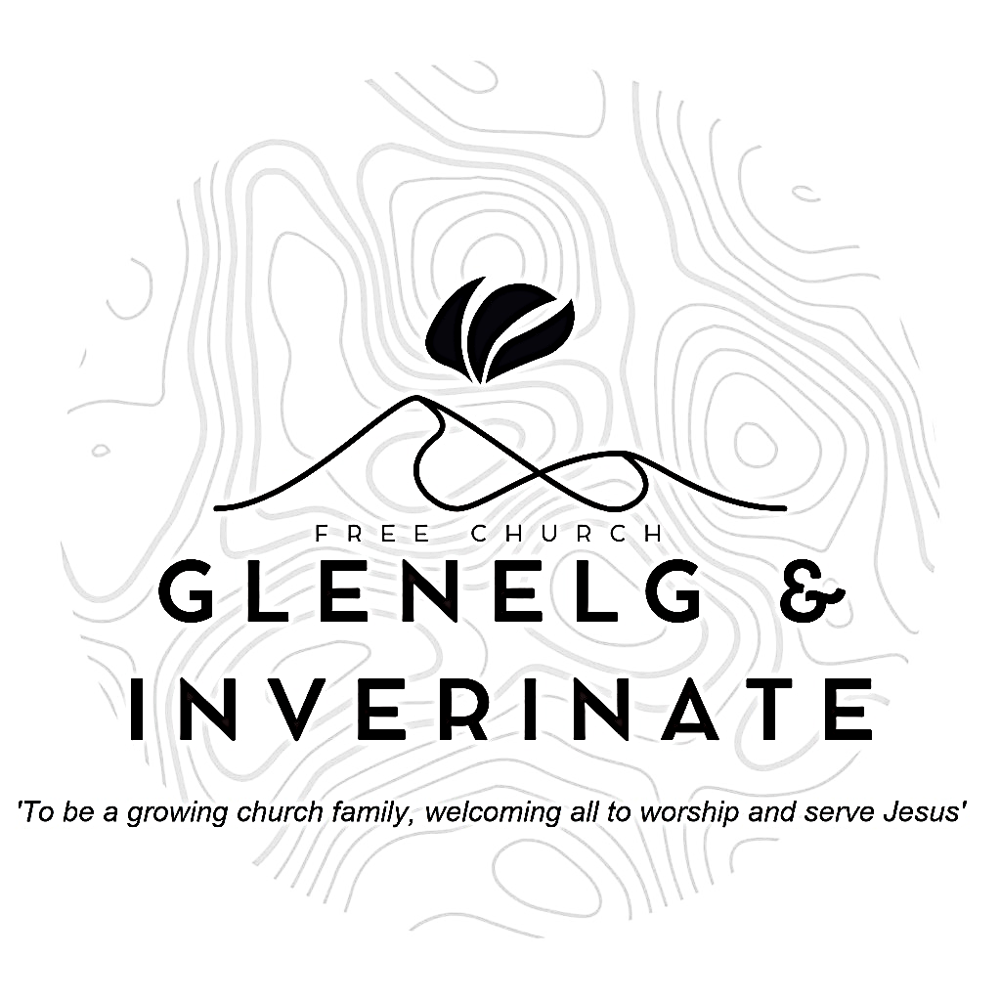

WEEKLY BULLETIN

Sunday 5th October 2025

Service at 12.00 noon in Inverinate Hall

and

6.00pm in Glenelg Church of Scotland

We warmly welcome you to this service of worship and would love you to join us for tea, coffee and refreshment

*Praise the Lord, all you nations; extol him, all you peoples.* *For great is his love toward us, and the faithfulness of the Lord endures forever. Praise the Lord.* ***Psalm 117: 1-2***

**NOTICES**

**•   Today’s Services:** We are delighted to have Rev James Blackwell, leading our 12 noon worship from Luke 13:10-19 for our harvest thanksgiving and communion service. Then from James 2:1-13, Sermon – ‘*Be wary of prejudice’*, this evening in Glenelg. The audio from both services is recorded and are accessible on our website.

* **Praise:**

Sing Psalms 67: 1-7 (page 84) – *God be merciful and bless us*

Hymn – *In Christ alone*

Hymn *– The Lord is King! Lift up your voice.*

Scottish Psalter 72: 16-19 (page 314) – *Of corn an handful in the earth*

* **Sunday School:**Sunday School and JaM Group will run as usual today during our service. There is also a creche for the very little ones.
* **Harvest Thanksgiving Lunch:** We hope you can stay and enjoy a “soup and pudding” lunch and time of fellowship following today’s service.
* **Next Sunday 12th October:** Rev James Blackwell will lead us in worship at the 12.00 noon Service at Inverinate Hall and our 6.00pm service in Glenelg
* **Retiring Collection:** There is a retiring collection for the Lochalsh Foodbank today, please give generously to this good cause if you are able.
* **Membership:** Following on from our mini-series on the church, if anyone has a desire to become a member or simply to ask what is entailed please get in touch with James or any of the elders and we would be delighted to chat about it.
* **Church Prayer Meeting:** Please remember that our Church Prayer Meeting is now held every Sunday at 11.15am before the Sunday Service. So please do come along and join us in prayer to our Heavenly Father.
* **Music and Worship Team:** We are looking at developing our music and worship team, if anyone would like to get involved please speak to one of the elders.
* **Glenelg Church Maintenance:**  The Glenelg Church of Scotland building is currently undergoing some maintenance to its pathway, as a result the surface may be more uneven than usual until works can be completed. Those who are attending the evening services are advised to take extra care when entering and leaving the building especially as it gets darker.
* **Wednesday Bible Studies:** Our Glenelg Study Group are meeting in Jon and Megan MacDonald's home at 7.30pm this Wednesday.We are continuing our study on the book of Proverbs. Our Dornie group meets at Colin and Vivienne MacKenzie’s home at 7.30pm. All are warmly invited to either meeting.
* **Online Studies:**Our Ladies Study Group are continuing their Two-Year Bible Read Through study. Our Men's Study Group are continuing their study on the Shorter Catechism. It's always a great time to join up so if you are interested in joining either group please speak to Moira, Barbara or Colin.
* **COOL Secretary and Treasurer:** COOL are currently looking to fill these two positions within their Management Committee:

**Secretary Job Description:** Acts as Secretary to the Management Committee, taking minutes at five meetings per year and handling key admin tasks. Liaises with Scripture Union, OSCR, and other agencies to help keep COOL compliant with regulations. Supports the smooth running of COOL and must join the Management Committee and thus, agree to COOL’s Statement of Faith.

**Treasurer Job Description:** Manages COOL’s simple finances, tracking donations and payments using Excel and monthly bank statements. Handles budgets, Gift Aid claims, and prepares regular financial updates for Trustees and the Management Committee. Sends donors an annual summary of their donations and Gift Aid reclaimed. Keeps records in order for annual reporting and external examination.

If this is something you feel able to take on, please contact Colin MacDonald on [colinmacdonald950@btinternet.com](mailto:colinmacdonald950@btinternet.com) for further details.

* **COOL Resource Library:** Attendees of the Enrich conference back in March may remember me saying there were plans in the works to create a resource library on the COOL website with materials that can help with the children and youth work they are already doing. This Resource Library is now live!

The link for the resource library is below:

<https://coolscotland.org.uk/resources/>​  
Thank you for your patience and happy planning.

* **In a Big Country Dingwall Conference** – Saturday 1st November Everyone is welcome to join us! No matter where you live or go to church. Our Keynote speaker is Rev. Thomas Davis, who will be speaking on “Creating Good Culture in the Rural Church”. We will have lunch, fellowship, seminars and time for discussion. It promises to be a fantastic day at Dingwall Free Church. Please see the attached slide and poster for promoting to churches. ETS students can attend for free; however, please email admin@centreforruralministry.org to secure a spot. Tickets can be purchased from https://www.eventbrite.com/e/in-a-big-country-dingwall-conferencetickets-1476674766979?aff=oddtdtcreator