- Church Income: Please see the graph below which shows our congregational income for the year to date. Our income is steady and we are thankful for that, but as you can see we are still slightly short of the target of becoming a self financing congregation. We would ask that you prayerfully consider your giving to the work of providing a full time ministry here in our community.
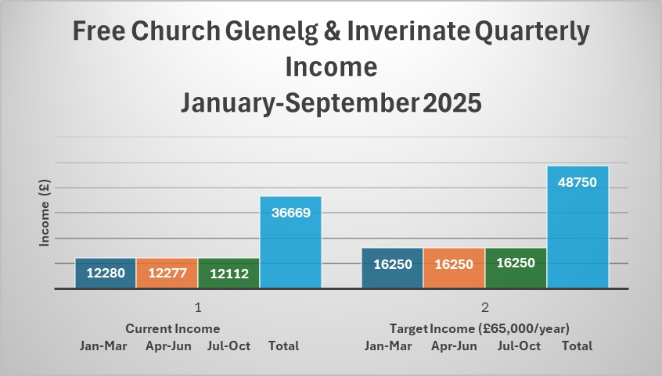

Minister: Rev. James Blackwell 07596 299970
01599 537223
Elders: Ken MacDonald 07895 678496
Colin MacDonald 01599 522719
Finlay MacDonald 07445 646444
Finance Committee: Donnie Lamont
Ronnie Lamont
Moira Lane
Craig Scobie 07502 485998
Safeguarding Co-ordinators: Barbara MacDonald 01599 522719
Moira Lane 01599 522709

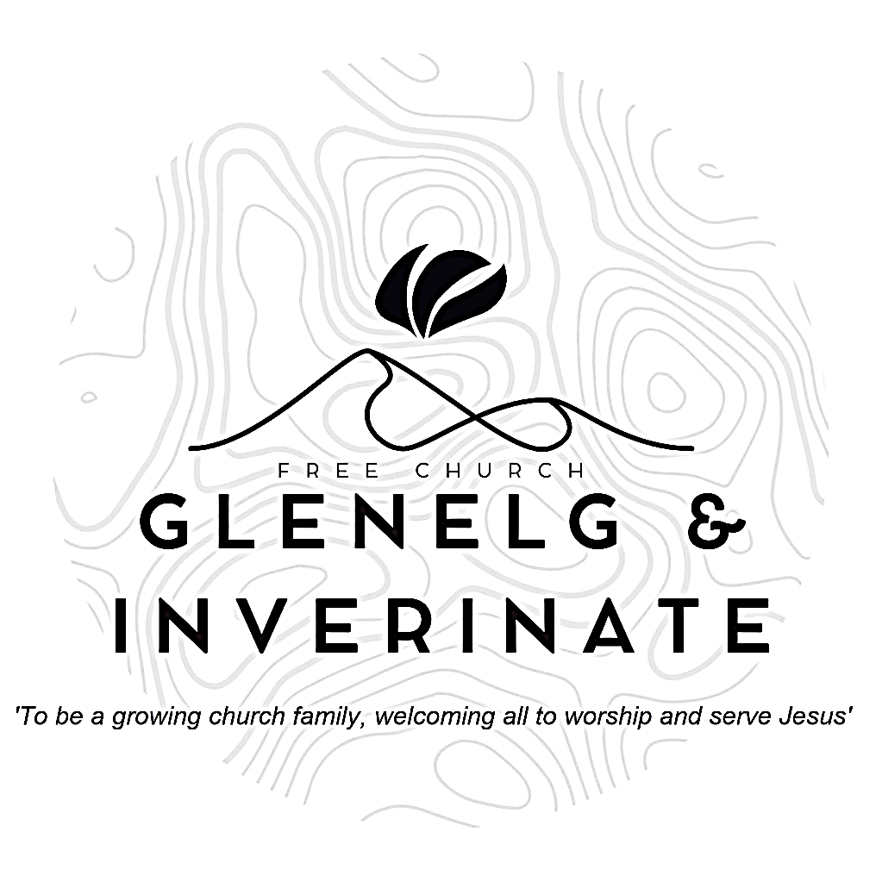

WEEKLY BULLETIN
Sunday 26th October 2025
Service at 12.00 noon in Inverinate Hall
and
6.00pm in Glenelg Church of Scotland

We warmly welcome you to this service of worship and would love you to join us for tea, coffee and refreshment

You, God, are my God, earnestly I seek you; I thirst for you, my whole being longs for you, in a dry and parched land where there is no water. I have seen you in the sanctuary and beheld your power and your glory. Psalm 63:1-2

NOTICES

• Today’s Services: We are delighted to have Rev James Blackwell, leading our 12 noon worship from Matthew 5:1-9, Sermon – ‘The Kingdom’s ethics – part 1’. Then from James 2:14-16, Sermon – ‘Can such faith save?’, this evening in Glenelg. The audio from both services is recorded and are accessible on our website.
- Praise:
Hymn – Christ the Lord is Risen Today
Sing Psalms 119(11): 81-88 (page 162) – My soul for your salvation yearns…..
Sing Psalms 85: 4-13 (page 113) – God our Saviour, now restore us
Hymn – Rock of Ages
- Sunday School: There will be no Sunday School this week due to school holidays. The JaM Group will be in with us for the whole service today. There is creche for the very little ones.
- Retiring Collection: The retiring collection for the Lochalsh Foodbank raised a total of £270. Many thanks to all who donated so generously to this worthy local cause.
- Finance Committee Meeting: The Finance Committee is due to meet on Monday 27th October at 7.30pm. If you have any items that you would like to add to the agenda, please let Craig Scobie know.
- Next Sunday 2nd November: Rev James Blackwell will lead us in worship at the 12.00 noon Service at Inverinate Hall and our 6.00pm service in Glenelg.
- Membership: Following on from our mini-series on the church, if anyone has a desire to become a member or simply to ask what is entailed please get in touch with James or any of the elders and we would be delighted to chat about it.
- Church Prayer Meeting: Please remember that our Church Prayer Meeting is now held every Sunday at 11.15am before the Sunday Service. So please do come along and join us in prayer to our Heavenly Father.
- Music and Worship Team: We are looking at developing our music and worship team, if anyone would like to get involved please speak to one of the elders.
- Wednesday Bible Studies: Our Glenelg Study Group are meeting at 7.30pm this Wednesday. We are continuing our study on the book of Proverbs. Our Dornie group meets at Colin and Vivienne MacKenzie’s home at 7.30pm. All are warmly invited to either meeting.
- Online Studies: Our Ladies Study Group are continuing their Two-Year Bible Read Through study. Our Men's Study Group are continuing their study on the Shorter Catechism. It's always a great time to join up so if you are interested in joining either group please speak to Moira, Barbara or Colin.

- Dates for the Diary: Please note the following dates for upcoming events.
Wednesday 5th November - COOL Area Prayer Meeting - Glenelg Church of Scotland at 7.00pm. Please make every effort to come along and join us an update on the work of COOL and a time of prayer for our young people and our schools. Everyone is warmly invited.
Sunday 9th November - Remembrance Day Service - Glenelg War Memorial at 2.00pm. We are invited to attend a short service or Remembrance at the War Memorial in Glenelg. James will be leading the service this year.
Wednesday 12th November - Faith Mission Service and Book Stall - Glenelg Hall at 7.30pm. Jeff Townend will be coming over to lead us in worship and tell us about the work of the Faith Mission this year. There will be the usual sale of Christmas cards, calendars and books. All are warmly invited and encouraged to attend.
- Kirk Session Report: Following our meeting last Tuesday the Kirk Session made the following decisions -
  - The Kirk Session discussed the Glenelg Church building and site.
  - Mother & Toddler Group - We agreed that the congregation would offer to provide a week's worth of dinners for families of mums who have just given birth, as a blessing from the church. Also we requested that the Finance Committee consider that we would purchase a small gift and Christian book for the children attending the Mother & Toddler Christmas Party.
  - We have requested the Finance Committee to consider the purchase of an Advent Devotional and encourage the whole congregation to read and study it together over the advent period.
  - We will hold a Communion Service on Saturday 6th and Sunday 7th December. James will conduct all services.
  - We are hoping to hold a 'Back to Church Sunday Service' on Sunday 18th January - more details to follow closer to the time.
  - Rev Alasdair Macleod, Moderator of the Free Church, will preach for us on Sunday 25th January.

