Praying for One Another: Please add the following points to your prayer diaries:
Knox Church Perth: Give thanks for the faithful ministry of Rev. Paul Gibson to Knox Church, and for his wife Debbie, please pray that the Lord would greatly bless Paul’s new ministry in the USA. Pray that the congregation would know the Lord’s guidance and unity during this time of vacancy, and that wisdom would be granted as they continue to witness the Gospel in Perth.
Centre for Rural Ministry: Please do pray for great wisdom as we work alongside congregations to discern where God is leading them and to encourage the people in each place to trust God for great things. Give thanks for an encouraging time at the first of our three ‘In a Big Country’ conferences. This was in Thurso and was a tremendous time. Just over 30 came and there was lively discussion. We believe it was a real encouragement to the representatives from various congregations and denominations in Caithness and Orkney. In October we have In a Big Country- Argyll and in November In a Big Country- Dingwall. Please pray that God would bless these gatherings and use them to build up and strengthen His Church.
Sashko, Poland: For the Children and Teens: Please pray that the gospel seeds planted during VBS and teen camp would take root and grow in young people's hearts. For Follow-up Opportunities: Pray that God would open doors for ongoing relationships with the families we connected with during VBS, particularly the parents who heard the gospel presentation.
Asian Outreach: Give thanks for continued good relations with the Muslim group and pray that God’s word would have a transforming impact in their lives.

Minister: Rev. James Blackwell 07596 299970
01599 537223
Elders: Ken MacDonald 07895 678496
Colin MacDonald 01599 522719
Finlay MacDonald 07445 646444
Finance Committee: Donnie Lamont
Ronnie Lamont
Moira Lane
Craig Scobie
Safeguarding Co-ordinators: Barbara MacDonald 01599 522719
Moira Lane 01599 522709

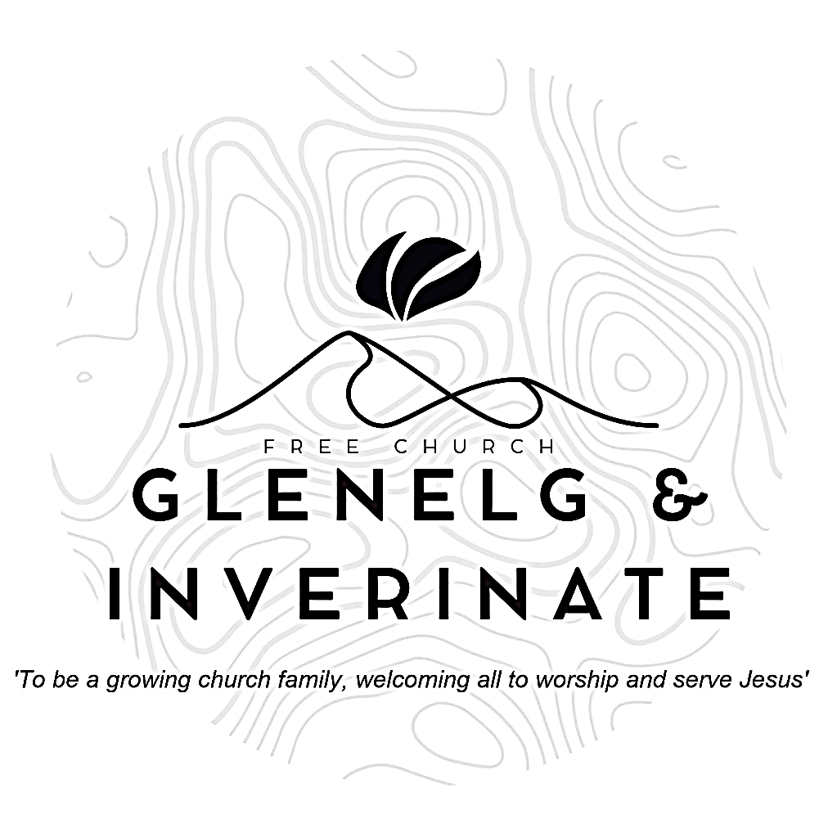

WEEKLY BULLETIN
Sunday 19th October 2025
Service at 12.00 noon in Inverinate Hall
and
6.00pm in Glenelg Church of Scotland

We warmly welcome you to this service of worship and would love you to join us for tea, coffee and refreshment

Therefore, since we are receiving a kingdom that cannot be shaken, let us be thankful, and so worship God acceptably with reverence and awe, for our God is a consuming fire. Hebrews 12:28-29

NOTICES

• Today’s Services: We are delighted to have Iain Alasdair Macdonald, an elder from Greyfriars in Inverness leading our 12 noon worship from Titus 2: 13-14, Sermon – ‘Great Saviour’. Then from Hebrews 12:2, Sermon – ‘Seated Saviour’, this evening in Glenelg. The audio from both services is recorded and are accessible on our website.
- Praise:
Sing Psalms 27: 1-4 (page 31) – The Lord’s my saviour and my light
Hymn – To God be the glory. (See separate sheet)
Sing Psalms 110: 1-7 (page 149) – The Lord said to my Lord
Hymn – How deep the fathers love for us (See separate sheet)
- Sunday School: There will be no Sunday School this week due to school holidays but JaM Group will run as usual today during our service. There is also a creche for the very little ones.
- Retiring Collection: The retiring collection for the Lochalsh Foodbank is being continued this Sunday, please give generously to this good cause if you are able.
- Next Sunday 26th October: Rev James Blackwell will lead us in worship at the 12.00 noon Service at Inverinate Hall and our 6.00pm service in Glenelg
- Membership: Following on from our mini-series on the church, if anyone has a desire to become a member or simply to ask what is entailed please get in touch with James or any of the elders and we would be delighted to chat about it.
- Church Prayer Meeting: Please remember that our Church Prayer Meeting is now held every Sunday at 11.15am before the Sunday Service. So please do come along and join us in prayer to our Heavenly Father.
- Music and Worship Team: We are looking at developing our music and worship team, if anyone would like to get involved please speak to one of the elders.
- Kirk Session Meeting: The Kirk Session is due to meet on Tuesday 21st October at 7.30pm at Ardelve Manse. If you have any items that you would like to add to the agenda, please let Colin MacDonald know.
- Glenelg Church Maintenance: The Glenelg Church of Scotland building is currently undergoing some maintenance to its pathway, as a result the surface may be more uneven than usual until works can be completed. Those who are attending the evening services are advised to take extra care when entering and leaving the building especially as it gets darker.
- Wednesday Bible Studies: Our Glenelg Study Group are meeting in Jon and Megan MacDonald's home at 7.30pm this Wednesday. We are continuing our study on the book of Proverbs. Our Dornie group meets at Colin and Vivienne MacKenzie’s home at 7.30pm. All are warmly invited to either meeting.

- Online Studies: Our Ladies Study Group are continuing their Two-Year Bible Read Through study. Our Men's Study Group are continuing their study on the Shorter Catechism. It's always a great time to join up so if you are interested in joining either group please speak to Moira, Barbara or Colin.
- COOL Secretary and Treasurer: COOL are currently looking to fill these two positions within their Management Committee:
Secretary Job Description: Acts as Secretary to the Management Committee, taking minutes at five meetings per year and handling key admin tasks. Liaises with Scripture Union, OSCR, and other agencies to help keep COOL compliant with regulations. Supports the smooth running of COOL and must join the Management Committee and thus, agree to COOL’s Statement of Faith.
Treasurer Job Description: Manages COOL’s simple finances, tracking donations and payments using Excel and monthly bank statements. Handles budgets, Gift Aid claims, and prepares regular financial updates for Trustees and the Management Committee. Sends donors an annual summary of their donations and Gift Aid reclaimed. Keeps records in order for annual reporting and external examination.
If this is something you feel able to take on, please contact Colin MacDonald on colinmacdonald950@btinternet.com for further details.
- COOL Resource Library: Attendees of the Enrich conference back in March may remember me saying there were plans in the works to create a resource library on the COOL website with materials that can help with the children and youth work they are already doing. This Resource Library is now live!
The link for the resource library is below:
https://coolscotland.org.uk/resources/​
Thank you for your patience and happy planning.
- In a Big Country Dingwall Conference – Saturday 1st November Everyone is welcome to join us! No matter where you live or go to church. Our Keynote speaker is Rev. Thomas Davis, who will be speaking on “Creating Good Culture in the Rural Church”. We will have lunch, fellowship, seminars and time for discussion. It promises to be a fantastic day at Dingwall Free Church. Please see the attached slide and poster for promoting to churches. ETS students can attend for free; however, please email admin@centreforruralministry.org to secure a spot. Tickets can be purchased from https://www.eventbrite.com/e/in-a-big-country-dingwall-conferencetickets-1476674766979?aff=oddtdtcreator
.

