**Praying for One Another:** Please add the following points to your prayer diaries:

**North Harris:** Please pray for the Rooted Youth Group (S1-S6) which takes place the first Sunday of each Month It’s our prayer that the young ones would be rooted in God’s word, and as it says in Colossians 2:7, we pray this would be the truth of our youth in North Harris. Please join us in praying for each of our young people. Please pray that we would continue to grow as a church at the heart of our community, where we see and meet the needs of the community, through living out the gospel. Please pray that as we seek to do this, the Lord would provide opportunity for us to witness to those around us.

**Biblical Revitalisation:** Please pray for the Biblical Revitalisation in Hard Places seminars taking place today in Glasgow, Friday in Dornoch, and Saturday in Portree. Please pray that these sessions would equip and encourage those serving in challenging ministry contexts for sustained gospel ministry. Please do pray for wisdom for Brian Croft and Matthew Spandler-Davison from Practical Shepherding who will be speaking, and that these sessions would be of great blessing to the wider church.

**Osamu and Mairi, Japan:** Praise God that Mrs. T who has been coming to our service over the last 2 years is to be baptized on 5th. Pray that she would grow in knowledge and grace of the Lord Jesus. She is very active 82 years old. Thank you for your prayers for her. Our daughter, Naomi and her husband, Matthew with 4 children, Daisy, Caleb,  
Micah and Ezra come to Japan to live on 15th from Glasgow. Pray for God’s undertaking and protection for the family as they take this huge step of faith.

**Dumisani:** Pray for the blessing of the Lord to be with lecturers David Galletta and Marten Boersema for Term Four at Dumisani Institute in the Eastern Cape, SA which begins on September 29th. We thank the Lord for these two brothers serving at this time at Dumisani and their commitment to do such.In November plans are being made for a special Dumisani Day. Please pray for the staff as they make plans for this special opportunity to advance the Lord's work and reach out to the communities.

Minister: Rev. James Blackwell 07596 299970

01599 537223

Elders: Ken MacDonald 07895 678496

Colin MacDonald 01599 522719

Finlay MacDonald 07445 646444

Finance Committee: Donnie Lamont

Ronnie Lamont

Moira Lane

Craig Scobie

Safeguarding Co-ordinators: Barbara MacDonald 01599 522719

Moira Lane 01599 522709

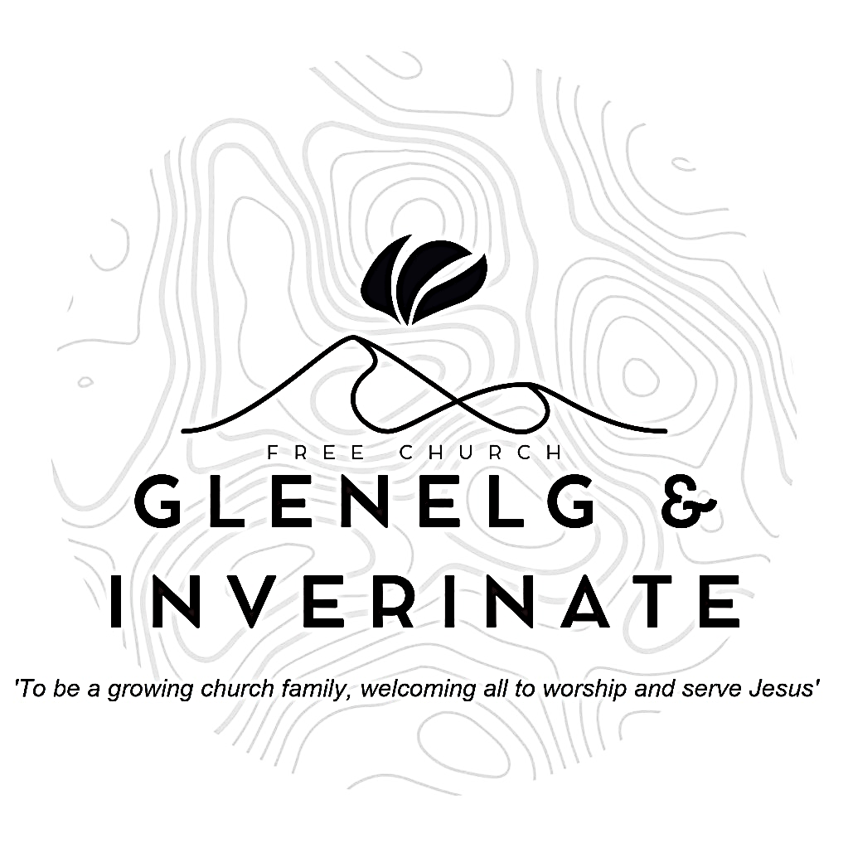

WEEKLY BULLETIN

Sunday 12th October 2025

Service at 12.00 noon in Inverinate Hall

and

6.00pm in Glenelg Church of Scotland

We warmly welcome you to this service of worship and would love you to join us for tea, coffee and refreshment

*All your works praise you, Lord; your faithful people extol you. They tell of the glory of your kingdom and speak of your might, so that all people may know of your mighty acts and the glorious splendour of your kingdom.*

***Psalm 145: 10-12***

**NOTICES**

**•   Today’s Services:** We are delighted to have Rev James Blackwell, leading our 12 noon worship from Matthew 4:23-5:2, Sermon – ‘The King Shines’. Then from James 2:1-13, Sermon – ‘*Be wary of prejudice’*, this evening in Glenelg. The audio from both services is recorded and are accessible on our website.

* **Praise:**

Hymn *– The Lord is King! Lift up your voice.*

Sing Psalms 2: 1-7 (page 2) – *Why do the heathen nations rage?*

Scottish Psalter 119(10): 73-80 (page 406) – *Thou mad’st and fashion’dst me*

Hymn – *In Christ alone*

* **Sunday School:**Sunday School and JaM Group will run as usual today during our service. There is also a creche for the very little ones.
* **Next Sunday 19th October: Iain Alasdair?** will lead us in worship at the 12.00 noon Service at Inverinate Hall and our 6.00pm service in Glenelg
* **Membership:** Following on from our mini-series on the church, if anyone has a desire to become a member or simply to ask what is entailed please get in touch with James or any of the elders and we would be delighted to chat about it.
* **Church Prayer Meeting:** Please remember that our Church Prayer Meeting is now held every Sunday at 11.15am before the Sunday Service. So please do come along and join us in prayer to our Heavenly Father.
* **Music and Worship Team:** We are looking at developing our music and worship team, if anyone would like to get involved please speak to one of the elders.
* **Glenelg Church Maintenance:**  The Glenelg Church of Scotland building is currently undergoing some maintenance to its pathway, as a result the surface may be more uneven than usual until works can be completed. Those who are attending the evening services are advised to take extra care when entering and leaving the building especially as it gets darker.
* **Wednesday Bible Studies:** Our Glenelg Study Group are meeting in Jon and Megan MacDonald's home at 7.30pm this Wednesday.We are continuing our study on the book of Proverbs. Our Dornie group meets at Colin and Vivienne MacKenzie’s home at 7.30pm. All are warmly invited to either meeting.
* **Online Studies:**Our Ladies Study Group are continuing their Two-Year Bible Read Through study. Our Men's Study Group are continuing their study on the Shorter Catechism. It's always a great time to join up so if you are interested in joining either group please speak to Moira, Barbara or Colin.
* **COOL Secretary and Treasurer:** COOL are currently looking to fill these two positions within their Management Committee:

**Secretary Job Description:** Acts as Secretary to the Management Committee, taking minutes at five meetings per year and handling key admin tasks. Liaises with Scripture Union, OSCR, and other agencies to help keep COOL compliant with regulations. Supports the smooth running of COOL and must join the Management Committee and thus, agree to COOL’s Statement of Faith.

**Treasurer Job Description:** Manages COOL’s simple finances, tracking donations and payments using Excel and monthly bank statements. Handles budgets, Gift Aid claims, and prepares regular financial updates for Trustees and the Management Committee. Sends donors an annual summary of their donations and Gift Aid reclaimed. Keeps records in order for annual reporting and external examination.

If this is something you feel able to take on, please contact Colin MacDonald on [colinmacdonald950@btinternet.com](mailto:colinmacdonald950@btinternet.com) for further details.

* **COOL Resource Library:** Attendees of the Enrich conference back in March may remember me saying there were plans in the works to create a resource library on the COOL website with materials that can help with the children and youth work they are already doing. This Resource Library is now live!

The link for the resource library is below:

<https://coolscotland.org.uk/resources/>​  
Thank you for your patience and happy planning.

* **In a Big Country Dingwall Conference** – Saturday 1st November Everyone is welcome to join us! No matter where you live or go to church. Our Keynote speaker is Rev. Thomas Davis, who will be speaking on “Creating Good Culture in the Rural Church”. We will have lunch, fellowship, seminars and time for discussion. It promises to be a fantastic day at Dingwall Free Church. Please see the attached slide and poster for promoting to churches. ETS students can attend for free; however, please email admin@centreforruralministry.org to secure a spot. Tickets can be purchased from https://www.eventbrite.com/e/in-a-big-country-dingwall-conferencetickets-1476674766979?aff=oddtdtcreator