**Praying for One Another:** Please add the following points to your prayer diaries:

**Matt and Maria, Greece:**Please pray that everyone we have shared Sofia's testimony with would take it seriously and recognise God's intervention. Please pray for the university outreach going forward, and for our ability to share clearly and gracefully.

Please pray for a smooth transition and the building up of good relationships with colleagues and students in our language teaching, and opportunities to share the Gospel.

**Sleat and Strath:** Susan Maclean (Presbytery Administrator) organises all Supply for vacant congregations in the Presbytery, which is a tremendous blessing and benefit to Interim Moderators. Give thanks for Susan and the work she does. Pray for the Presbytery Strategy Team as they support the witness and vision of the congregation going forward. Pray that the Lord will stir up the Team and the congregation and send us out in the power of the Spirit.

**Healthy Gospel Church: Prayer:** Pray for the Healthy Gospel Church Prayer Gatherings taking place in Portree, Plockton and Kyle, and Aultbae this week. Pray that as a Church, we would see God at work among us, and at work in this nation, so that many people hear and respond to the good news of the gospel of Jesus Christ.

**Central Office:** Please pray for the right candidate for the role of Finance Manager in the Central Office. Pray that God’s hand will be in the process, from the application through to the interviews, and that the right person would be appointed.

Minister: Rev. James Blackwell 07596 299970

01599 537223

Elders: Ken MacDonald 07895 678496

Colin MacDonald 01599 522719

Finlay MacDonald 07445 646444

Finance Committee: Donnie Lamont

Ronnie Lamont

Moira Lane

Craig Scobie

Safeguarding Co-ordinators: Barbara MacDonald 01599 522719

Moira Lane 01599 522709

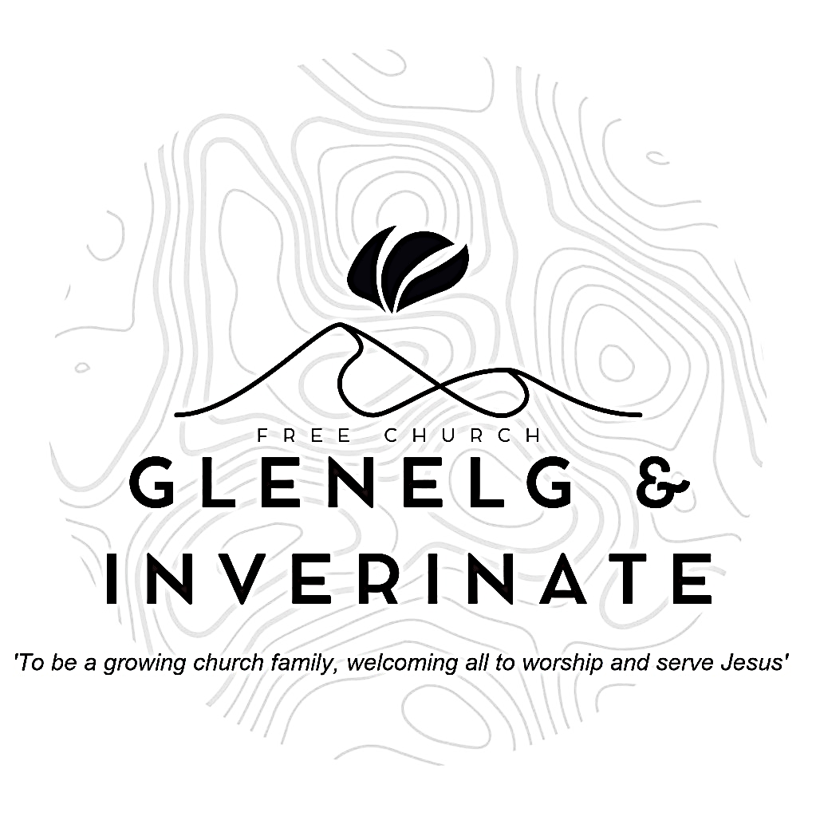

WEEKLY BULLETIN

Sunday 21st September 2025

Service at 12.00 noon in Inverinate Hall

and

6.00pm in Glenelg Church of Scotland

We warmly welcome you to this service of worship and would love you to join us for tea, coffee and refreshment

*He reached down from on high and took hold of me; he drew me out of deep waters. He rescued me from my powerful enemy, from my foes, who were too strong for me.**They confronted me in the day of my disaster, but the Lord was my support. He brought me out into a spacious place; he rescued me because he delighted in me.* ***Psalm 18: 16-19***

**NOTICES**

**•   Today’s Services:** We are delighted to have Rev James Blackwell, leading our 12 noon worship from Matthew 4:1-11, Sermon – *‘The King is Tested’*. Then from James 1:1-18, Sermon – ‘*Joy in Trials?’*, this evening in Glenelg. The audio from both services is recorded and are accessible on our website.

* **Praise:**

Hymn – *Be still for the presence of the Lord*

Scottish Psalter 119(8): 57-64 (page 404) – *Thou my sure portion art alone*

Sing Psalms 11: 1-5 (page 13) – *I find my refuge in the Lord*

Hymn *– I heard the voice of Jesus say*

* **Sunday School:**Sunday School and JaM Group will run as usual today during our service. There is also a creche for the very little ones.
* **Next Sunday 28th September:** Rev James Blackwell will lead us in worship at the 12.00 noon Service at Inverinate Hall and our 6.00pm service in Glenelg
* **Boardgames Evening:** There will boardgames in the manse on Friday 26th September at 19:30. Speak to James or Claire if you would like to come.
* **Church Prayer Meeting:** Please remember that our Church Prayer Meeting is now held every Sunday at 11.15am before the Sunday Service. So please do come along and join us in prayer to our Heavenly Father.
* **Slow Cooker Supper and Quiz Fundraiser event!** Join us at the Glenelg and Arnisdale Community Hall on **Saturday 27th September from 18:00-20:00** for a night of delicious food and brain-teasing quizzes. Bring your appetite and your thinking cap for a fun-filled evening with friends and neighbours. We will be raising money for the Glenelg Shop Community Purchase. Ticket cost is £10 / adult and a donation for kids (Cash on the door), booking is essential and you need to reserve your place either online or by calling Colin MacDonald on 01599 522719. There will also be a raffle. Don't miss out on this exciting event that brings the community together for a good cause. See you there!
* **Music and Worship Team:** We are looking at developing our music and worship team, if anyone would like to get involved please speak to one of the elders.
* **Glenelg Church Maintenance:**  The Glenelg Church of Scotland building is currently undergoing some maintenance to its pathway, as a result the surface may be more uneven than usual until works can be completed. Those who are attending the evening services are advised to take extra care when entering and leaving the building especially as it gets darker.
* **Harvest Thanksgiving and Communion:** We will be celebrating our annual Harvest Thanksgiving along with our Communion Service on **Sunday 5th October**. Please invite anyone you feel may be interested in coming. Invite cards are available. There will be a church lunch after the service.
* **Membership:** Following on from our mini-series on the church, if anyone has a desire to become a member or simply to ask what is entailed please get in touch with James or any of the elders and we would be delighted to chat about it.
* **Wednesday Bible Studies:** Our Glenelg Study Group are meeting in Jon and Megan MacDonald's home at 7.30pm this Wednesday.Our Dornie group meets at Colin and Vivienne MacKenzie’s home at 7.30pm. All are warmly invited to either meeting.
* **Online Studies:**Our Ladies Study Group are continuing their Two-Year Bible Read Through study. Our Men's Study Group are continuing their study on the Shorter Catechism. It's always a great time to join up so if you are interested in joining either group please speak to Moira, Barbara or Colin.
* 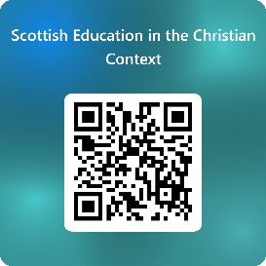**Scottish Education in the Christian Context survey:** A survey has been commissioned by the Christian Education working group from the Free Church of Scotland to gather views, insights, and ideas for Christian Education in Scotland from a wide range of Christians across the country. The Group was established by the Free Church General Assembly in May 2024 and is chaired by Rev Allan Shearer. In the past year, the Group assisted the Public Engagement Group with the response to the Consultation on Removing Religious Observance in Schools. Answers from the survey, Scottish Education in the Christian Context, will help inform the next steps of the working group. Questions include ‘What does Christian Education mean to you? Do you have an opinion on Christian Education?’ The sections enable parents, guardians, and grandparents, those within the teaching profession and church leadership or church worker roles the opportunity to share their insights and experience.

The deadline for the survey is 4th October. Complete the survey at <https://forms.office.com/r/GA9aqnGYQd> or scan the QR code.

* **COOL Resource Library:** Attendees of the Enrich conference back in March may remember me saying there were plans in the works to create a resource library on the COOL website with materials that can help with the children and youth work they are already doing. This Resource Library is now live!

The link for the resource library is below:

<https://coolscotland.org.uk/resources/>​  
Thank you for your patience and happy planning