**Praying for One Another:** Please add the following points to your prayer diaries:

**Stornoway:** We were delighted to welcome 4 new members and pray that God will richly bless them.  As we go forward, please pray that we will continue to see the Lord’s blessing, leading and guiding us in his ways day by day. Pray that the Lord would bless the ministry of His Word, strengthening the congregation in faith, holiness, and witness to Christ in their community.

**Tearfund:** Please pray for the people of Afghanistan, that the Lord would comfort the bereaved, strengthen the injured, and provide for all in need following the recent earthquakes. Pray for Tearfund and its partners, that God would guide and uphold them as they deliver aid, and move many to give generously in support of this work.Pray that God, in His mercy, would grant healing, safety, and hope to communities, through His church, to those devastated by loss and destruction.Pray that the Lord would bless international efforts, giving wisdom to leaders and aid workers as they respond to this crisis.

**Campbeltown:** Pray for the Water of Life cafe taking place today, and every two weeks on a Wednesday, that this would be an opportunity to connect the community with the Church, and would be an opportunity to build up relationships.

Please pray for the house groups as they begin an 8-week Prayer Course, journeying through the Lord’s prayer. Pray that this would deepen our prayer life as we explore the Lord's Prayer as a model for communication with God.

Minister: Rev. James Blackwell 07596 299970

01599 537223

Elders: Ken MacDonald 07895 678496

Colin MacDonald 01599 522719

Finlay MacDonald 07445 646444

Finance Committee: Donnie Lamont

Ronnie Lamont

Moira Lane

Craig Scobie

Safeguarding Co-ordinators: Barbara MacDonald 01599 522719

Moira Lane 01599 522709

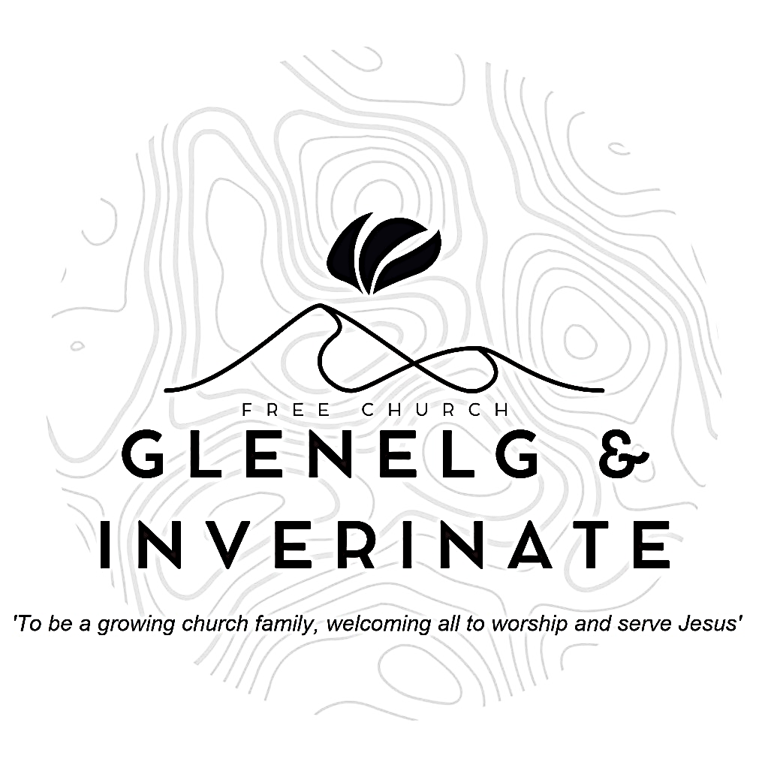

WEEKLY BULLETIN

Sunday 14th September 2025

Service at 12.00 noon in Inverinate Hall

and

6.00pm in Glenelg Church of Scotland

We warmly welcome you to this service of worship and would love you to join us for tea, coffee and refreshment

*I will give thanks to you, Lord, with all my heart; I will tell of all your wonderful deeds. I will be glad and rejoice in you;  I will sing the praises of your name, O Most High.* ***Psalm 9: 1-2***

**NOTICES**

**•   Today’s Services:** We are delighted to have Mr. George Barnie, an elder from Smithton, leading our 12 noon worship from Ruth, chapter 1, Sermon – *‘New Beginnings’*. Then from 1 Kings 3: 1-15, Sermon – ‘*Solomon: The Wise King?’*, this evening in Glenelg. The audio from both services is recorded and are accessible on our website.

* **Praise:**

Scottish Psalter 103: 8-15 (page 369) – *The Lord our God is merciful*

Hymn – *Rock of Ages*

*Hymn – What a Friend We Have in Jesus*

Sing Psalms 145: 1-9 (page 189) – *I will exalt you, O my God and King*

* **Sunday School:**There is no Sunday School or JaM Group this Sunday as it is the half term break, Creche will run as normal.
* **Next Sunday 21st September:** Rev James Blackwell will lead us in worship at the 12.00 noon Service at Inverinate Hall and our 6.00pm service in Glenelg
* **Membership:** Following on from our mini-series on the church, if anyone has a desire to become a member or simply to ask what is entailed please get in touch with James or any of the elders and we would be delighted to chat about it.
* **Wednesday Bible Studies:** Our Glenelg Study Group are meeting in Jon and Megan MacDonald's home at 7.30pm this Wednesday.Our Dornie group meets at Colin and Vivienne MacKenzie’s home at 7.30pm. All are warmly invited to either meeting.
* **Online Studies:**Our Ladies Study Group are continuing their Two-Year Bible Read Through study. Our Men's Study Group are continuing their study on the Shorter Catechism. It's always a great time to join up so if you are interested in joining either group please speak to Moira, Barbara or Colin.
* **Church Prayer Meeting:** Please remember that our Church Prayer Meeting is now held every Sunday at 11.15am before the Sunday Service. So please do come along and join us in prayer to our Heavenly Father.
* **Slow Cooker Supper and Quiz Fundraiser event!** Join us at the Glenelg and Arnisdale Community Hall on **Saturday 27 September from 18:00-20:00** for a night of delicious food and brain-teasing quizzes. Bring your appetite and your thinking cap for a fun-filled evening with friends and neighbours. We will be raising money for the Glenelg Shop Community Purchase.

Ticket cost is £10 / adult and a donation for kids (Cash on the door), booking is essential and you need to reserve your place either online or by calling Colin MacDonald on 01599 522719. There will also be a raffle. Don't miss out on this exciting event that brings the community together for a good cause. See you there!

* 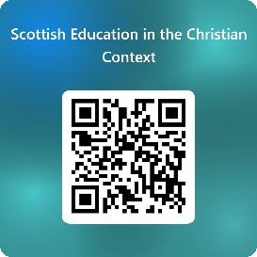**Scottish Education in the Christian Context survey:** A survey has been commissioned by the Christian Education working group from the Free Church of Scotland to gather views, insights, and ideas for Christian Education in Scotland from a wide range of Christians across the country. The Group was established by the Free Church General Assembly in May 2024 and is chaired by Rev Allan Shearer. In the past year, the Group assisted the Public Engagement Group with the response to the Consultation on Removing Religious Observance in Schools. Answers from the survey, Scottish Education in the Christian Context, will help inform the next steps of the working group. Questions include ‘What does Christian Education mean to you? Do you have an opinion on Christian Education?’ The sections enable parents, guardians, and grandparents, those within the teaching profession and church leadership or church worker roles the opportunity to share their insights and experience.

The deadline for the survey is 4th October. Complete the survey at <https://forms.office.com/r/GA9aqnGYQd> or scan the QR code.

* **Invitation to Area Prayer Meeting – A Time of Thanksgiving & Prayer**

The vision of the Free Church of Scotland is for ‘A Healthy Gospel Church for Every Community in Scotland’. We recognise that we are completely dependent on God to bring about this vision.

Therefore, our focus in 2025 is going to be on thanksgiving and prayer. Giving thanks to God for all that he has done among us in the last 5 years and praying for the next 5 years.

We would love for you to join us at an Area Prayer Meeting at Kyle Free Church on **Wednesday 17th September**. It will start at 7.30pm but doors will be open from 7pm with the opportunity for conversation and a cup of tea.

We look forward to joining with you in prayer. In prayer we express our complete dependence on God.  And we join together in prayer asking that we might indeed see A Healthy Gospel Church for Every Community in Scotland.

To find out more, go to: freechurch.org/hgc-area-prayer-meetings

* **COOL Resource Library:** Attendees of the Enrich conference back in March may remember me saying there were plans in the works to create a resource library on the COOL website with materials that can help with the children and youth work they are already doing. This Resource Library is now live!

The link for the resource library is below:

<https://coolscotland.org.uk/resources/>​  
Thank you for your patience and happy planning