**FATHER GOD I WONDER**

Father God I wonder,   
how I managed to exist  
without the knowledge   
of Your parenthood,  
and Your loving care.  
But now I am Your child,   
I am adopted in Your family  
and I can never be alone   
'cause, Father God   
You're there beside me.  
  
I will sing Your praises  
I will sing Your praises,  
I will sing Your praises for evermore  
I will sing your praises  
I will sing your praises,  
I will sing your praises for evermore.

(CCLI No 58202)

Minister: Rev. James Blackwell 07596 299970

01599 537223

Elders: Ken MacDonald 07895 678496

Colin MacDonald 01599 522719

Finlay MacDonald 07445 646444

Finance Committee: Donnie Lamont

Ronnie Lamont

Moira Lane

Craig Scobie

Safeguarding Co-ordinators: Barbara MacDonald 01599 522719

Moira Lane 01599 522709

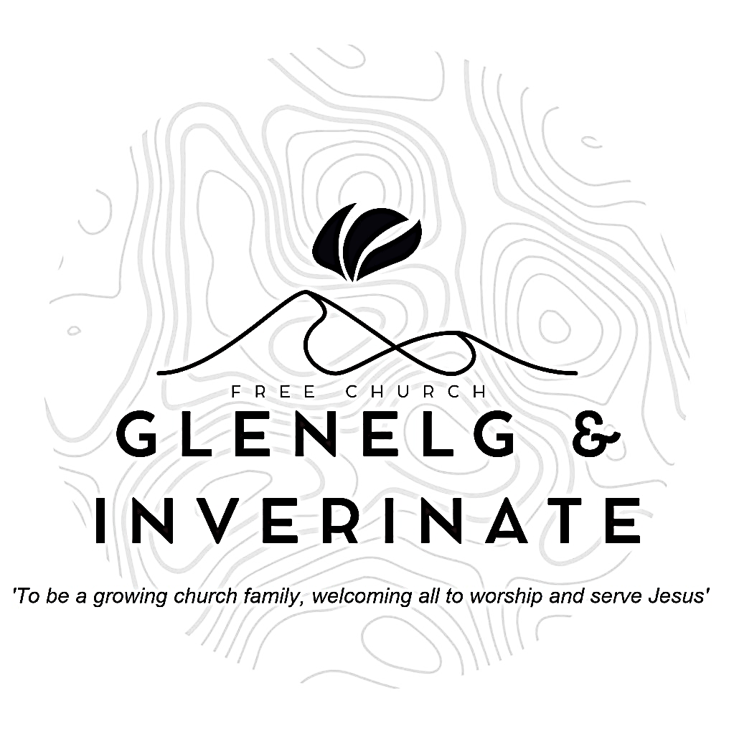

WEEKLY BULLETIN

Sunday 3rd August 2025

Service at 12.00 noon in

Chocolates of Glenshiel Cafe

and

6.00pm in Glenelg Church of Scotland

We warmly welcome you to this service of worship and would love you to join us for tea, coffee and refreshment

*Surely God is my salvation; I will trust and not be afraid.  
The Lord, the Lord himself, is my strength and my defence; he has become my salvation.” With joy you will draw water from the wells of salvation.* ***Isaiah 12:2-3***

**NOTICES**

**•   Today’s Services: Today’s Services:**We are delighted to have Rev James Blackwell, leading our 12 noon worship from Matthew 1:18-25, Sermon – *‘The King is Born’*. Then from Amos 7:1-17, Sermon – ‘*What the Sovereign Lord showed me’*, this evening in Glenelg. The audio from both services is recorded and are accessible on our website.

* **Praise:**

Sing Psalms 8:1-9 (page 7) – *In all the earth, O Lord our Lord*

Sing Psalms 127:1-5 (page 171) – *Unless the Lord builds up the house*

Hymn – *Father God I wonder* – see back page

* **Sunday School:**The JaM Group and Sunday School are taking a break for the School Holidays. There will be crèche for the very little ones.
* **Wednesday Bible Studies:** Glenelg and Dornie Bible studies will restart this Wednesday 6th August.
* **Communion Weekend:** We plan to celebrate the Sacrament of Holy Communion as a church family next weekend. Rev James Blackwell  will lead all of the services
  + **Saturday 9th August:** Evening Service in Chocolates of Glenshiel Café at 7.30pm.
  + **Sunday 10th August:** 12 noon Communion Service in Dornie Hall and 6.00pm Evening Service in Glenelg church.
* **Membership:** Following on from our mini-series on the church, if anyone has a desire to become a member or simply to ask what is entailed please get in touch with James or any of the elders and we would be delighted to chat about it.
* **Kyleakin Meeting:** A fellowship is planned for Sunday 10th August in Kyleakin Church of Scotland Hall at 6:30pm at which Morag Macleod will give an update on her work and on her recent cancer treatment.
* **Kirk Session Meeting:** The Kirk Session are due to meet on Monday 11th August at 7.30pm in Ardelve Manse. If you would like to raise anything for discussion at that meeting please speak to James, Ken, Finlay or Colin and we will put it on the agenda.
* **Sunday Services in August**:  The Estate have informed us that they plan to extend their visit until 23rd August. This means that Inverinate Hall will be out of commission for the next few weeks. Details of our Sunday services are given below -
  + Sunday 17th August - 12noon Service - 'Venue to be arranged'

6.00pm Service in Glenelg church

* + Sunday 24th August - 12 noon Service in Inverinate Hall - Evening: *'Back to School with God*' Community Service in Kyleakin Hall
* **Date for Your Diary:** The next Psalms and Sausages is currently scheduled for the 23rd August. Further details to be announced**.**
* **Hope Explored:** We hope to run a short course called Hope Explored in September. This is a three-session series looking the life, death, and resurrection of Jesus that examines his extraordinary claims and offers a hope worth having a hope that won't disappoint us. If you are interested in taking part or bringing a friend, please let us know so we can order enough materials. Thanks.
* **Church Prayer Meeting:** Please remember that our Church Prayer Meeting is now held every Sunday at 11.15am before the Sunday Service. Prayer is the engine room of the church and this is a wonderful opportunity every Sunday to come together as brothers and sisters in Christ and pray together. So please do come along and join us in prayer to our Heavenly Father.
* **Online Studies:**Our Ladies Study Group are continuing their Two-Year Bible Read Through study. Our Men's Study Group are continuing their study on the Shorter Catechism. It's always a great time to join up so if you are interested in joining either group please speak to Moira, Barbara or Colin.
* **Volunteers:** An opportunity has arisen to bless the Dornie community by adopting the local Playgroup. The cost would be small to us and the Finance Committee are willing to fund it but before we can commit we need a few volunteers to help run it. It runs on Monday mornings 10-12 in the Dornie hall. If you would like more information speak to Claire. Thanks
* **Heating Oil Scheme:** Argyle Energy have historically offered a preferential rate on heating oil for church buildings and manses. Recently they have expanded this scheme to include the personal residences of the congregation and the churches wider community. Anyone that is interested in joining can send an email asking for an application form to [claire@argyleuk.com](mailto:claire@argyleuk.com) or telephone Hugh or Claire on 07760 446262 to request an application form.
* **Praying for One Another:** Please add the following points to your prayer diaries:

**Asian Outreach:** Please pray for H, that his interest in Christ would be more than curiosity, that he would read the Scriptures and find salvation in Messiah Jesus. Please pray for other conversations with Muslim friends – for wisdom, boldness, sensitivity and grace in commending the message of Christ

**Fortrose**: Please pray for the holiday club taking place this week. Please pray that all of the children coming along would engage, have fun, and most importantly hear the gospel. Pray for all of the leaders running the club, for wisdom and energy.

Please pray thatconnections with those in the community would grow, and that God would provide opportunity to witness and share the gospel with those who do not know Him. Pray particularly for connections with families made through the holiday club, that the Lord would grow these and use these for His glory.

**Central Office:** Pray for God to prepare and provide the right people for the Finance Manager and Property Officer in roles within the central office. Please pray for God’s wisdom and guidance.