**COOL Update**

* **COOL Prayer Meeting Zoom:** Thursday 21st August 7.30pm - 8.30pm Prayer meeting on Zoom hosted by COOL praying for our local schools, ahead of them going back for the term. Speak to Heather if you are keen to come and she will make sure you get the details.
* **COOL Resource Library:** Attendees of the Enrich conference back in March may remember me saying there were plans in the works to create a resource library on the COOL website with materials that can help with the children and youth work they are already doing.

You will be glad to know that the Resource Library is now live!

Apologies for how long it has taken to get this out to you, but I really hope this link can help with planning and preparing for the year ahead. I'm hoping to keep updating this link as and when I find new resources that I think would be beneficial, so keep checking back on the link to find different resources. The link for the resource library is below:

<https://coolscotland.org.uk/resources/>​

Thank you for your patience and happy planning

Minister: Rev. James Blackwell 07596 299970

01599 537223

Elders: Ken MacDonald 07895 678496

Colin MacDonald 01599 522719

Finlay MacDonald 07445 646444

Finance Committee: Donnie Lamont

Ronnie Lamont

Moira Lane

Craig Scobie

Safeguarding Co-ordinators: Barbara MacDonald 01599 522719

Moira Lane 01599 522709

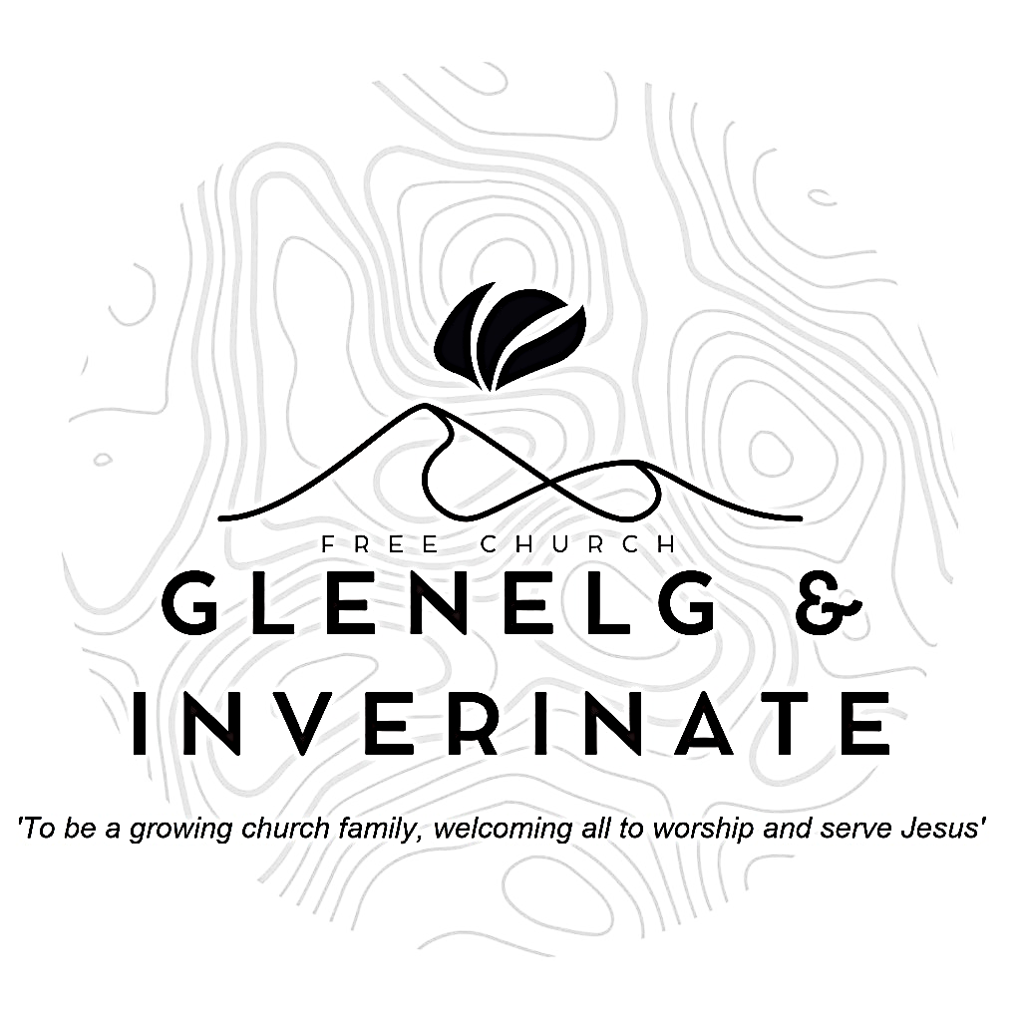

WEEKLY BULLETIN

Sunday 17th August 2025

Service at 12.00 noon in

Chocolates of Glenshiel Cafe

and

6.00pm in Glenelg Church of Scotland

We warmly welcome you to this service of worship and would love you to join us for tea, coffee and refreshment

*Praise the Lord, all you nations; extol him, all you peoples.**For great is his love toward us, and the faithfulness of the Lord endures forever.*

*Praise the Lord* ***Psalm 117: 1-2***

**NOTICES**

**•   Today’s Services:** We are delighted to have Rev James Blackwell, leading our 12 noon worship from Matthew 2:1-12, Sermon – *‘The King’s Subjects’*. Then from Amos 8:1-14, Sermon – ‘*Ripe Fruit’*, this evening in Glenelg. The audio from both services is recorded and are accessible on our website.

* **Praise:**

Sing Psalms 24: 1-10 (page 28) – *The world and all in it are God’s*

Sing Psalms 22: 25-31 (page 27) – *You are the theme of all my praise*

Hymn – *And can it be* – see separate sheet

* **Sunday School:**The JaM Group and Sunday School are taking a break for the School Holidays. There will be crèche for the very little ones. Sunday School and  
  JaM Group will be starting again next Sunday, 24th August
* **Next Sunday 24th August**:  : Rev James Blackwell will lead us in worship at the 12.00 noon Service at Inverinate Hall. There will be no 6.00pm Service in Glenelg as there will be the COOL *'Back to School with God*' Community Service in Kyleakin Hall at 6pm.
* **Membership:** Following on from our mini-series on the church, if anyone has a desire to become a member or simply to ask what is entailed please get in touch with James or any of the elders and we would be delighted to chat about it.
* **Finance Committee Meeting:** The Finance Committee are due to meet on Monday 18th August. If you would like to raise anything for discussion at that meeting please speak to James, Ken, Finlay or Colin and we will put it on the agenda.
* **Psalms and Sausages:** Psalms and Sausages at the manse on Saturday 23rd August at 17:00. Come and join us for some food, praise and a celebration of our first anniversary here. Thanks
* **Wednesday Bible Studies:** Our Glenelg Study Group are meeting in Jon and Megan MacDonald's home at 7.30pm this Wednesday and we will look at Paul's letter to Titus. Our Dornie group meets at Colin and Vivienne MacKenzie’s home at 7.30pm. All are warmly invited to either meeting.
* **Online Studies:**Our Ladies Study Group are continuing their Two-Year Bible Read Through study. Our Men's Study Group are continuing their study on the Shorter Catechism. It's always a great time to join up so if you are interested in joining either group please speak to Moira, Barbara or Colin.
* **Hope Explored:** We hope to run a short course called Hope Explored in September. This is a three-session series looking at the life, death, and resurrection of Jesus that examines his extraordinary claims and offers a hope worth having a hope that won't disappoint us. If you are interested in taking part or bringing a friend, please let us know so we can order enough materials. Thanks.
* **Church Prayer Meeting:** Please remember that our Church Prayer Meeting is now held every Sunday at 11.15am before the Sunday Service. So please do come along and join us in prayer to our Heavenly Father.
* **The Kirk Session met on Monday 11th August and the following decisions were made -**

We anticipate a visit from the IMJP representative in March 2026. The visit will include our congregation along with Plockton and Kyle and the local Free Church Continuing congregation.

The Kirk Session wants to provide more opportunities for us to gather for prayer as a church family. We agreed that we would meet on the first Wednesday evening of every second month, in the Chocolates of Glenshiel Café. The first meeting to be on Wednesday 3rd September at 7.30pm. The prayer meeting would be in place of the usual Bible Study running on these evenings.

Harvest Service and Communion will be held on Sunday 5th October and will be an invite service with a Church Lunch.

Our Slow Cooker Supper and Quiz in aid of the Glenelg Shop Community Purchase will take place on Saturday 27th September in Glenelg Community Hall at 6.00pm.

The Kirk Session agreed that we should begin the use of a projector and screen in Inverinate Hall when we move back in on Sunday 24th August.

We look to complete the gathering of personal information for the congregation to bring us into line with Data Protection regulations and to formulate Email and WhatsApp groups.

* **Scottish Education in the Christian Context survey:** A survey has been commissioned by the Christian Education working group from the Free Church of Scotland to gather views, insights, and ideas for Christian Education in Scotland from a wide range of Christians across the country.

The Group was established by the Free Church General Assembly in May 2024 and is chaired by Rev Allan Shearer. In the past year, the Group assisted the Public Engagement Group with the response to the Consultation on Removing Religious Observance in Schools. Answers from the survey, Scottish Education in the Christian Context, will help inform the next steps of the working group. Questions include ‘What does Christian Education mean to you? Do you have an opinion on Christian Education?’ The sections enable parents, guardians, and grandparents, those within the teaching profession and church leadership or church worker roles the opportunity to share their insights and experience.

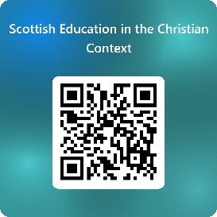The deadline for the survey is 4th October. Complete the survey at <https://forms.office.com/r/GA9aqnGYQd> or scan the QR code.