* **Persecuted Church:** We have some material from Open Doors on the persecuted church available for you. It includes details of the worst 50 countries in the world to be a Christian and prayer points. There are also resources for children available. Please take one if you can use it. Thanks.
* **Finance Manager Vacancy: Free Church of Scotland Central Office Team**

The Free Church of Scotland is looking for an enthusiastic and capable person to serve as Finance Manager in the Central Office staff team.  The Finance Manager will manage the finances of the denomination, provide financial information to boards, support congregational treasurers and lead a small finance team.  This is an exciting opportunity for someone to use their professional skills in a vocational Christian role. More information, a full job description and an application form can be obtained from the [Free Church website](https://freechurch.org/vacancy-finance-manager/" \t "_blank) or by emailing Fiona Russell ([fiona.russell@freechurch.org](mailto:fiona.russell@freechurch.org))

* **Book your place at The Gathering:** The Centre for Rural Ministry is excited to be hosting its next Gathering in Skye, from the 31st July to- 3rd August, for people in their 20s and 30s. There are two spaces left! Organisers say: “We are really looking forward to sheep shearing, hay-making and a trip to the Portree Show. There will also be daily devotionals, time for discussion and reflection on how we can serve the local church, and think about the importance of rural ministry. Do you have anyone in your church who you could recommend this to?” Contact Megan at admin@centreforruralministry.org
* **Big Free Rally – Saturday 20th September:** The Big Free Rally is back for 2025, and we’d love your support in encouraging young people to come along. This year’s rally will take place on Saturday 20th September in Smithton Church, Inverness, bringing together young people from across Scotland for a day of fun, fellowship, and time in God’s Word. Please save the date and begin spreading the word in your congregation. More details, including booking information, will be shared closer to the time.

Minister: Rev. James Blackwell 07596 299970

01599 537223

Elders: Ken MacDonald 07895 678496

Colin MacDonald 01599 522719

Finlay MacDonald 07445 646444

Finance Committee: Donnie Lamont

Ronnie Lamont

Moira Lane

Craig Scobie

Safeguarding Co-ordinators: Barbara MacDonald 01599 522719

Moira Lane 01599 522709

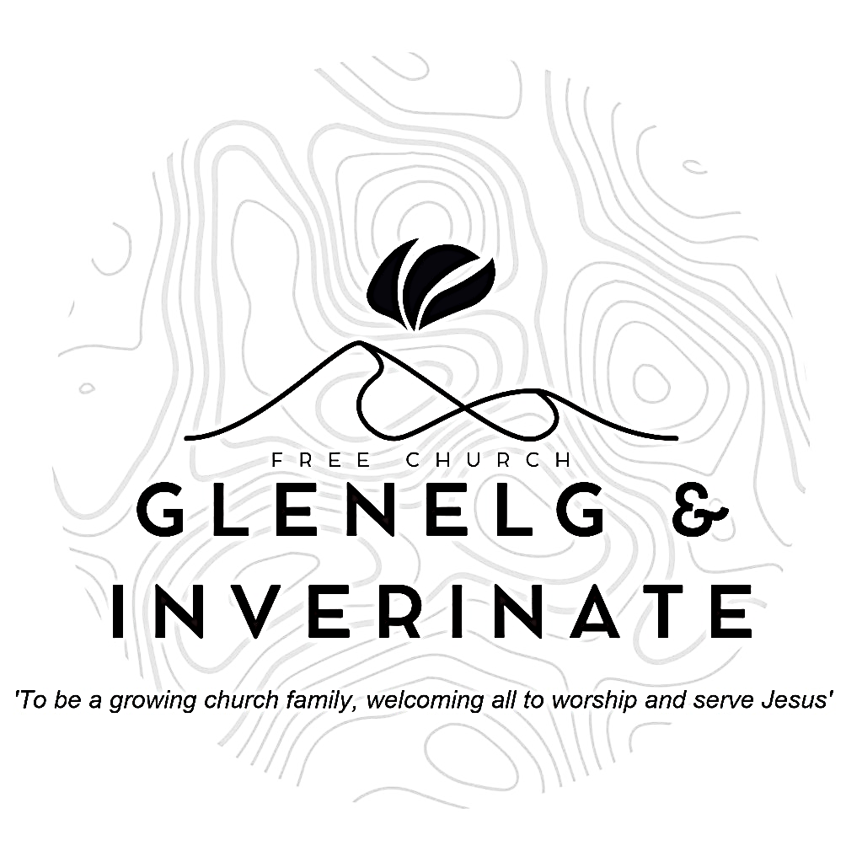

WEEKLY BULLETIN

Sunday 6th July 2025

Service at 12.00 noon in Inverinate Hall

and

6.00pm in Glenelg Church of Scotland

We warmly welcome you to this service of worship and would love you to join us for tea, coffee and refreshment

*So do not fear, for I am with you; do not be dismayed, for I am your God. I will strengthen you and help you; I will uphold you with my righteous right hand.* **Isaiah 41:10**

**NOTICES**

**•   Today’s Services:**We are delighted to have Mr. Arran Macdonald leading us in worship from Exodus 20:1-21. Sermon – ‘Not One Iota: The Ten Commandments For Today.’ Arran has been working at Teen Ranch, a Christian youth activity centre near Perth, and there will be a retiring collection for the work of Teen ranch at the end of our 12 noon service today. Please do give generously to this excellent cause if you can.

This evening Rev James Blackwell will lead us in worship from Titus 3:3-8, Sermon – *‘From Slave to Free’* in Glenelg.

The audio from both services are recorded and are accessible on our website.

* **Praise:**

Sing Psalms 1(a) (page 1) – *Blessed is the one who turns away*

Sing Psalms 15 (page 16) –*Lord, who may stay within your tent*

Scottish Psalter 119(3):17-24 (page 401) – *With me thy servant, in thy grace*

Hymn – *Trust and Obey* – see separate sheet

* **Sunday School:**The JaM Group and Sunday School are taking a break for the School Holidays. There will be crèche for the very little ones.
* **Next weekend 13th July**: Rev James Blackwell will lead us in worship at the 12.00 noon Service at Inverinate Hall and the 6.00pm Service in Glenelg.
* **Estate Visit:** We have been informed that the Estate plan a visit from the week beginning 14th July for two weeks. This means that Inverinate Hall will be unavailable for Sunday 20th July (our Holiday Club Service and Barbecue) and Sunday 27th July. Thankfully Dornie Hall is available for both these dates, so we will hold our 12 noon services in Dornie for those two Sundays.
* **Holiday Club, Youth Activity Week and Holiday Club Service and Barbecue:**

There is still time to book for our Holiday Bible Club and our Youth Activity Week. Please do be passing on information for these weeks to children, young people and their families in our congregation. The link to book **is:**[**https://coolscotland.org.uk/events/**](https://coolscotland.org.uk/events/)

On Sunday 20th July our 12 noon service in Dornie Hall will be our Holiday Club Service and Family Barbecue. Please be praying over who you can invite along to the service and the barbecue to follow. Prayer for One invite cards are in the Bulletin and at the back of the church to make it easier to invite friends, neighbours and family members to join us. Please take as many as you want.

* **Holiday Club Materials:** If you have any useful bits of cardboard or tubes that the kids can use to build a castle with please let Barbara know.
* **Holiday Club Baking:** We’re looking for volunteers to provide baking for holiday club week. If you can help, please speak to Fiona.
* **Women for Mission (WfM):** Every year, WfM organises a fundraising project that everyone in the church can get involved in. The years project is called 'Flourish: Cultivating the seed of God's Word.' If you would like further information about this year's project there are leaflets at the door. Please do take one.
* **Church Prayer Meeting:** Please remember that our Church Prayer Meeting is now held every Sunday at 11.15am in Inverinate Hall before the Sunday Service. Prayer is the engine room of the church and this is a wonderful opportunity every Sunday to come together as brothers and sisters in Christ and pray together. So please do come along and join us in prayer to our Heavenly Father.
* **Wednesday Bible Studies:** Our Glenelg Study Group are meeting in Jon and Megan MacDonald's home at 7.30pm and this Wednesday when we will starting a new study on 1 Timothy, 2 Timothy and Titus. Our Dornie group meets at Colin and Vivienne MacKenzie’s home at 7.30pm. All are warmly invited to either meeting.
* **Online Studies:**Our Ladies Study Group are continuing their Two-Year Bible Read Through study. Our Men's Study Group are continuing their study on the book of Genesis. It's always a great time to join up so if you are interested in joining either group please speak to Moira, Barbara or Colin.
* **Volunteers:** An opportunity has arisen to bless the Dornie community by adopting the local Playgroup. The cost would be small to us and the Finance Committee are willing to fund it but before we can commit we need a few volunteers to help run it. It runs on Monday mornings 10-12 in the Dornie hall. If you would like more information speak to Claire. Thanks
* **Heating Oil Scheme:** Argyle Energy have historically offered a preferential rate on heating oil for church buildings and manses. Recently they have expanded this scheme to include the personal residences of the congregation and the churches wider community. Anyone that is interested in joining can send an email asking for an application form to [claire@argyleuk.com](mailto:claire@argyleuk.com) or telephone Hugh or Claire on 07760 446262 to request an application form.
* **Praying for One Another:** Please add the following points to your prayer diaries:

**South Uist and Benbecula:** We give thanks for the possibility that we may soon have a part-time minister in place.

**St Peter’s, Dundee:** Please pray for our recently established Church Planting Committee as they prayerfully consider areas of potential outreach in and around Dundee. Please also remember the Connections Group tasked with exploring evangelistic opportunities in the West End of Dundee.

**Free Church Youth Camps:** Please pray for Oswestry Juniors. Arbroath Juniors, Oswestry Seniors 2 and Renfrew Girls camps which are all taking place over the upcoming week. Pray for safe travels, strong bonds between campers and leaders, and God’s word to take deep roots. Pray that Godly friendships would grow over the week.