**WHEN I SURVEY THE WONDROUS CROSS**When I survey the wondrous cross  
on which the Prince of glory died,  
my richest gain I count but loss  
and pour contempt on all my pride.  
  
Forbid it, Lord, that I should boast,  
save in the death of Christ my God:  
all the vain things that charm me most,  
I sacrifice them to His blood.  
  
See from His head, His hands, His feet,  
sorrow and love flow mingled down:  
did e’er such love and sorrow meet,  
or thorns compose so rich a crown?  
  
Were the whole realm of nature mine,  
that were an offering far too small,  
love so amazing, so divine,  
demands my soul, my life, my all.  
  
(CCLI No 2922236)

Minister: Rev. James Blackwell 07596 299970

01599 537223

Elders: Ken MacDonald 07895 678496

Colin MacDonald 01599 522719

Finlay MacDonald 07445 646444

Finance Committee: Donnie Lamont

Ronnie Lamont

Moira Lane

Craig Scobie

Safeguarding Co-ordinators: Barbara MacDonald 01599 522719

Moira Lane 01599 522709

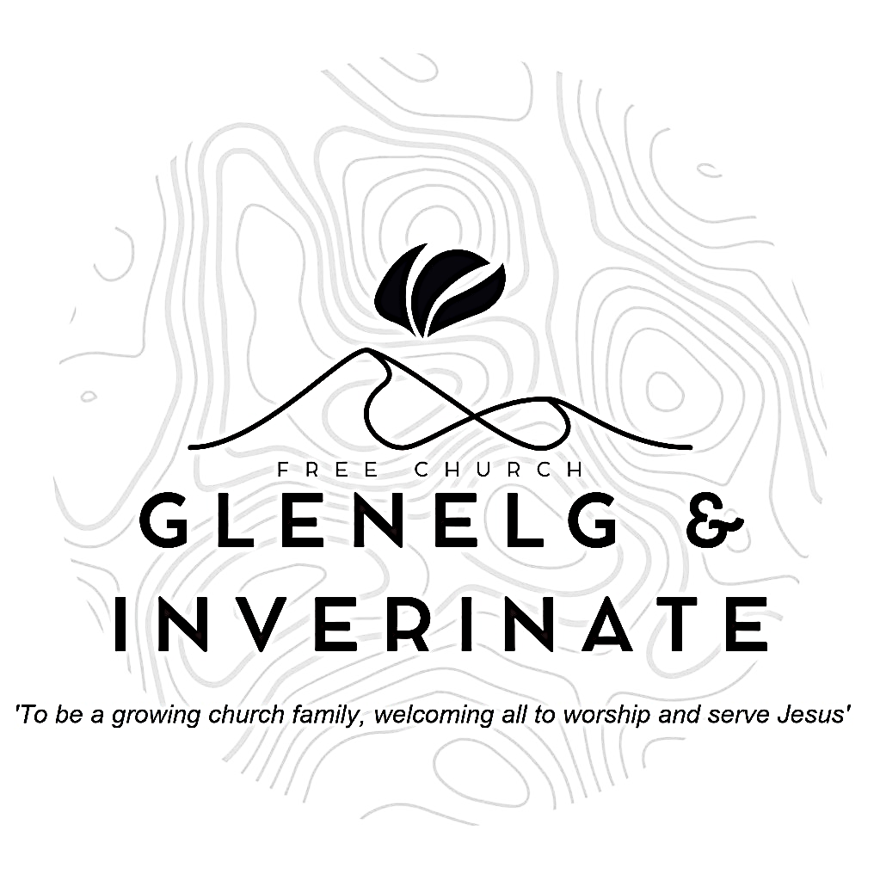

WEEKLY BULLETIN

Sunday 27th July 2025

Service at 12.00 noon in Dornie Hall

and

6.00pm in Glenelg Church of Scotland

We warmly welcome you to this service of worship and would love you to join us for tea, coffee and refreshment

*So do not fear, for I am with you; do not be dismayed, for I am your God. I will strengthen you and help you; I will uphold you with my righteous right hand.* ***Isaiah 41:10***

**NOTICES**

**•   Today’s Services:**We are delighted to have Ken Macdonald leading us in worship from Revelation 7:9-17inDornie. Then Finlay Macdonald this evening in Glenelg. The audio from both services is recorded and are accessible on our website.

* **Praise:**

Sing Psalms 98 (page 129) – *O sing a new song to the Lord*

Sing Psalms 138 (page 179) – *I’ll praise you, Lord, with all my heart*

Sing Psalms 29:1-5 (page 34) –*You mighty ones, give to the Lord as his right* Hymn – *When I Survey the Wonderous Cross* – see back page

* **Sunday School:**The JaM Group and Sunday School are taking a break for the School Holidays. There will be crèche for the very little ones.
* **Next Sunday 3rd August**: Rev James Blackwell will lead the 12.00 noon Service at the Chocolates of Glenshiel Cafe and the 6.00pm Service in Glenelg.
* **Communion Services**:  We plan to celebrate the Sacrament of Holy Communion as a church family on the weekend of 9th and 10th August. Dates and times of services are shown below. Please put these dates in your diaries.
* **Estate Visit**:  The estate have informed us that they plan to extend their visit until 23rd August. This means that Inverinate Hall will be out of commission for the next few weeks. Details of our Sunday services are given below -
  + Sunday 3rd August - 12 noon Service at the Chocolates of Glenshiel Cafe - 6.00pm service in Glenelg church
  + Saturday 9th August - 7.30pm Preparatory Service in Chocolates of Glenshiel Cafe
  + Sunday 10th August - 12 noon Communion Service in Dornie Hall - 6.00pm Closing Service in Glenelg church
  + Sunday 17th August - 12 noon Service in Dornie Hall - 6.00pm Service in Glenelg church
  + Sunday 24th August - 12 noon Service in Inverinate Hall - Evening: 'Back to School with God' Community Service in Kyleakin Hall
* **Church Prayer Meeting:** Please remember that our Church Prayer Meeting is now held every Sunday at 11.15am before the Sunday Service. Prayer is the engine room of the church and this is a wonderful opportunity every Sunday to come together as brothers and sisters in Christ and pray together. So please do come along and join us in prayer to our Heavenly Father.
* **Wednesday Bible Studies:** There will be no Bible Study in Glenelg or Dornie this week. Both studies will restart on 6th August.
* **Online Studies:**Our Ladies Study Group are continuing their Two-Year Bible Read Through study. Our Men's Study Group are continuing their study on the Shorter Catechism. It's always a great time to join up so if you are interested in joining either group please speak to Moira, Barbara or Colin.
* **Date for Diary:** The next Psalms and Sausages is currently scheduled for the 23rd August. Further details to be announced.
* **Volunteers:** An opportunity has arisen to bless the Dornie community by adopting the local Playgroup. The cost would be small to us and the Finance Committee are willing to fund it but before we can commit we need a few volunteers to help run it. It runs on Monday mornings 10-12 in the Dornie hall. If you would like more information speak to Claire. Thanks
* **Membership:** Following on from our mini-series on the church, if anyone has a desire to become a member or simply to ask what is entailed please get in touch with James or any of the elders and we would be delighted to chat about it.
* **Heating Oil Scheme:** Argyle Energy have historically offered a preferential rate on heating oil for church buildings and manses. Recently they have expanded this scheme to include the personal residences of the congregation and the churches wider community. Anyone that is interested in joining can send an email asking for an application form to [claire@argyleuk.com](mailto:claire@argyleuk.com) or telephone Hugh or Claire on 07760 446262 to request an application form.
* **Praying for One Another:** Please add the following points to your prayer diaries:

**Healthy Gospel Church:** Please pray for the Thanksgiving and Prayer gatherings taking place in August in Inverness and Elgin, that as God’s people gather to pray, He be at work among believers. Pray that the Lord would be at work across Scotland, and every nation, so that many people hear and respond to the good news of the gospel of Jesus Christ.

**Free Church Youth Camps:** As the final camps return today, please give thanks to God for all He has done and provided for over the summer. Give thanks to all the leaders, cooks, chaperones, and drivers who have made it possible, and please also give thanks to Rohan and Donald for the work they have done to make the camp program happen. Please pray that each of the children (over 300) who heard the gospel and learned more about who Jesus is, would hold fast to Scripture, and know Jesus as their personal Lord and Saviour.

