**COME PEOPLE OF THE RISEN KING**

Come, people of the Risen King  
Who delight to bring Him praise  
Come all and tune your hearts to sing  
To the Morning Star of grace.  
From the shifting shadows of the earth  
We will life our eyes to Him  
Where steady arms of mercy reach  
To gather children in.

*Rejoice, rejoice, let every tongue rejoice  
One heart, one voice, O Church of Christ, rejoice.*

Come, those whose joy is morning sun  
And those weeping through the night  
Come, those who tell of battles won  
And those struggling in the fight.  
For His perfect love will never change  
And His mercies never cease  
But follow us through all our days  
With the certain hope of peace.

*Rejoice, rejoice ……….*

Come, young and old from every land  
Men and women of the faith  
Come, those will full or empty hands  
Find the riches of His grace.  
Over all the world His people sing  
Shore to shore we hear them call  
The Truth that cries through every age  
“Our God is all in all.”

*Rejoice, rejoice ……….*

(CCLI No 5232617)

Minister: Rev. James Blackwell 07596 299970

01599 537223

Elders: Ken MacDonald 07895 678496

Colin MacDonald 01599 522719

Finlay MacDonald 07445 646444

Safeguarding Co-ordinators: Barbara MacDonald 01599 522719

Moira Lane 01599 522709

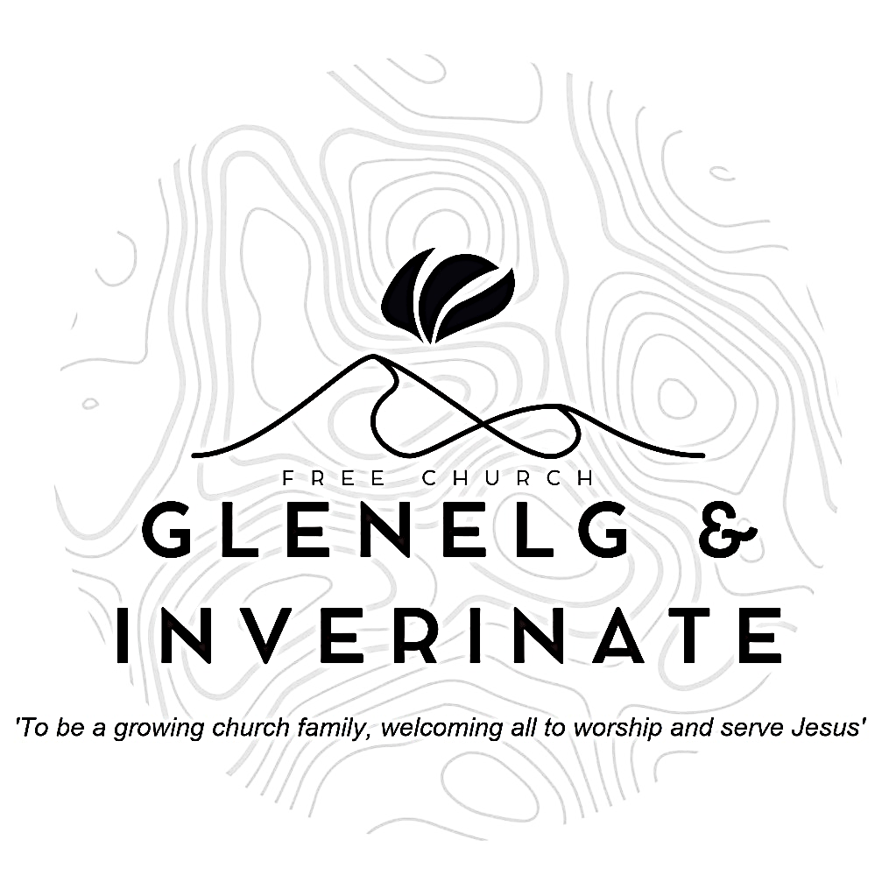

WEEKLY BULLETIN

Sunday 20th July 2025

Service at 12.00 noon in Dornie Hall

and

6.00pm in Glenelg Church of Scotland

We warmly welcome you to this service of worship and would love you to join us for tea, coffee and refreshment

*For you make me glad by your deeds, Lord; I sing for joy at what your hands have done.**How great are your works, Lord, how profound your thoughts!* ***Psalm 92:4-5***

**NOTICES**

**•   Today’s Services:**We are delighted to have Rev James Blackwell, leading us in worship from 2 Samuel 7:12-16 & Mark 12:35-37, Sermon – *‘Son of David, Son of God’* inDornie. Then from Amos 6:1-14, Sermon – ‘*The Sin of Complacency’*, this evening in Glenelg. The audio from both services are recorded and are accessible on our website.

* **Praise:**

Sing Psalms 9(a):7-11 (page 9) – *The Lord for ever reigns on high*

Hymn – *Come People of the Risen King* – see back page

Sing Psalms 23:1-6 (page 174) –The *Lord is my shepherd; no want shall I know*

* **Sunday School:**The JaM Group and Sunday School are taking a break for the School Holidays. There will be crèche for the very little ones.
* **Next Sunday 27th July**: James will be on annual leave from Monday for the week, so our 12.00 noon Service at **Dornie** will be taken by Ken Macdonald and the 6.00pm Service in Glenelg by Finlay Macdonald.
* **Estate Visit:** We have been informed that the Estate plan a visit from the week beginning 14th July, so please note the following -

Sunday 27th July - 12 Noon Service in Dornie Hall

Sunday 3rd August - 12 Noon Services back in Inverinate Hall as usual

The 6.00pm Glenelg Services remain as normal.

* **Holiday Club:** A huge thank you to all who helped to make our Holiday Club and the Youth Activity week a huge success. Please pray for God to be at work in the hearts of our young people.
* **Church Prayer Meeting:** Please remember that our Church Prayer Meeting is now held every Sunday at 11.15am before the Sunday Service. Prayer is the engine room of the church and this is a wonderful opportunity every Sunday to come together as brothers and sisters in Christ and pray together. So please do come along and join us in prayer to our Heavenly Father.
* **Wednesday Bible Studies:** There will be no Bible Study in Glenelg this Wednesday because of the Holiday Club and Youth Activity Week and no Bible Study in Dornie for the next two Wednesdays.
* **Online Studies:**Our Ladies Study Group are continuing their Two-Year Bible Read Through study. Our Men's Study Group are continuing their study on the book of Genesis. It's always a great time to join up so if you are interested in joining either group please speak to Moira, Barbara or Colin.
* **Volunteers:** An opportunity has arisen to bless the Dornie community by adopting the local Playgroup. The cost would be small to us and the Finance Committee are willing to fund it but before we can commit we need a few volunteers to help run it. It runs on Monday mornings 10-12 in the Dornie hall. If you would like more information speak to Claire. Thanks
* **Membership:** Following on from our mini-series on the church, if anyone has a desire to become a member or simply to ask what is entailed please get in touch with James or any of the elders and we would be delighted to chat with you about it.
* **Date for Diary:** The next Psalms and Sausages is currently scheduled for the 23rd August. Further details to be announced.
* **Heating Oil Scheme:** Argyle Energy have historically offered a preferential rate on heating oil for church buildings and manses. Recently they have expanded this scheme to include the personal residences of the congregation and the churches wider community. Anyone that is interested in joining can send an email asking for an application form to [claire@argyleuk.com](mailto:claire@argyleuk.com) or telephone Hugh or Claire on 07760 446262 to request an application form.
* **Women for Mission (WfM):** Every year, WfM organises a fundraising project that everyone in the church can get involved in. The years project is called 'Flourish: Cultivating the seed of God's Word.' If you would like further information about this year's project there are leaflets at the door. Please do take one.
* **Persecuted Church:** We have some material from Open Doors on the persecuted church available for you. It includes details of the worst 50 countries in the world to be a Christian and prayer points. There are also resources for children available. Please take one if you can use it. Thanks.
* **Praying for One Another:** Please add the following points to your prayer diaries: **Christ Church Glasgow**: Give thanks for Tots & Tunes on Friday mornings. Pray for good connections with local families so that the group would be a means to people coming to faith in Jesus. Give thanks for the many children on Sundays. Pray for more volunteers as we add another group after the summer.

**Central Office**: Please pray as we look to appoint a motivated and capable Property Officer to join our team of committed staff in the Central Office to help look after the main Mound Building and other centrally held properties. Please pray the right person steps forward for the role. Please pray for the right candidate for the role of Finance Manager in the Central Office. Pray that God’s hand will be in the process, from the application through to the interviews.

**Knockbain**: Please pray for healing as we seek to move forward as a congregation and for a fresh vision of mission to reach the people of North Kessock, Munlochy and the surrounding areas. Pray for our Christianity Explored Course starting in September. Pray that hearts would be softened and people would be made willing to come and learn more about our wonderful Saviour.

**Free Church Youth Camps**: Please pray for Kincraig Kids 3 and Renfrew Seniors which head to camp today. Please pray that the campers would settle in well, and that the Lord would speak to each of them through His word throughout the week. Pray for energy for the leaders and cooks across the week.