**Jesus, be the centre**

Jesus, be the centre  
Be my source, be my light, Jesus  
Jesus, be the centre  
Be my hope, be my song, Jesus

*Be the fire in my heart  
Be the wind in these sails  
Be the reason that I live  
Jesus, Jesus*

Jesus, be my vision  
Be my path, be my guide, Jesus

*Be the fire in my heart  
Be the wind in these sails  
Be the reason that I live  
Jesus, Jesus*

CCLI No. 2650429

Minister: Rev. James Blackwell 07596 299970

01599 537223

Elders: Ken MacDonald 07895 678496

Colin MacDonald 01599 522719

Finlay MacDonald 07445 646444

Finance Committee: Donnie Lamont

Ronnie Lamont

Moira Lane

Craig Scobie

Safeguarding Co-ordinators: Barbara MacDonald 01599 522719

Moira Lane 01599 522709

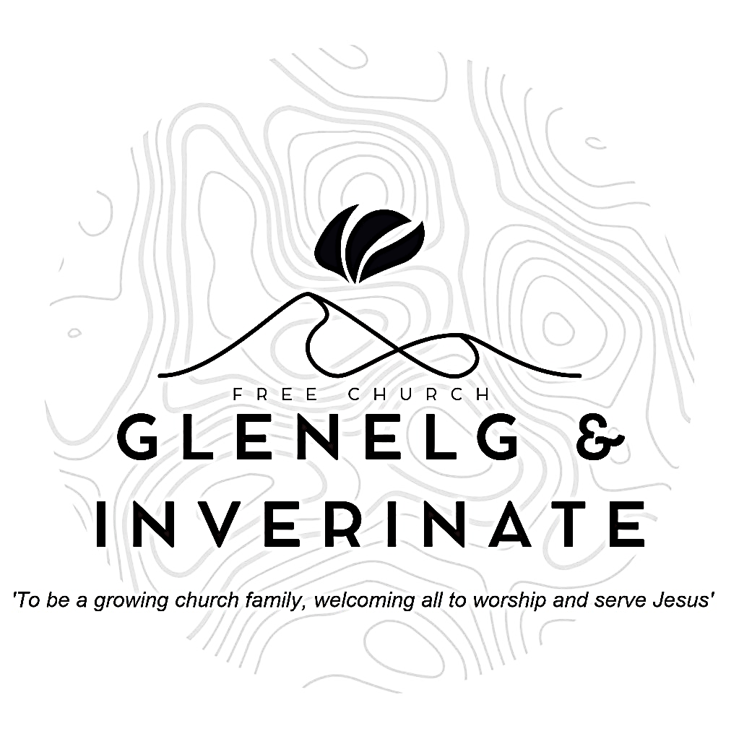

WEEKLY BULLETIN

Sunday 8th June 2025

Service at 12.00 noon in Inverinate Hall

and

6.00pm in Glenelg Church of Scotland

We warmly welcome you to this service of worship and would love you to join us for tea, coffee and refreshment

*Give thanks to the Lord, for he is good; his love endures forever. Cry out, “Save us, God our Savior; gather us and deliver us from the nations, that we may give thanks to your holy name, and glory in your praise.” Praise be to the Lord, the God of Israel, from everlasting to everlasting. Then all the people said “Amen” and “Praise the Lord.”*

**1 Chronicles 16:34-36**

**NOTICES**

* **Today’s Services:**We are delighted to have Rev James Blackwell, leading us in worship from Hebrews 10:19-25 & Matthew 18:15-20, Sermon – *‘The Church: Where?/Why?’ in* Inverinate. Then from Amos 3:9-15, Sermon – ‘*The Witnesses Summoned’*, this evening in Glenelg
* **Praise:**

Scottish Psalter 100: 1-5 (1st) (page 362) – *All people that on earth do dwell*  
Sing Psalms 67: 1-7 (page 84) – *God be merciful and bless us*

Hymn – *Jesus be the centre* – see back page

* **Sunday School:** Sunday School will run as usual today during our 12.00 noon service. There is also a creche for the very little ones.
* **Next weekend 14th&15th June**: Next week we look forward to a joint Communion weekend with our friends in Plockton and Kyle Free Church. The Rev. Ali Sewell from Haddington Community Church will conduct all the following services.

**Saturday: 7:00pm in Kyle Free Church**. (Worship and update from Ali on Haddington and Church planting) **Sunday *11:00am*Communion Service in Inverinate Hall -** followed by a light church lunch. **(Note the earlier time) Sunday 5:30pm service in Kyle Free Church**. If anyone would like to join the congregation in membership please speak to one of the elders.

* **Holiday Club and Youth Activity Week:** Bookings have opened for our Holiday Bible Club and our Youth Activity Week. Please do be passing on information for these weeks to children, young people and their families in our congregation. The link to book is: https://coolscotland.org.uk/events/​
* **Baptism:** We are excited to celebrate the Baptism of Nidge Hoyland and welcome him into church membership on 22nd June at our noon service. Remember Nidge in your prayers as he prepares for the day.
* **Joint Communion:** We once again look forward to joining with other local congregations for a joint Communion Service in Kyleakin Hall on Sunday 29th June at 6.00pm. James will preach at the service. There will be no Glenelg evening service that day.
* **Church Prayer Meeting:** Please remember that our Church Prayer Meeting is now held every Sunday at 11.15am in Inverinate Hall before the Sunday Service. Prayer is the engine room of the church and this is a wonderful opportunity every Sunday to come together as brothers and sisters in Christ and pray together. So please do come along and join us in prayer to our Heavenly Father.
* **Wednesday Bible Studies:** Our Glenelg Study Group are meeting in Jon and Megan MacDonald's home at 7.30pm and this Wednesday we will continue our study on the book of Romans. Our Dornie group meets at Colin and Vivienne MacKenzie’s home at 7.30pm. All are warmly invited to either meeting.
* **Online Studies:**Our Ladies Study Group are continuing their Two-Year Bible Read Through study. Our Men's Study Group are continuing their study on the book of Genesis. It's always a great time to join up so if you are interested in joining either group please speak to Moira, Barbara or Colin.
* **Persecuted Church:** We have some material from Open Doors on the persecuted church available for you. It includes details of the worst 50 countries in the world to be a Christian and prayer points. There are also resources for children available. Please take one if you can use it. Thanks.
* **Praying for One Another:** Please add the following points to your prayer diaries:

**Broughty Ferry:** Pray for the work among the young coordinated by our youth worker. Pray for the whole congregation as we reached another milestone with the purchase of our place of worship and ministry. We are finalising the process to buy the Baptist Church building where we have been running services since late 2021. Once it is done, the building will need thorough refurbishment. Pray for provision, stamina and that we will remain focused on our mission here.

**Sashko, Poland: New Worship Space**: Our church faces a transformative opportunity to rent a worship space above our current ministry centre. As a congregation, we lack the financial resources to complete this project alone. Please pray that God would provide the external support and partnerships needed to make this vision a reality.

**Publishing Ministry**: We give thanks for continued progress in our publishing ministry, especially with several significant projects underway in both Polish and Ukrainian. Please pray specifically for our team working on the translation of the Reformation Study Bible, that God would grant them clarity, theological precision, and perseverance to complete this important resource for the Church.

**Turkey:** Churches in Turkey have started planning their summer activities. Pray especially for a children's ministry in the country. Ask for God's blessing on the camps they run and all those involved.

Churches in Turkey have started planning their summer activities. Pray especially for a children's ministry in the country. Ask for God's blessing on the camps they run and all those involved.

**Duirinish:** Give thanks for the ministry happening in the North of Skye, and ask that the Lord would bless it, and continue to raise up workers for the harvest.

**Please Note:**

There will be a congregational meeting following the Service **Today** regarding the Glenelg church building.