**SEE WHAT A MORNING**

See, what a morning, gloriously bright,  
With the dawning of hope in Jerusalem;  
Folded the grave-clothes, tomb filled with light,  
As the angels announce, "Christ is risen!"  
See God's salvation plan,  
Wrought in love, borne in pain, paid in sacrifice,  
Fulfilled in Christ, the Man,  
For He lives: Christ is risen from the dead!  
  
See Mary weeping, "Where is He laid?"  
As in sorrow she turns from the empty tomb;  
Hears a voice speaking, calling her name;  
It's the Master, the Lord raised to life again!  
The voice that spans the years,  
Speaking life, stirring hope, bringing peace to us,  
Will sound till He appears,  
For He lives: Christ is risen from the dead!  
  
One with the Father, Ancient of Days,  
Through the Spirit who clothes faith with certainty.  
Honour and blessing, glory and praise  
To the King crowned with power and authority!  
And we are raised with Him,  
Death is dead, love has won, Christ has conquered;  
And we shall reign with Him,  
For He lives: Christ is risen from the dead!

(CCLI No. 4108797)

Minister: Rev. James Blackwell 07596 299970

01599 537223

Elders: Ken MacDonald 07895 678496

Colin MacDonald 01599 522719

Finlay MacDonald 07445 646444

Finance Committee: Donnie Lamont

Ronnie Lamont

Moira Lane

Craig Scobie

Safeguarding Co-ordinators: Barbara MacDonald 01599 522719

Moira Lane 01599 522709

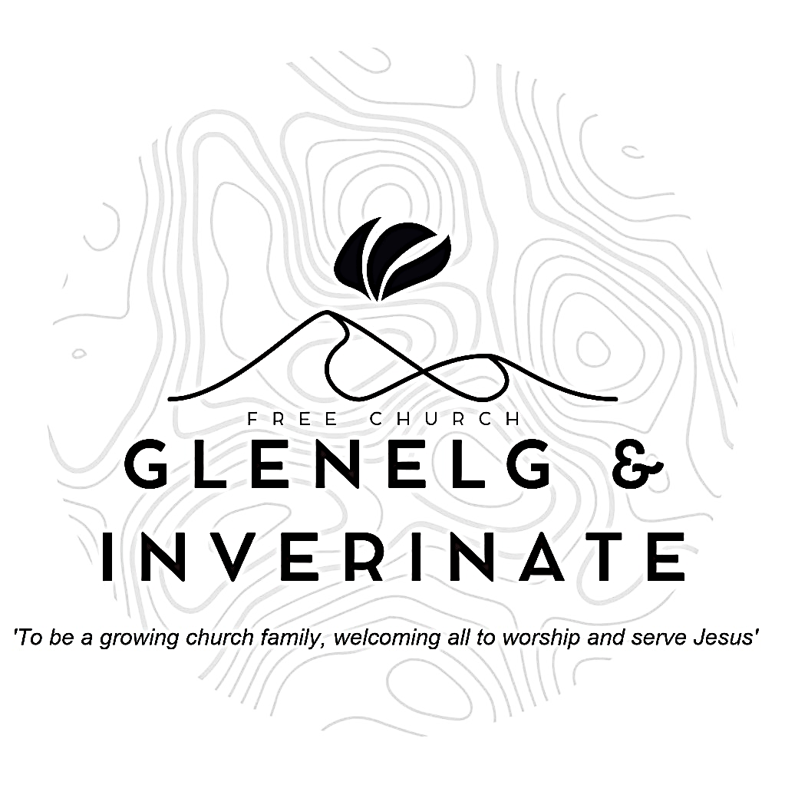

WEEKLY BULLETIN

Sunday 29th June 2025

Service at 12.00 noon in Inverinate Hall

We warmly welcome you to this service of worship and would love you to join us for tea, coffee and refreshment

*Let the heavens rejoice, let the earth be glad; let them say among the nations, “The Lord reigns!” Let the sea resound, and all that is in it; let the fields be jubilant, and everything in them!* **1 Chronicles 16:31-32**

**NOTICES**

* **Today’s Services:**We are delighted to have Rev. James Blackwell leading us in worship from Exodus 31:12-18 and Acts 20:7-12. Sermon – *‘The Church: When?’*

The service will include our Sunday School Prizegiving.

This evening there is a **Joint Communion Service** in Kyleakin Hall at 6.00pm. There will be no evening service in Glenelg.

* **Praise:**

Scottish Psalter 45(2nd): 1-5 (page 269) – *My heart inditing is ……..*

Hymn – *See What a Morning* – see back page

Sing Psalms 23 (page 28) – *The Lord is my shepherd*

Sing Psalms 22:23-29 (page 27) – *Praise him, all you that fear the Lord*

* **Sunday School:** Sunday School and JaM Group will run as usual today during our service. There is also a creche for the very little ones.
* **Next weekend 6th July**: Our Inverinate service will be led by Mr. Arran Macdonald. And our evening service in Glenelg by Rev. James Blackwell.
* **Holiday Club and Youth Activity Week:** Bookings have opened for our Holiday Bible Club and our Youth Activity Week. Please do be passing on information for these weeks to children, young people and their families in our congregation. The link to book is: https://coolscotland.org.uk/events/​
* **Church Prayer Meeting:** Please remember that our Church Prayer Meeting is now held every Sunday at 11.15am in Inverinate Hall before the Sunday Service. Prayer is the engine room of the church and this is a wonderful opportunity every Sunday to come together as brothers and sisters in Christ and pray together. So please do come along and join us in prayer to our Heavenly Father.
* **Wednesday Bible Studies:** Our Glenelg Study Group are meeting in Jon and Megan MacDonald's home at 7.30pm and this Wednesday we will continue our study on the book of Romans. Our Dornie group meets at Colin and Vivienne MacKenzie’s home at 7.30pm. All are warmly invited to either meeting.
* **Online Studies:**Our Ladies Study Group are continuing their Two-Year Bible Read Through study. Our Men's Study Group are continuing their study on the book of Genesis. It's always a great time to join up so if you are interested in joining either group please speak to Moira, Barbara or Colin.
* **Finance Committee Report from our meeting on 23rd June:**

Finlay Macdonald has agreed to be the Finance Committee representative for congregational communications

New bank account, still with RBS, is well underway and should facilitate direct banking.

* **Volunteers:** An opportunity has arisen to bless the Dornie community by adopting the local Playgroup. The cost would be small to us and the Finance Committee are willing to fund it but before we can commit we need a few volunteers to help run it. It runs on Monday mornings 10-12 in the Dornie hall. If you would like more information speak to Claire. Thanks
* **Women for Mission (WfM):** Every year, WfM organises a fundraising project that everyone in the church can get involved in. The years project is called 'Flourish: Cultivating the seed of God's Word.' If you would like further information about this year's project there are leaflets at the door. Please do take one.
* **Heating Oil Scheme:** Argyle Energy have historically offered a preferential rate on heating oil for church buildings and manses. Recently they have expanded this scheme to include the personal residences of the congregation and the churches wider community. Anyone that is interested in joining can send an email asking for an application form to [claire@argyleuk.com](mailto:claire@argyleuk.com) or telephone Hugh or Claire on 07760 446262 to request an application form.
* **Persecuted Church:** We have some material from Open Doors on the persecuted church available for you. It includes details of the worst 50 countries in the world to be a Christian and prayer points. There are also resources for children available. Please take one if you can use it. Thanks.
* **Praying for One Another:** Please add the following points to your prayer diaries:

**Gardenstown**: Please pray for our congregation to grow "in grace and in the knowledge of our Lord Jesus Christ", and that we would see conversions amongst people of all ages. Please pray for our summer outreach event, Good News for Gamrie, to be held on Saturday 30th August, God-willing. Pray for preparation, for good connections to be made, for good follow-up through people signing up to the Hope Explored course, and for real spiritual fruit to the praise and glory of God.

**Tearfund - Democratic Republic of Congo:** Give thanks for those in Tearfund and through partner organisations serving in the DRC. Pray for an end to the violence in eastern DRC. Ask God to bring peace and for people to be able to return safely to their homes and lives. Pray for Tearfund staff and partners and their families. Ask God to protect them and allow them to continue to work safely. Pray for healing for people who have experienced deep trauma and injury from the conflict.

**Kilmallie**: There are a number of primary schools and one High school near the church. Our schools work has yet to recover after the pandemic. Please pray for opportunities and leaders who could reinstate this ministry in the area. This past year we have been holding services across 3 locations: Kilmallie, Acharacle and Kilchoan. Acharacle is one hour from Kilmallie and Kilchoan two hours away. Give thanks that supply preachers have been willing to travel and we have the means to livestream. However, it would be wonderful to see more labourers moving to the area to live and work and to exercise their gifts in the church.

**Free Church Youth Camps:** Please pray for Kincraig Juniors, Oswestry Seniors 1 and Renfrew Kids camps which are all taking place over the upcoming week. Pray for safe travels, unity in the leaders, and God’s word to be faithfully sown in these young peoples lives. Pray that Godly friendships would be grown and fostered.