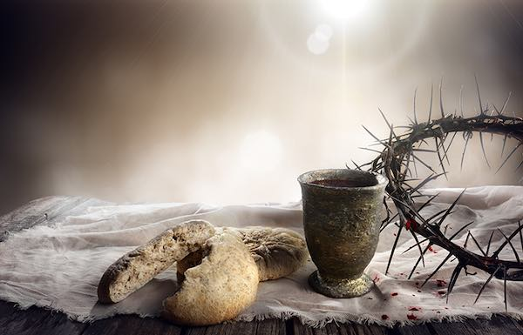
This Photo by Unknown Author is licensed under CC BY-NC-ND

Minister: Rev. James Blackwell 07596 299970
01599 537223
Elders: Ken MacDonald 07895 678496
Colin MacDonald 01599 522719
Finlay MacDonald 07445 646444
Finance Committee: Donnie Lamont
Ronnie Lamont
Moira Lane
Craig Scobie
Safeguarding Co-ordinators: Barbara MacDonald 01599 522719
Moira Lane 01599 522709

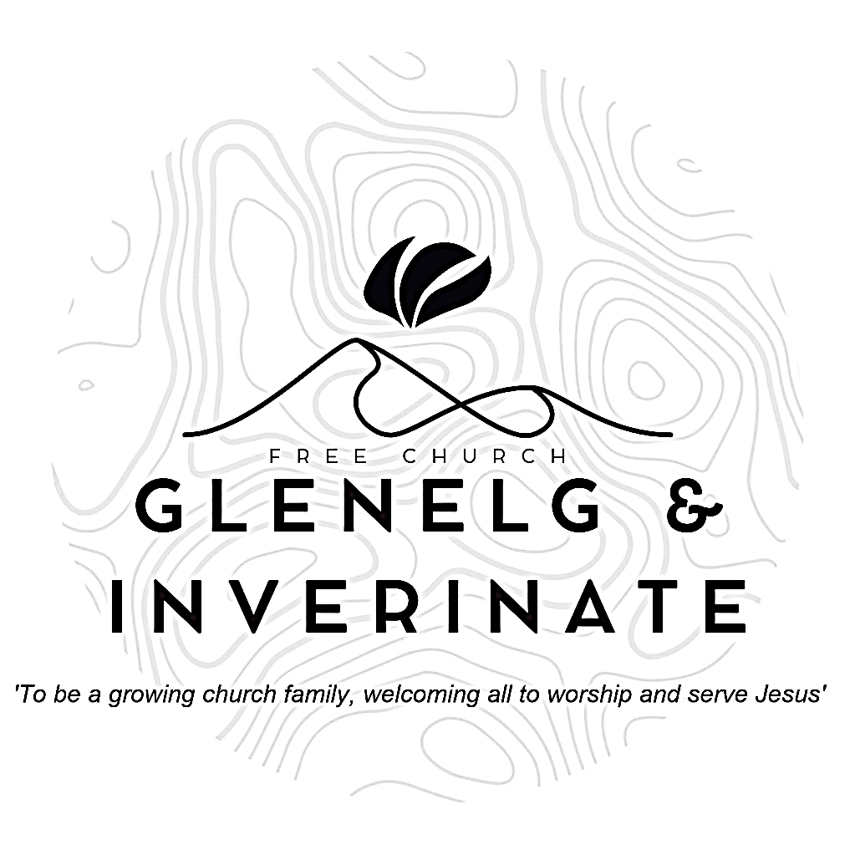

WEEKLY BULLETIN

Sunday 15th June 2025
Service at 12.00 noon in Inverinate Hall

We warmly welcome you to this service of worship and would love you to join us for tea, coffee and refreshment

For he has rescued us from the dominion of darkness and brought us into the kingdom of the Son he loves, in whom we have redemption, the forgiveness of sins.
Colossians 1:13-14
NOTICES

- Today’s Services: We are delighted to have Rev. Ali Sewell from Haddington Community Church, leading us in worship from John 20:1-23.
- This evening there is a joint service at 5:30pm in Kyle Free Church.
- Praise:
Sing Psalms 138: 1-8 (page 179) – I’ll praise you, Lord, with all my heart
Hymn – When Peace like a River – see separate sheet
Sing Psalms 16: 8-11 (page 17) – Before me constantly
Hymn – In Christ Alone – see separate sheet
Scottish Psalter 72: 17-19 (page 314) – His name for ever shall endure
- Sunday School: Sunday School will run as usual today during our service. There is also a creche for the very little ones.
- Next weekend 22nd June: Rev. James Blackwell will lead our 12.00 noon Service at Inverinate Hall and the 6.00pm Service in Glenelg.
- Baptism: We are excited to celebrate the Baptism of Nidge Hoyland and welcome him into church membership on 22nd June at our noon service. Remember Nidge in your prayers as he prepares for the day.
- Holiday Club and Youth Activity Week: Bookings have opened for our Holiday Bible Club and our Youth Activity Week. Please do be passing on information for these weeks to children, young people and their families in our congregation. The link to book is: https://coolscotland.org.uk/events/​
- Joint Communion: We once again look forward to joining with other local congregations for a joint Communion Service in Kyleakin Hall on Sunday 29th June at 6.00pm. James will preach at the service. There will be no Glenelg evening service that day.
- Church Prayer Meeting: Please remember that our Church Prayer Meeting is now held every Sunday at 11.15am in Inverinate Hall before the Sunday Service. Prayer is the engine room of the church and this is a wonderful opportunity every Sunday to come together as brothers and sisters in Christ and pray together. So please do come along and join us in prayer to our Heavenly Father.
- Wednesday Bible Studies: Our Glenelg Study Group are meeting in Jon and Megan MacDonald's home at 7.30pm and this Wednesday we will continue our study on the book of Romans. Our Dornie group meets at Colin and Vivienne MacKenzie’s home at 7.30pm. All are warmly invited to either meeting.
- Online Studies: Our Ladies Study Group are continuing their Two-Year Bible Read Through study. Our Men's Study Group are continuing their study on the book of Genesis. It's always a great time to join up so if you are interested in joining either group please speak to Moira, Barbara or Colin.

- Persecuted Church: We have some material from Open Doors on the persecuted church available for you. It includes details of the worst 50 countries in the world to be a Christian and prayer points. There are also resources for children available. Please take one if you can use it. Thanks.
- Praying for One Another: Please add the following points to your prayer diaries:
Broughty Ferry: Pray for the work among the young coordinated by our youth worker. Pray for the whole congregation as we reached another milestone with the purchase of our place of worship and ministry. We are finalising the process to buy the Baptist Church building where we have been running services since late 2021. Once it is done, the building will need thorough refurbishment. Pray for provision, stamina and that we will remain focused on our mission here.
Sashko, Poland: New Worship Space: Our church faces a transformative opportunity to rent a worship space above our current ministry centre. As a congregation, we lack the financial resources to complete this project alone. Please pray that God would provide the external support and partnerships needed to make this vision a reality.
Publishing Ministry: We give thanks for continued progress in our publishing ministry, especially with several significant projects underway in both Polish and Ukrainian. Please pray specifically for our team working on the translation of the Reformation Study Bible, that God would grant them clarity, theological precision, and perseverance to complete this important resource for the Church.
Turkey: Churches in Turkey have started planning their summer activities. Pray especially for a children's ministry in the country. Ask for God's blessing on the camps they run and all those involved.
Duirinish: Give thanks for the ministry happening in the North of Skye, and ask that the Lord would bless it, and continue to raise up workers for the harvest.

