**BE THOU MY VISION**

Be Thou my vision, O Lord of my heart;  
naught be all else to me, save that Thou art –  
Thou my best thought, by day or by night,  
waking or sleeping, Thy presence my light.

Be Thou my wisdom, Thou my true Word;  
I ever with Thee, Thou with me, Lord;  
Thou my great Father, I Thy true son;  
Thou in me dwelling and I with Thee one.

Be Thou my battle shield, sword for the fight,  
be Thou my dignity, Thou my delight,  
Thou my soul’s shelter, Thou my high tower:  
raise Thou me heavenward, O Power of my power.

Riches I heed not, nor man’s empty praise,  
Thou mine inheritance, now and always:  
Thou and Thou only, first in my heart,  
High King of heaven, my treasure Thou art.

High King of heaven, after victory won,  
may I reach heaven’s joys, O bright heaven’s Sun!  
Heart of my own heart, whatever befall,  
still be my vision, O ruler of all.

(CCLI No. 30639 – Public Domain)

Minister: Rev. James Blackwell 07596 299970

01599 537223

Elders: Ken MacDonald 07895 678496

Colin MacDonald 01955 522719

Finlay MacDonald 07445 646444

Finance Committee: Donnie Lamont

Ronnie Lamont

Moira Lane

Craig Scobie

Safeguarding Co-ordinators: Barbara MacDonald 01599 522719

Moira Lane 01599 522709

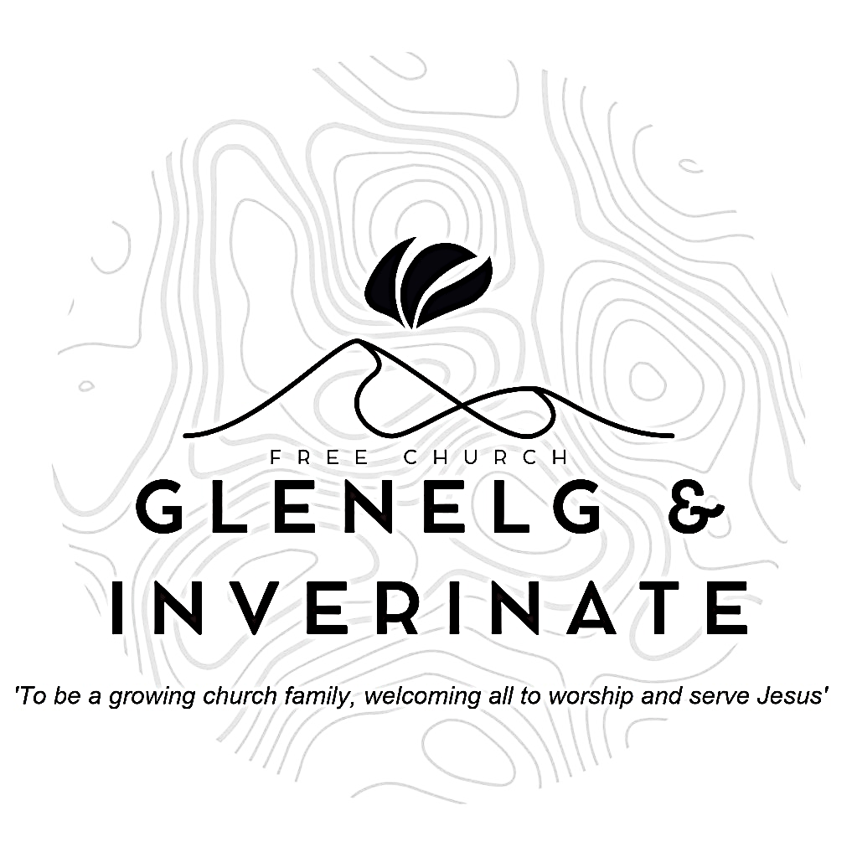

WEEKLY BULLETIN

Sunday 4th May 2025

Service at 12.00 noon in Inverinate Hall

and

6.00pm in Glenelg Church of Scotland

We warmly welcome you to this service of worship and would love you to join us for tea, coffee and refreshment

*I will give thanks to the Lord because of his righteousness; I will sing the praises of the name of the Lord Most High*

***Psalm 7: 17***

**NOTICES**

* **Today’s Service:**We are delighted to have Finlay MacKenzie, leading us in worship from Revelation chapter 4 inInverinate. Then from 1st Corinthians, chapter 13 this evening in Glenelg.
* **Praise:**

Scottish Psalter 19:1-7 (page 223) – The heav’ns God’s glory do declare  
Scottish Psalter 33:6-10 (page 245) – *The heavens by the word of God*

Sing Psalms 34:1-9 (page 40) – *At all time I will bless the Lord*

Hymn – *Be thou my vision* – see back page

* **Next Sunday 11th May:** Rev James Blackwell will lead us in worship at the 12.00 noon Service at Inverinate Hall and the 6.00pm Service in Glenelg.
* **Sunday School:** Sunday School and JaM Group will run as usual today during our 12.00 noon service. There is also a creche for the very little ones.
* **Congregational meetin**g**:** There will be a congregational meeting after the Inverinate Service on **Sunday 18th June** regarding the Glenelg church building. Please make every effort to attend, especially if you are a member of the congregation, thank you. **[Please note the change of date]**
* **Church Prayer Meeting:** Please remember that our Church Prayer Meeting is now held every Sunday at 11.15am in Inverinate Hall before the Sunday Service. Prayer is the engine room of the church and this is a wonderful opportunity every Sunday to come together as brothers and sisters in Christ and pray together. So please do come along and join us in prayer to our Heavenly Father.
* **Holiday Club Request: Cotton Material Scraps Needed!** We are looking for cotton material scraps to help create bunting for this year’s Holiday Club! If you have any spare fabric, we’d love to put them to good use. Please speak to Cheryl if you can donate any materials. Thank you for your support in making our club extra special!
* **Plant Sale and Afternoon Tea:**On Saturday 17th May from 2.00-4.00pm in Glenelg Hall. In aid of the Holiday Bible Club and Youth Activity Week. Please come along and bring all your friends to stock up on your summer plants.
* **Wednesday Bible Studies:** Our Glenelg Study Group are meeting in Jon and Megan MacDonald's home at 7.30pm and this Wednesday we will continue our study on the book of Romans. Our Dornie group meets at Colin and Vivienne MacKenzie’s home at 7.30pm. All are warmly invited.

**• Online Studies:**Our Ladies Study Group are continuing their Two-Year Bible Read Through study. Our Men's Study Group have just begun a new study on the book of Genesis. It's always a great time to join up so if you are interested in joining either group please speak to Moira, Barbara or Colin.

* **Church Baking:** Anyone who would like to volunteer to be on the Baking Rota are invited to speak to Barbara MacDonald to have their name added.
* **Persecuted Church:** We have some material from Open Doors on the persecuted church available for you. It includes details of the worst 50 countries in the world to be a Christian and prayer points. There are also resources for children available. Please take one if you can use it. Thanks.

|  |
| --- |
|  |

* **Adopt a Church Plant:** As part of the Free Church of Scotland's vision to plant 30 churches by 2030 (30x30), we are excited to launch a new initiative: Adopt a Church Plant. This initiative pairs church plants with established congregations for mutual encouragement and prayer.

Through this partnership, your church will have the opportunity to:

• Pray regularly for a church plant and its planter.

• Offer encouragement and support as the church navigates the joys and challenges of planting.

• Stay informed through updates and visits.

• Host a church planter (in person or online) to share their journey and specific prayer needs.

We’re inviting churches to commit to a one-year partnership, allowing relationships to grow while maintaining flexibility for future partnerships as more churches are planted.

Our goal is to establish these partnerships before the summer. Please let us know by Friday 27th June, if your church would like to participate. We’ll follow up with a suggested church plant partner and next steps. If you’re not matched this year, don’t worry! We’d love to connect you in the future. We look forward to seeing how God works through these partnerships!

* **Praying for One Another:** Please add the following points to your prayer diaries:

**Cornerstone:** Give thanks for Neil and Louise MacMillan who have served faithfully in Cornerstone over the past 10 years. Give thanks for their ministry and for all they have contributed to the life of the church. Please pray as Neil steps into his new roe as director of City to City Europe that the Lord would continue to use him as he seeks to serve the church.

**Cumbernauld:** Please pray for the youth club which meets every Friday for crafts, games and bible discussion. Please pray that our young people would grow in friendship with one another, and that they would know Jesus as their personal Lord and Saviour. Pray that the Lord would continue to strengthen the congregation, and that He would provide opportunities for outreach into the community.

**General Assembly:** Please pray for the commissioners as they prepare for the General Assembly later this month. Pray that God would grant them wisdom as they make decisions for the church in the upcoming year.