**How Great Thou Art**

O Lord my God, when I in awesome wonder,  
Consider all the works Thy hand hath made;  
I see the stars, I hear the mighty thunder,  
Thy power throughout the universe displayed:  
  
*Chorus:  
Then sings my soul, my Saviour God, to Thee:  
How great Thou art! How great Thou art!  
Then sings my soul, my Saviour God, to Thee:  
How great Thou art! How great Thou art!*  
  
When through the woods and forest glades I wander  
And hear the birds sing sweetly in the trees,  
When I look down from lofty mountain grandeur,  
And hear the brook and feel the gentle breeze:

*Chorus:*

And when I think how God, His Son not sparing,  
Sent him to die, I scarce can take it in;  
That on the cross, my burden gladly bearing,  
He bled and died to take away my sin:

*Chorus:*

When Christ shall come with shouts of acclamation,  
And take me home, what joy will fill my heart!  
Then I will bow in humble adoration,  
And there proclaim, my God, how great Thou art!

*Chorus:*

(CCLI No. 14181)

Minister: Rev. James Blackwell 07596 299970

01599 537223

Elders: Ken MacDonald 07895 678496

Colin MacDonald 01599 522719

Finlay MacDonald 07445 646444

Finance Committee: Donnie Lamont

Ronnie Lamont

Moira Lane

Craig Scobie

Safeguarding Co-ordinators: Barbara MacDonald 01599 522719

Moira Lane 01599 522709

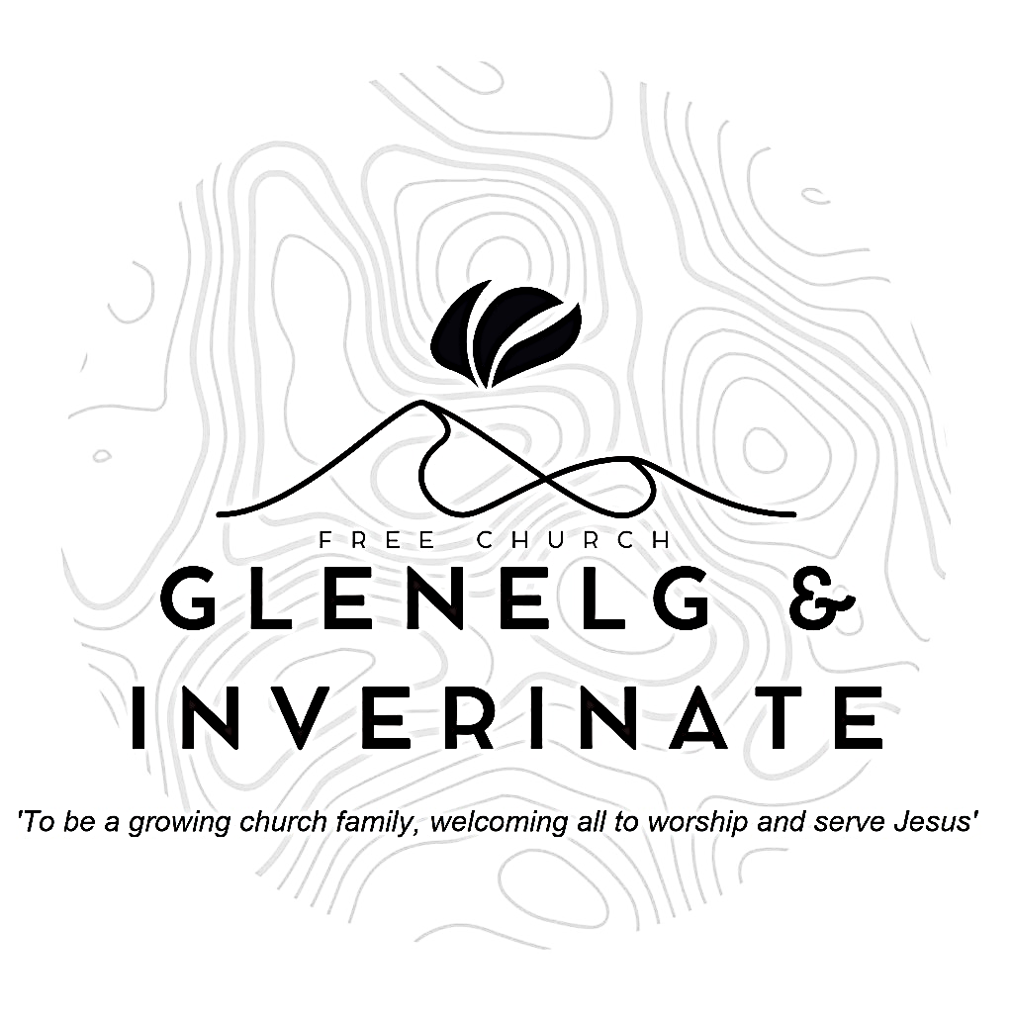

WEEKLY BULLETIN

Sunday 11th May 2025

Service at 12.00 noon in Inverinate Hall

and

6.00pm in Glenelg Church of Scotland

We warmly welcome you to this service of worship and would love you to join us for tea, coffee and refreshment

*The Lord is my rock, my fortress and my deliverer; my God is my rock, in whom I take refuge, my shieldand the hornof my salvation. He is my stronghold, my refuge and my saviour—from violent people you save me.* ***2 Samuel 22: 2-3***

**NOTICES**

* **Today’s Service:**We are delighted to have Rev James Blackwell, leading us in worship from Genesis 10: 1-11 Sermon – *‘The Nations Grow’ in* Inverinate. Then from Amos 2:4-16, Sermon – ‘*God’s People Judged’*, this evening in Glenelg.
* **Praise:**

Scottish Psalter 19:1-8 (page 223) – The heav’ns God’s glory do declare  
Sing Psalms 116:1-9 (page 154) – *I love the Lord because he heard my voice*

Sing Psalms 11:1-4 (page 13) – *I find my refuge in the Lord*

Hymn – *Lord my God! When I in awesome wonder* – see back page

* **Next Sunday 18th May:** Rev James Blackwell will lead us in worship at the 12.00 noon Service at Inverinate Hall and the 6.00pm Service in Glenelg.
* **Sunday School:** Sunday School and JaM Group will run as usual today during our 12.00 noon service. There is also a creche for the very little ones.
* **Congregational meetin**g**:** There will be a congregational meeting after the Inverinate Service on **Sunday 18th June** regarding the Glenelg church building. Please make every effort to attend, especially if you are a member of the congregation, thank you. **[Please note the change of date]**
* 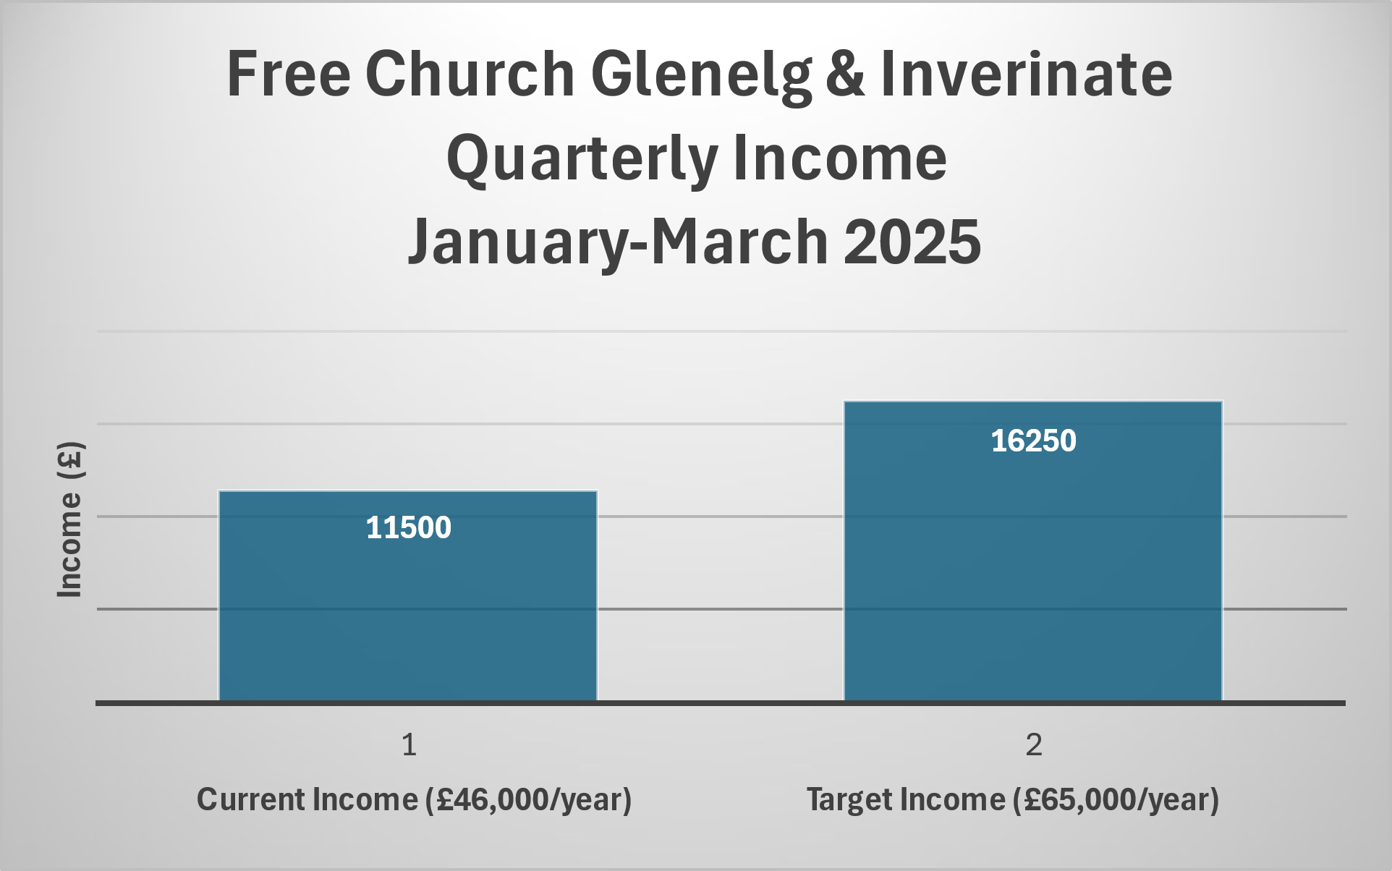**Church Prayer Meeting:** Please remember that our Church Prayer Meeting is now held every Sunday at 11.15am in Inverinate Hall before the Sunday Service. Prayer is the engine room of the church and this is a wonderful opportunity every Sunday to come together as brothers and sisters in Christ and pray together. So please do come along and join us in prayer to our Heavenly Father.
* **Holiday Club Request: Cotton Material Scraps Needed!** We are looking for cotton material scraps to help create bunting for this year’s Holiday Club! If you have any spare fabric, we’d love to put them to good use. Please speak to Cheryl if you can donate any materials. Thank you for your support in making our club extra special!
* **Plant Sale and Afternoon Tea:**On Saturday 17th May from 2.00-4.00pm in Glenelg Hall. In aid of the Holiday Bible Club and Youth Activity Week. Please come along and bring all your friends to stock up on your summer plants.
* **Wednesday Bible Studies:** Our Glenelg Study Group are meeting in Jon and Megan MacDonald's home at 7.30pm and this Wednesday we will continue our study on the book of Romans. Our Dornie group meets at Colin and Vivienne MacKenzie’s home at 7.30pm. All are warmly invited.

**• Online Studies:**Our Ladies Study Group are continuing their Two-Year Bible Read Through study. Our Men's Study Group are continuing their study on the book of Genesis. It's always a great time to join up so if you are interested in joining either group please speak to Moira, Barbara or Colin.

* **Church Baking:** Anyone who would like to volunteer to be on the Baking Rota are invited to speak to Barbara MacDonald to have their name added.
* **Persecuted Church:** We have some material from Open Doors on the persecuted church available for you. It includes details of the worst 50 countries in the world to be a Christian and prayer points. There are also resources for children available. Please take one if you can use it. Thanks.
* **Congregational Income Quarterly Update:** The graph below shows our congregational income for the months of January to March 2025 set against the target income to be a self sustaining congregation. It is very heartening indeed to see that giving is up on 2024 levels and we thank you sincerely for your generosity, we are moving in the right direction. However, there is still some small way to go to reach our target. Following Andre Giffen's visit we expect to see an increase in the income and we trust in God to provide generous hearts to meet our target and sustain a settled ministry in Glenelg, Inverinate and Dornie for the coming years. We will give out our next quarterly update for the period April-June at the beginning of July.
* **Gift Aid:**Did you know that for every £1 donated under the Gift Aid scheme, the church receives 25p from the government? If you are a taxpayer and you are donating to the church, it's a very simple process to make sure we can benefit directly at no extra cost to you. Just fill out a Gift Aid form and make your donations clear, either by setting up a Direct Debit with your bank or by placing your donation in a marked envelope. For further information speak to Ronnie or Moira.

|  |
| --- |
|  |