**TO GOD BE THE GLORY**

To God be the glory! great things He hath done,

So loved He the world that He gave us His Son,

Who yielded His life an atonement for sin,

And opened the life-gate that all may go in.

*Praise the Lord, praise the Lord,*

*Let the earth hear His voice;*

*Praise the Lord, praise the Lord,*

*Let the people rejoice;*

*O come to the Father, through Jesus the Son,*

*And give Him the glory; great things He hath done.*

O perfect redemption, the purchase of blood!

To every believer the promise of God;

The vilest offender who truly believes,

That moment from Jesus a pardon receives.

*(Chorus)*

Great things He hath taught us, great things He hath done,

And great our rejoicing through Jesus the Son;

But purer, and higher, and greater will be

Our wonder, our rapture when Jesus we see.

*(Chorus)*

(CCLI No. 7009143)

Minister: Rev. James Blackwell 07596 299970

01599 537223

Elders: Ken MacDonald 07895 678496

Colin MacDonald 01955 522719

Finlay MacDonald 07445 646444

Finance Committee: Donnie Lamont

Ronnie Lamont

Moira Lane

Craig Scobie

Safeguarding Co-ordinators: Barbara MacDonald 01599 522719

Moira Lane 01599 522709

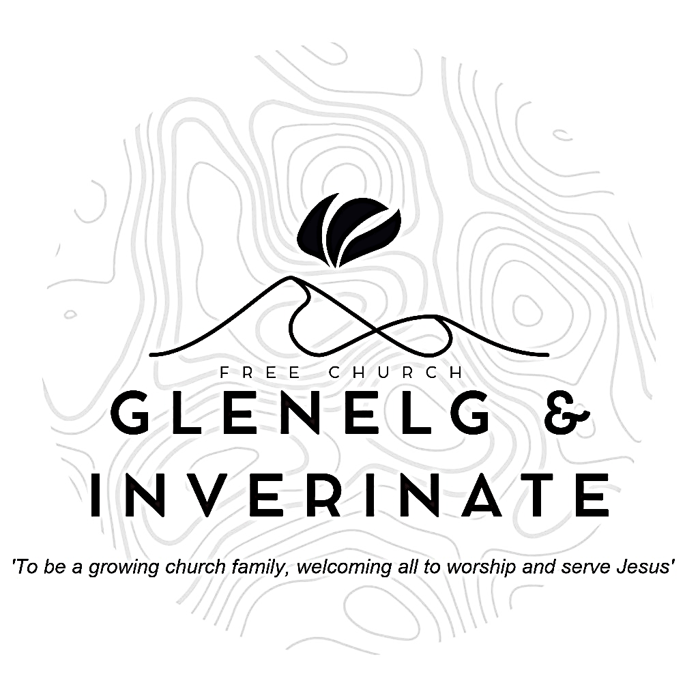

WEEKLY BULLETIN

Easter Sunday 20th April 2025

Service at 12.00 noon in Inverinate Hall

We warmly welcome you to this service of worship and would love you to join us for tea, coffee and refreshment

*For what we preach is not ourselves, but Jesus Christ as Lord, and ourselves as your servants for Jesus’ sake. For God, who said, ‘Let light shine out of darkness,’ made his light shine in our hearts to give us the light of the knowledge of God’s glory displayed in the face of Christ.* ***2 Corinthians 4:5-6***

**NOTICES**

* **Today’s Service:**This afternoon James will lead us in our Easter Sunday Communion Service from 1 Corinthians 15:1-34, a sermon entitled - *‘The Necessity of the Resurrection.’* The service will include the Celebration of Holy Communion. The bread is gluten free and the wine is non-alcoholic. The service will be followed by our congregational lunch, please do stay and join us in this time of fellowship as a church family. All are most warmly welcome.
* **Praise:**  
  Scottish Psalter 100 (1) (page 362) – *All people that on earth do dwell*

Praise – *Come people of the risen king* (see page opposite)  
Sing Psalms 23:1-6 (page 28) – *The LORD is my shepherd; no want shall I know*

Sing Psalms 16:5-11 (page 17) – *O LORD, you are to me*

Praise – *To God be the glory* (see back page)

* **Sunday School:** There will be no Sunday School or JaM Group during the Easter Holidays (back on Sunday 27th April). However, there are Sermon Helper Sheets available on the table by the door. There is a crèche for the very little ones.
* **Joint Evening Service:** At 6.00pm in Kyleakin Hall this evening. You are warmly invited to come together with friends from across the South Skye and Lochalsh area for worship, fellowship and focus on our crucified and risen Saviour Jesus. There will be a time of praise, followed by reflection on Christ’s word, concluding with the celebration of the Lord’s Supper. The service will last for about an hour, include crèche provision, and tea and coffee will be served afterwards.
* **Psalms and Sausages:** The next Psalms and Sausages will take place on **Saturday 26th April** at 2.00pm at the Manse. Please put the date in your diary and come along if you can.
* **Next Sunday, 27th April:** In light of our AGM we are delighted to announce that Andrew Giffen the CEO of the Free Church is coming to preach for us next Sunday. Following the 12 noon service in Inverinate, Andrew will meet with the congregation to answer any questions you may have on the financial position of our church. If you have any questions you would like to submit beforehand please email them to me at [j.blackwell42@outlook.com](mailto:j.blackwell42@outlook.com) or let one of the elders know. Questions can be submitted anonymously.
* **Holiday Club Request: Cotton Material Scraps Needed!** We are looking for cotton material scraps to help create bunting for this year’s Holiday Club! If you have any spare fabric, we’d love to put them to good use. Please speak to Cheryl if you can donate any materials. Thank you for your support in making our club extra special!
* **Church Baking:** Anyone who would like to volunteer to be on the Baking Rota is invited to speak to Barbara MacDonald to have their name added.
* **Online Studies:**Our Ladies Study Group are continuing their Two-Year Bible Read Through study. Our Men's Study Group are starting a study on the book of Genesis. It's always a great time to join up. If you are interested in joining either group please speak to Moira, Barbara or Colin.
* **Persecuted Church:** We have some material from Open Doors on the persecuted church available for you. It includes details of the worst 50 countries in the world to be a Christian and prayer points. There are also resources for children available. Please take one if you can use it. Thanks.

|  |
| --- |
|  |

**COME PEOPLE OF THE RISEN KING**

Come, people of the Risen King

Who delight to bring Him praise

Come all and tune your hearts to sing

To the Morning Star of grace.

From the shifting shadows of the earth

We will life our eyes to Him

Where steady arms of mercy reach

To gather children in.

*Rejoice, rejoice, let every tongue rejoice*

*One heart, one voice, O Church of Christ, rejoice.*

Come, those whose joy is morning sun

And those weeping through the night

Come, those who tell of battles won

And those struggling in the fight.

For His perfect love will never change

And His mercies never cease

But follow us through all our days

With the certain hope of peace.

*Rejoice, rejoice ……….*

Come, young and old from every land

Men and women of the faith

Come, those will full or empty hands

Find the riches of His grace.

Over all the world His people sing

Shore to shore we hear them call

The Truth that cries through every age

“Our God is all in all.”

*Rejoice, rejoice ……….*

(CCLI No 5232617)