**SEEK YE FIRST**

Seek ye first the kingdom of God  
and His righteousness and all these things  
shall be added unto you.

Allelu, alleluia. Seek ye first ……….

Man shall not live by bread alone  
but by every word  
that proceeds from the mouth of God.

Allelu, alleluia. Man shall not ……….

Ask and it shall be given unto you,  
seek and ye shall find;  
knock and the door shall be opened up to you.

Allelu, alleluia. Ask and it ……….

(CCLI No. 1352)

Minister: Rev. James Blackwell 07596 299970

01599 537223

Elders: Ken MacDonald 07895 678496

Colin MacDonald 01955 522719

Finlay MacDonald 07445 646444

Finance Committee: Donnie Lamont

Ronnie Lamont

Moira Lane

Craig Scobie

Safeguarding Co-ordinators: Barbara MacDonald 01599 522719

Moira Lane 01599 522709

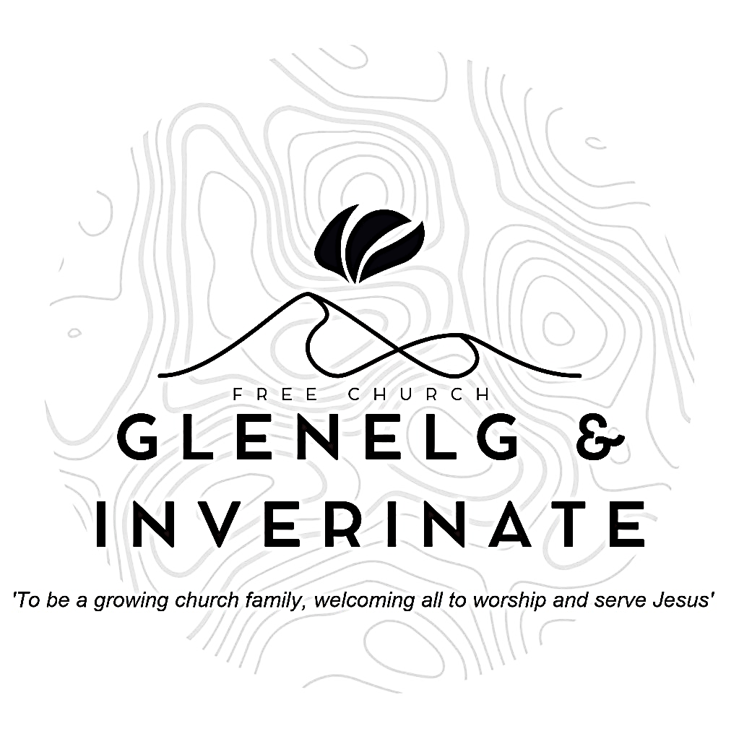

WEEKLY BULLETIN

Sunday 27th April 2025

Service at 12.00 noon in Inverinate Hall

and

6.00pm in Glenelg Church of Scotland

We warmly welcome you to this service of worship and would love you to join us for tea, coffee and refreshment

*I will give thanks to the Lord because of his righteousness; I will sing the praises of the name of the Lord Most High*

***Psalm 7: 17***

**NOTICES**

* **Today’s Service:**We are delighted to have Andrew Giffen leading us in worship from Ephesians 4:1-16, Sermon – A Vision of the Church *in* Inverinate. Then, this evening in Glenelg, Rev James Blackwell will be leading us from Amos 1:1-2:3, Sermon – Israel’s neighbours Judged.
* **Praise:**

Sing Psalms 147:1-7 (page 192) – O *praise the Lord! How good it is*  
Sing Psalms 119(5):33-40 (page 159) – *Teach me to follow your decrees*

Sing Psalms 24:7-10 (page 159) – *You ancient gates, lift up your heads*

Hymn – *Seek ye first the kingdom of God* – see back page

* **Next Sunday 4th May:** Rev James Blackwell will be on holiday and Mr. Finlay MacKenzie, an elder from Dingwall Free Church and recently retired from Blythswood will lead us in worship at the 12.00 noon Service at Inverinate Hall and the 6.00pm Service in Glenelg.
* **Sunday School:** Sunday School and JaM Group will run as usual today during our 12.00 noon service. There is also a creche for the very little ones.
* **Congregational meetin**g**:** There will be a congregational meeting after the Inverinate Service on Sunday 18th May regarding the Glenelg church building. Please make every effort to attend, especially if you are a member of the congregation, thank you.
* **Church Prayer Meeting:** Please remember that our Church Prayer Meeting is now held every Sunday at 11.15am in Inverinate Hall before the Sunday Service. Prayer is the engine room of the church and this is a wonderful opportunity every Sunday to come together as brothers and sisters in Christ and pray together. So please do come along and join us in prayer to our Heavenly Father.
* **Holiday Club Request: Cotton Material Scraps Needed!** We are looking for cotton material scraps to help create bunting for this year’s Holiday Club! If you have any spare fabric, we’d love to put them to good use. Please speak to Cheryl if you can donate any materials. Thank you for your support in making our club extra special!
* **Wednesday Bible Studies:** Our Glenelg Study Group are meeting in Jon and Megan MacDonald's home at 7.30pm and this Wednesday we will begin a study on the book of Romans, so this would be a great time to join us. Our Dornie group meets at Colin and Vivienne MacKenzie’s home at 7.30pm. All are warmly invited.

**• Online Studies:**Our Ladies Study Group are continuing their Two-Year Bible Read Through study. Our Men's Study Group have just begun a new study on the book of Genesis. It's always a great time to join up so if you are interested in joining either group please speak to Moira, Barbara or Colin.

* **Church Baking:** Anyone who would like to volunteer to be on the Baking Rota are invited to speak to Barbara MacDonald to have their name added.
* **Persecuted Church:** We have some material from Open Doors on the persecuted church available for you. It includes details of the worst 50 countries in the world to be a Christian and prayer points. There are also resources for children available. Please take one if you can use it. Thanks.

|  |
| --- |
|  |

* **Praying for One Another:** Please add the following points to your prayer diaries:

**Cornerstone:** Give thanks for Neil and Louise MacMillan who have served faithfully in Cornerstone over the past 10 years. Give thanks for their ministry and for all they have contributed to the life of the church. Please pray as Neil steps into his new roe as director of City to City Europe that the Lord would continue to use him as he seeks to serve the church. Please pray for the Spanish Speaking congregation, that the Lord would continue to grow each individual in knowledge and love for Him. Please also pray for the Gilmerton Church Plant, that God would work in the hearts those reached in the community, that many would be saved in Gilmerton.

**Sashko, Poland: Pray For Our Ukrainian Ministry**: Continue to pray for the Ukrainian teens and families in our congregation, especially those led by Yurii and Olya Boiko. Pray for healing from the trauma of war, for spiritual growth among the youth, and for wisdom as we minister to their needs. **Pray For Our Publishing Ministry (MW Books)**: Pray for all those involved in our Reformed publishing work. Ask that God would use the translated materials to combat theological famine in Poland and Ukraine, and that these resources would strengthen the Church throughout Eastern Europe.

**Cumbernauld:** Please pray for the youth club which meets every Friday for crafts, games and bible discussion. Please pray that our young people would grow in friendship with one another, and that they would know Jesus as their personal Lord and Saviour. Pray that the Lord would continue to strengthen the congregation, and that He would provide opportunities for outreach into the community.

**General Assembly:** Please pray for the commissioners as they prepare for the General Assembly later this month. Pray that God would grant them wisdom as they make decisions for the church in the upcoming year.