**O CHURCH ARISE**

O Church, arise, and put your armour on;  
Hear the call of Christ our Captain.  
For now the weak can say that they are strong  
In the strength that God has given.  
With shield of faith and belt of truth,  
We’ll stand against the devil’s lies;  
An army bold, whose battle-cry is Love,  
Reaching out to those in darkness.

Our call to war, to love the captive soul  
But to rage against the captor;  
And with the sword that makes the wounded whole,  
We will fight with faith and valour.  
When faced with trials on every side  
We know the outcome is secure,  
And Christ will have the prize for which He died,  
An inheritance of nations.  
  
Come see the cross, where love and mercy meet,  
As the Son of God is stricken;  
Then see His foes lie crushed beneath His feet,  
For the Conqueror has risen!  
And as the stone is rolled away,  
And Christ emerges from the grave,  
This victory march continues till the day  
Every eye and heart shall see Him.  
  
So Spirit, come put strength in every stride,  
Give grace for every hurdle,  
That we may run with faith to win the prize  
Of a servant good and faithful.  
As saints of old still line the way,  
Retelling triumphs of His grace,  
We hear their calls and hunger for the day  
When with Christ we stand in glory.

(CCLI No. 4611992)

Minister: Rev. James Blackwell 07596 299970

01599 537223

Elders: Ken MacDonald 07895 678496

Colin MacDonald 01955 522719

Finlay MacDonald 07445 646444

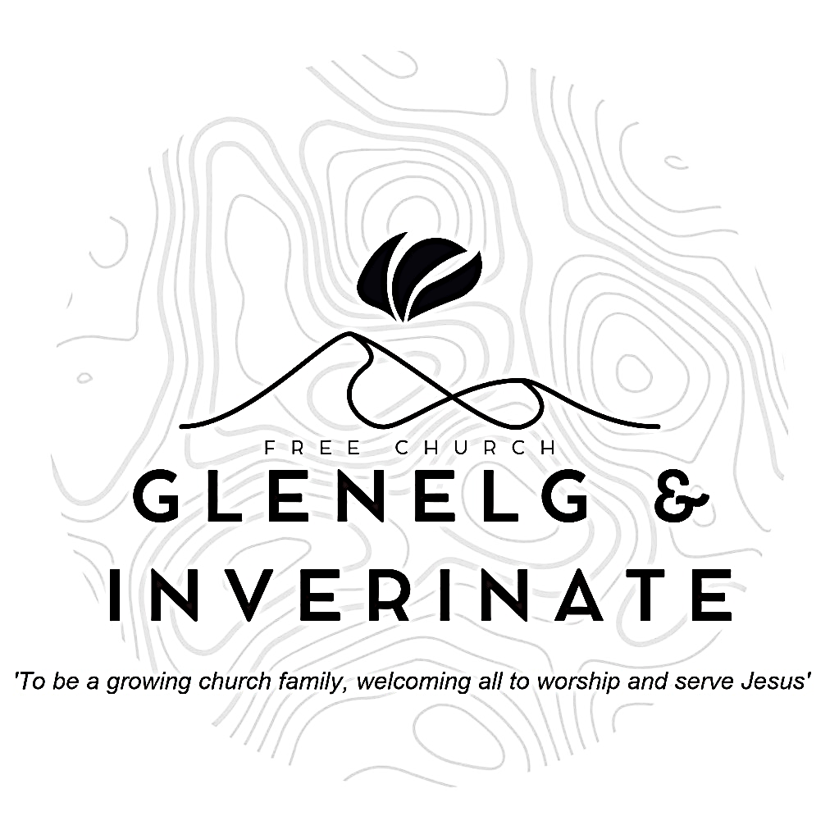

WEEKLY BULLETIN

Sunday 13th April 2025

Service at 12.00 noon in Inverinate Hall

and

6.00pm in Glenelg Church of Scotland

We warmly welcome you to this service of worship and would love you to join us for tea, coffee and refreshment

*I will give thanks to you, Lord, with all my heart; I will tell of all your wonderful deeds. I will be glad and rejoice in you;*

*I will sing the praises of your name, O Most High.*

***Psalm 9: 1-2***

**NOTICES**

* **Today’s Service:**We are delighted to have Rev James Blackwell leading us in worship from Genesis 9:18-28, Sermon – *‘The Second Fall’ in* Inverinate. Then from Amos 1:1-15, Sermon – ‘*Amos - Introduction’*, this evening in Glenelg
* **Praise:**  
  Hymn – *O Church Arise* – see back page

Sing Psalms 117:1-2 x2 (page 155) – *Praise the Lord, O all you nations*  
Sing Psalms 51:1-12 (page 67) – *O my God, have mercy on me*

Scottish Psalter 121:1-8 (page 416) – *I to the hills will lift mine eyes*

* **Sunday School:** There will be no Sunday School or JaM Group during the Easter Holidays (back on Sunday 27th April). However, there are Sermon Helper Sheets available on the table by the door and there will be the usual 'Three Questions' at the end of the service, with rewards for correct answers! There is a crèche for the very little ones.
* **Easter Services 18th and 20th April:** We plan to hold the following services over Easter. Good Friday Service on Friday 18th April at 7.30pm led by James Blackwell, Easter Sunday Outdoor Service, in Glenelg (venue to be confirmed) at 9.00am, led by Finlay Macdonald and our Easter Communion Service at 12 noon in Inverinate Hall, conducted by James Blackwell and followed by a congregational lunch. If anyone would like to join the church in membership please come and speak to James or one of the other elders. There will be a Joint Community Communion Service at 6.00pm on Easter Sunday evening in Kyleakin Village Hall.
* **Prayer for One:**You should have received a 'Prayer for One' invite card with your Bulletin last Sunday. Please do use it to pray for someone you would like to invite to our Easter Sunday Service and Lunch, then you can use the card itself as an invite to ask them along. If you didn’t get one, or you want to ask more than one person there are more cards at the back of the church.
* **Church Prayer Meeting:** Please remember that our Church Prayer Meeting is now held every Sunday at 11.15am in Inverinate Hall before the Sunday Service. Prayer is the engine room of the church and this is a wonderful opportunity every Sunday to come together as brothers and sisters in Christ and pray together. So please do come along and join us in prayer to our Heavenly Father.
* **Holiday Club Request: Cotton Material Scraps Needed!** We are looking for cotton material scraps to help create bunting for this year’s Holiday Club! If you have any spare fabric, we’d love to put them to good use. Please speak to Cheryl if you can donate any materials. Thank you for your support in making our club extra special!
* **Family Easter Crafts:** Saturday 19th April Inverinate Community Hall 2-4pm

Drop in crafting session for the young ones. Tea and Coffee and other refreshments available. Drop in and get crafty!

* **Free Church CEO Visit:** In light of our AGM we are delighted to announce that Andrew Giffen the CEO of the Free Church is coming to preach on Sunday 27th April. Following the 12 noon service in Inverinate, Andrew will meet with the congregation to answer any questions you may have on the financial position of our church. If you have any questions you would like to submit beforehand please email them to me at [j.blackwell42@outlook.com](mailto:j.blackwell42@outlook.com) or let one of the elders know.
* **Psalms and Sausages:** The next Psalms and Sausages will take place on Saturday 26th April at 2.00pm at the Manse. Please put the date in your diary and come along if you can.
* **Church Baking:** Anyone who would like to volunteer to be on the Baking Rota are invited to speak to Barbara MacDonald to have their name added.
* **Wednesday Bible Studies:**  Our Glenelg Study Group are meeting in Jon and Megan MacDonald's home at 7.30pm. our Dornie group meets at Colin and Vivienne MacKenzie’s home at 7.30pm. All are warmly invited.
* **Online Studies:**Our Ladies Study Group are continuing their Two-Year Bible Read Through study. Our Men's Study Group are continuing with our Easter Bible Study, 'In Quietness & Trust', it's always a great time to join up. If you are interested in joining either group please speak to Moira, Barbara or Colin**.**
* **Persecuted Church:** We have some material from Open Doors on the persecuted church available for you. It includes details of the worst 50 countries in the world to be a Christian and prayer points. There are also resources for children available. Please take one if you can use it. Thanks.

|  |
| --- |
|  |

* **Praying for One Another:** Please add the following points to your prayer diaries:

**Maryburgh and Killearnan:** Pray for our Drop-in Cafe on Tuesdays at 10am - 12 noon. Pray that as we invite people to our Easter service, God will move hearts to come along

**Falkirk:** We have been encouraged in recent months by numerical growth in the congregation, including a number of young men coming along; pray that this would continue, as we are built up in our faith around the Word of God. We would love to see more young families coming and committing themselves to the life and witness of the church.

**OM**: Please pray for our team in Poland who continue to serve our Ukrainian brothers and sisters who have been displaced. Please pray for continued strength for them. Please pray for the young people in Cabul-an who have a passion for reaching people with the gospel.

**Teens Conference:** Please pray for the committee organising the teens conference, that they would be granted wisdom as they finalise plans for the conference in June. This year, Rev Robin Gray, of Gardenstown Free Church of Scotland, will speak on the theme of **One with Jesus: The Blessing of Being in Christ.**